[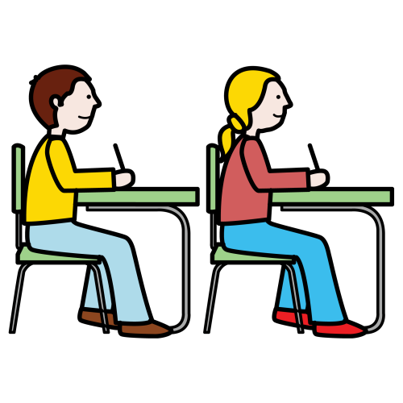](https://www.google.fi/url?sa=i&rct=j&q=&esrc=s&source=images&cd=&ved=2ahUKEwjU8fKZu97jAhWcw8QBHVZxA_UQjRx6BAgBEAU&url=http%3A%2F%2Fpapunet.net%2Ftaxonomy%2Fterm%2F11148&psig=AOvVaw2MOz0X9tLAbXntUzCf6ErQ&ust=1564638598779735)LUOKASSA ON KOE

 OLE HILJAA