WELCOME TO PÄIVIÖNSAARI DAYCARE CENTRE

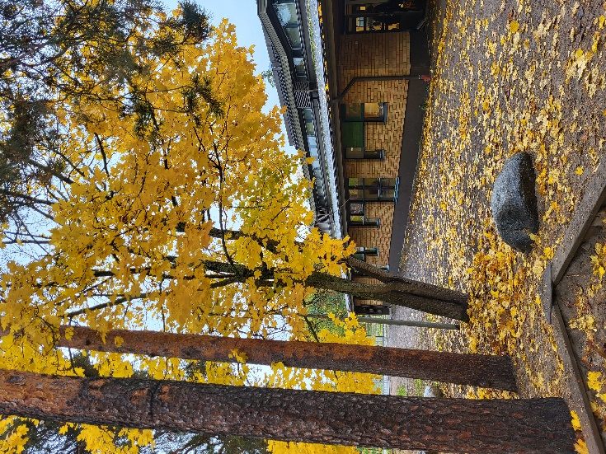

Hamsterit 3-yr-olds, tel. 044-743 6611
Oravat 1-3-yr-olds, tel. 044-743 6615
Hiiret 1-3-yr-olds, tel. 044-743 6617
Myyrät 3-5-yr-olds, tel. 044-743 6614
Sopulit 3-5-yr-olds, small rehabilitation group, tel. 044-743 6609
Siilit 3-5-yr-olds, tel. 044-743 6610

Director of daycare centre Tiina Siivola, tel. 040 7524920
Päiviönsaari early childhood special education teacher, tel. 040,484 0984
Early childhood education director: Anne Tuunainen, tel. 040 8347988
Payment matters related to early childhood education: Sari Liuska, tel. 044 4442408
STARTING AT THE DAYCARE CENTRE
Before starting in daycare, it is important that you and your child get to know your child’s future daycare centre, group and group caregivers. During your visit to the centre, you will be able to discuss matters concerning your child with the group caregivers, including your child’s daily routine, allergies, games that your child likes, etc. The more the daycare centre knows about your child, the easier it will be for your child to start in daycare. All caregivers at the daycare centre are bound by professional secrecy.
During your visit, a caregiver from your child’s group will show you the facilities of your child’s group and the daycare centre, talk about activities carried out in the group and practical issues.
It is natural for some separation anxiety to occur in both parents and their children when a child first enrols in daycare. When you take your child to daycare, make sure you don't drag out goodbyes, but wish your child a nice day, give them a kiss and hug, and leave with a cheerful mind. Crying and frustrated children usually calm down quickly in the arms of a caregiver after their parents have left.

ARRIVING AT AND LEAVING FROM THE DAYCARE CENTRE
Please make sure you close the gate latch when entering and leaving the daycare centre! Children are not allowed to pass through the gates alone! As a safety measure, we teach children not to climb over the fence and that only caregivers may open the gate.
Children who arrive at the centre between 6:30 and 7:00 a.m. are put into the on-guard group Myyrät. From 7:00 a.m. onwards, when the group caregivers have arrived, children may join their own group.
Shoes and rain gear should be left in the hallway, while outdoor clothes may be kept in the child's locker. Please take off your outdoor shoes before approaching the lockers, as children often play on the floor. First, children wash their hands together with their guardian, after which the guardian may accompany their child to the daycare centre caregivers.
When you pick your child up from daycare, please make sure that the daycare personnel is aware that your child has been picked up. We are normally outside in the afternoon, but depending on the weather, you may also find us inside the daycare centre. Group-specific caregivers work until 4:15 p.m., after which children are handed over to the on-guard caregivers. If we have to stay inside in the afternoon, the remaining children join the Myyrät group at 4:15 p.m. The daycare centre closes at 5:00 p.m. We recommend checking your child’s locker every day to see if there are are any dirty clothes, bulletins or your child’s creations that you can take home. Please also check the notice board to see if there is any new information about excursions, for example. If a child is picked up by someone other than a parent, please inform your child's group beforehand. Children are only handed over to persons that the daycare centre has been informed of. Children may only be picked up by over 18-year-old adults.

SUPPORTING CHILDREN’S DEVELOPMENT TOGETHER
Trustful and open collaboration between children’s guardians and the daycare centre is essential for ensuring high-quality early childhood education. Small everyday matters can be discussed when dropping off or picking up your child from the daycare centre. The daily routines and development of each child are discussed in more detail at an agreed time at the child’s early childhood education talk (VASU).
Guardians must inform the daycare centre of their preferred daycare schedule electronically. Daycare times must be announced no later than by 11:55 p.m. on Monday of the previous week. It is essential that daycare schedules be reported in advance! The daycare centre plans activities, orders food and plans employees’ work shifts based on reported daycare schedules and absences. If any changes occur in the reported daycare schedule, please contact the caregivers in your child’s group.
You can register your child’s daycare schedule electronically at www.varkaus.fi
Wilma is an electronic communication platform. Through Wilma, you can contact the early childhood education teacher of your child's group as well as view all important announcements from the City of Varkaus and Päiviönsaari daycare centre. Vasus or early childhood education plans are also uploaded to Wilma.
Päiviönsaari daycare centre also has its own peda.net webpage. There you will find information about the daycare centre groups as well as additional data about the activities of each group throughout the year.

Daily routines are generally the same in every group:
6.30 a.m. - the daycare centre opens. 6.30-7.00 a.m. children are received in the Myyrät group
8.00-8.30 a.m. breakfast
9.00-11.00 a.m. group activity/outing
11.00 a.m. -12.00 noon lunch
12.00 noon -2.00 p.m. midday rest
2.00-2.30 p.m. snack
2.30 p.m. - group activity/outing
5 p.m. the daycare centre closes

WHAT DO YOU NEED TO PACK FOR YOUR CHILD?

- nappies if necessary
- xylitol lozenges
- a soft toy if desired
- spare clothes (e.g., underwear, socks, long trousers, shirts)
- weather-appropriate outdoor clothing (outdoor jacket, outdoor trousers, hat, gloves)
- Warm clothes for cold weather (e.g., mid-layer set, woollen socks, scarf/neckwarmer)
- rain clothes (rubber boots, rain trousers, rain jacket, rain gloves)
Please also make sure that the clothes are the right size so that your child can move and play comfortably!
ALL CLOTHES MUST BE LABELLED WITH THE CHILD’S NAME!

