Emotion regulation refers to our ability to control our feelings and not let them get the best of us. Kids who are able to use effective emotion regulation skills tend to have less meltdowns and tantrums. At the end of the day, fewer meltdowns is a win for both kids and caregivers. Therefore, it makes sense that we teach kids how to identify their feelings at an early age.
So how do we teach kids emotion regulation skills you ask?
Well, it starts by teaching them how to identify and express their feelings. I’ve included some fun feelings identification activities below that are perfect for most preschool, Pre-K, and Kindergarten-aged kids. These feelings identification activities give kids a chance to practice feelings identification by using emoji feeling faces.
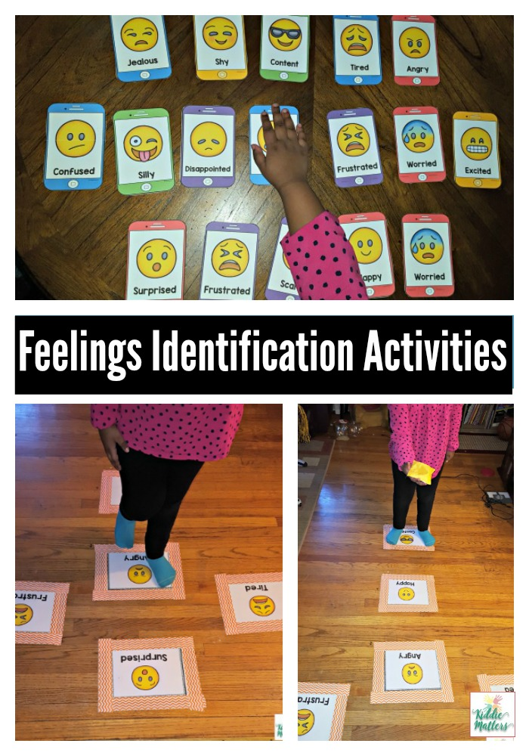Feelings Charades
People’s body language tells a lot about how they are feeling. For instance, when some people are mad, they cross their arms and squint their eyes. Teaching kids how to ‘read’ body language will help them tune in to how other people are feeling. It will also help them tune in to their own body language which can give them a sense of self control . This will go a long way in helping them to practice emotion regulation when faced with big emotions.
In this feelings charades game, have kids pick a card from the deck of feeling faces and act out the feeling written on the card. Others must try and guess what emotion they are acting out. This is recommended for two or more players.
Feelings Matching Game
The feelings matching game is played like the classic Memory game. You’ll need to print out two sets of feeling faces cards so that you have pairs of all the feeling faces.
Shuffle the feeling cards and then lay them face down. Players will take turns flipping over two cards per turn until they find a match. In order to keep the match, players must share what makes them feel the emotion written on the card. Players get to go again when they find a match. The player with the most matches win. This is recommended for one or more players.
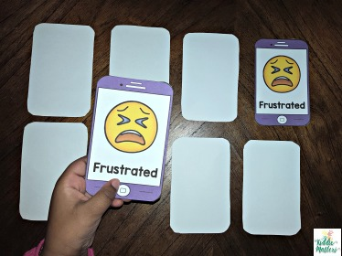
Feelings Go Fish
Print out two sets of feelings cards. Like the classic Go Fish game, kids get 5 cards and fish for pairs by asking other players if they have the match they need to make a pair. If the other player doesn’t have the card asked for, they say “Go Fish.” If the player gets a match, they lay the pair down and take another turn. The first player to get rid of all the cards in their hand wins. This is perfect for two or more players
Feelings Slap Game
Lay all the feeling faces cards face up. As you call out a feeling, the player must slap the card that has the feeling face you called. You can use a fly swatter for this game, but kids will have just as much fun using their hands or a pointer. Kids can play this alone oe with one other player. When playing with two players, the player who slaps the feeling card first gets to keep it.
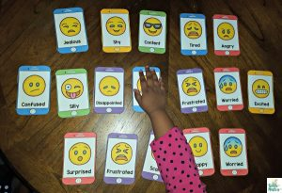
Feelings Hop
Tape the Feeling Faces Mats to the floor with painters tape or duct tape. For kids who are just learning about feelings, it helps to only tape a few feelings on the ground so as not to overwhelm them. The fun starts when you call out a feeling and kids must hop or jump to the feeling you called out. They must then say how their bodies feel when they experience the emotion they hopped to.
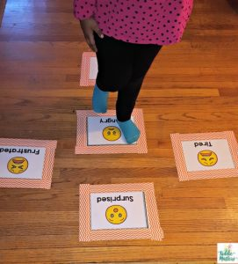<
Feelings Bean Bag Toss
Set up the Feelings Mats on the floor using painters tape or duct tape to keep the mats in place. Call out a feeling. The child then tosses the bean bag to the feeling you called out. Another option is to have the child toss the bean bag on a random feeling and then have them tell about a time they experienced that emotion or give examples of things or situations that makes them feel the emotion the bean bag lands on.
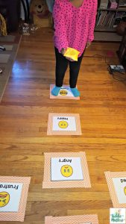

You can find all the materials needed to complete this activity in my Feelings Identification Activities resource pack.

