[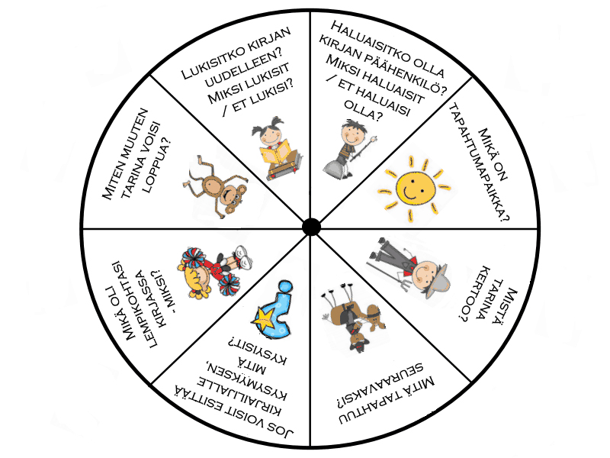](http://www.google.fi/url?sa=i&rct=j&q=&esrc=s&source=images&cd=&cad=rja&uact=8&ved=0ahUKEwjW2MeaxpDPAhXKkywKHRFxBqAQjRwIBw&url=http://www.kolumbus.fi/mm.salo/LinkitAidinkieli.htm&psig=AFQjCNHp6irpNRN5DSuPMF7bbpxw_n9wsA&ust=1474000565837577)