

Composition by Miro Turakainen

The NBA - National Basketball Association

In this composition I will introduce you the fascinating world of one of the world’s biggest sports league and discuss the diversity of nations represented in the NBA.

The NBA - National Basketball Association

Composition by Miro Turakainen

Did You know that…

Wilton ”Wilt” Chamberlain (August 21, 1936 – October 12, 1999) holds the record of most points scored (100) in one game? He is considered to be the second most dominant basketball player of all-time after Michael Jordan, since only Jordan’s points/career average (30,12) is better than his (30,06).

# Good to know…

National Basketball Association, or NBA shortly, is the third largest professional sports in the USA and fourth largest professional sports league in the whole world by revenue. It was founded on June 6th 1946 in New York, United States and the first game was played between the Toronto Huskies and the New York Knickerbockers on November 1st in Toronto, Canada.

Back in 1946 NBA used to have 11 teams, most of which no longer exist or have changed their name or the location. Nowadays the NBA has 30 teams, three of which are original teams founded in 1946: Boston Celtics, New York Knickerbockers (commonly referred as New York Knicks), and Golden State Warriors (formerly known as Philadelphia Warriors).

During the regular season, each team plays 82 games; 41 games home and 41 games away. The league is divided to two conferences, eastern and western, and to six divisions, Atlantic, Central, Southeast, Northwest, Pacific and Southwest. (See page number two for map of the conferences and divisions and the team logos, black line divides the map to eastern and western conference.)

After the regular season, the playoffs begin in late April with the top eight teams in each conference. The first seeded teams will play against the eight seeded teams, the second seeded teams against the seventh seeded teams, and so on in a best-of-seven-series, with the first team to win four games advancing into the next round, while the other team is eliminated from the playoffs. (See page number three last year’s standings and playoffs results)

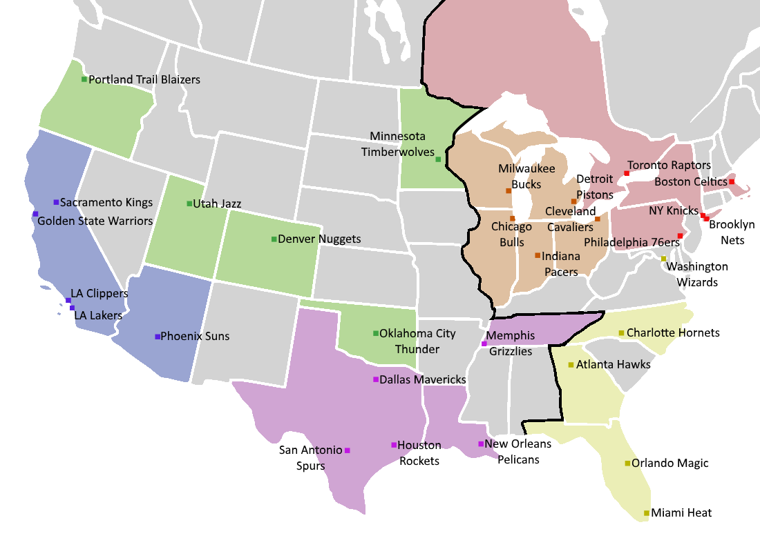

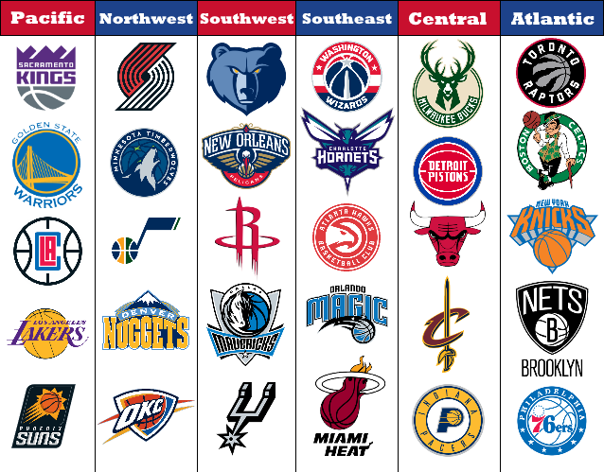

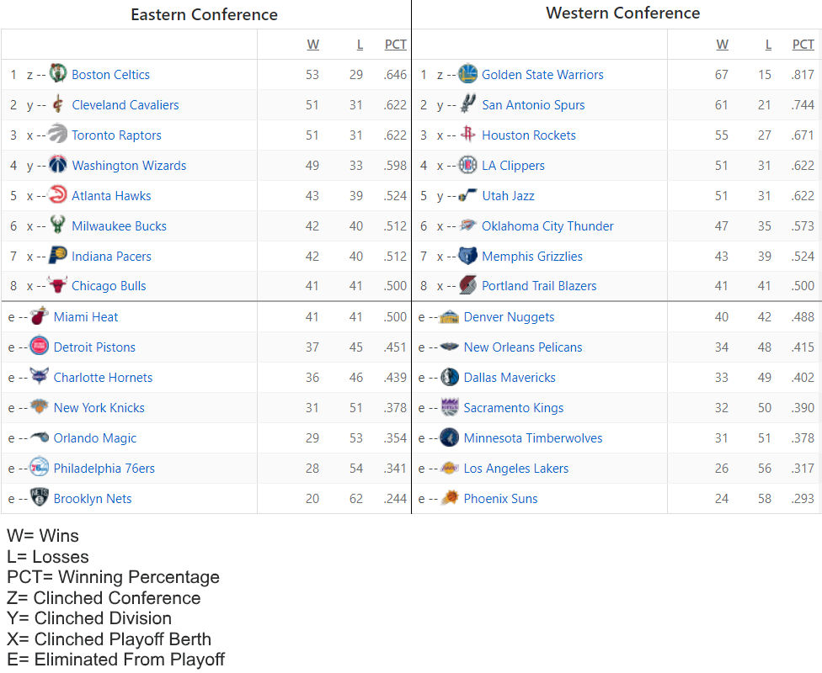

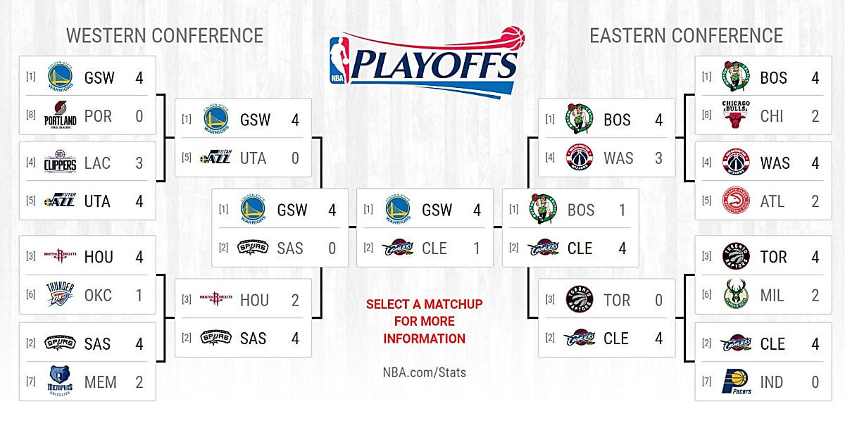

# Question number 1: How international is the nba?

Every team sport is dominated by one or a few countries: soccer by European and South American teams, ice hockey by Canada, USA and a few European countries, and floorball by Nordic countries. But basketball, alongside with football, is dominated by the Americans. However, the NBA has become more diverse during the past two decades, and nowadays NBA has 118 international players from 43 different countries. The three countries with most players, when the USA is not included, are Canada (12 players), Australia (10 players), and France (nine players).

Down below you can see a map that shows you all the countries that are currently represented in the NBA and how many players come from each country.

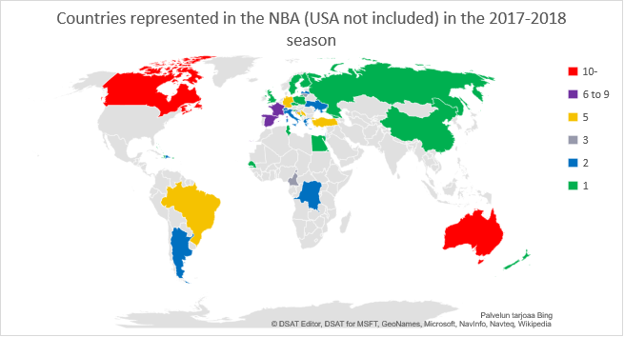

Since the figure is a bit small, here are all the countries, with the exception of USA, that are represented in the NBA: Canada with 12 players, Australia with 10 players, France with nine players, Spain with eight players, Turkey, Bosnia and Herzegovina, Brazil, Germany and Serbia with five players, Lithuania, Cameroon and Croatia with three players, Italy, Latvia, Argentina, Democratic Republic of Congo, Dominican Republic, Greece, Israel, Switzerland, and Ukraine with two players and finally New Zealand, United Kingdom, Puerto Rico, Bahamas, China, Czech Republic, Egypt, Finland, Georgia, Haiti, Montenegro, Poland, Russia, Senegal, Slovenia, Sweden and Tunisia with one player.

# My opinion: best international of all time

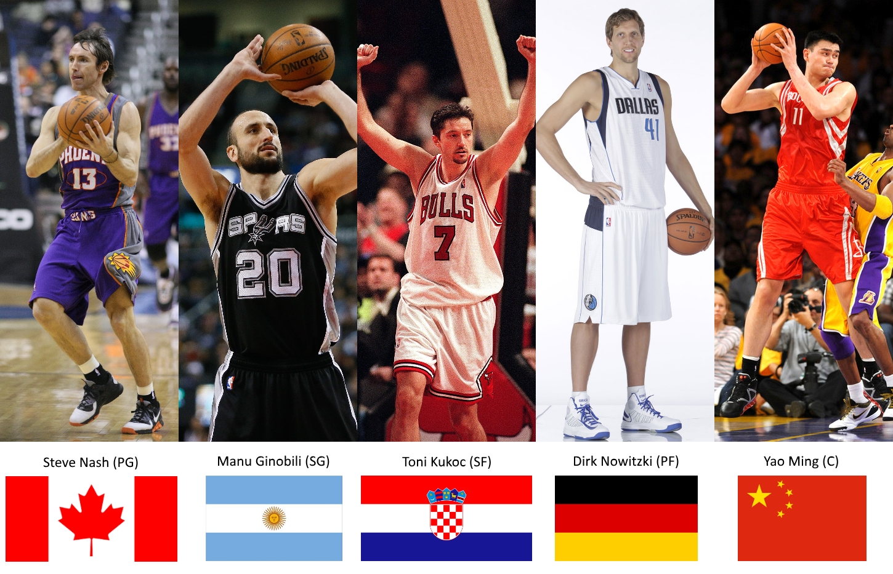

### Steve nash (190 cm/88 KG, Born February 7th, 1974 in Johannesburg, SOuth Africa)

15th pick in the 1996 NBA Draft by the Phoenix Suns. Played for Phoenix during 1996-1998, and during 2004-2012, winning the MVP (Most Valuable Player) in 2005 and 2006. He also played for Dallas Mavericks (1998-2004) and Los Angeles Lakers 2012-2015. Nash retired in 2015. Alongside with the MVP, he is 5x assist champion, 7x NBA All-NBA member (three teams, that consist of 15 players that are considered to have been best during the season), and 8x All Star.

Fun fact: Nash’s family sure loves sports. His younger brother, Martin, played soccer for the Vancouver Whitecaps FC and made 30 appearances for the Canadian national soccer team. Their younger sister, Joann, was the captain of the University of Victoria Vikes’ women's soccer team for three years and was named a Canada West Universities Athletic Association All-Star. She is married to professional ice hockey player Manny Malhotra. Nash has a godson named R.J. Barrett, who is considered to be a star basketball player in the making.

### Manu ginobili (198 cm/92 kg, Born July 28th, 1977 in Bahia blanca, argentina)

28th pick in the 1999 NBA Draft by the San Antonio Spurs, for which he still plays. Known for his passing abilities and humble outlook on his role as a player. 2x All Star, 4x NBA Champion, 2x All NBA, 2002-03 All-Rookie (Best 10 rookies divided to two teams), 2007-08 Sixth Man.

Fun fact: Ginobili is one of only two players in basketball history, along with Bill Bradley, who has won the EuroLeague, an Olympic gold medal, and an NBA Championship ring. He is also the first non-U.S. player to win both the NBA championship ring and the Olympic gold medal, and the second Latin American to be selected to play in an NBA All-Star game (after Panama's Rolando Blackman).

### toni kukoc (208 CM/87 KG, Born September 18th, 1968 in Split, SR croatia, sfr jugoslavia)

29th pick in the 1990 NBA Draft by the Chicago Bulls. Had a huge impact on the Bulls’ success in the 90’s, when Chicago won another three championships in a row during 1996-1998, just three years after Bulls won their first three champions during 1991-1993. Kukoc is also 1993-94 All-Rookie and 1995-96 Sixth Man of the Year. Later played for Philadelphia 76ers, Atlanta Hawks and Milwaukee Bucks, retired in the year 2006.

Fun fact: Kukoc was a so called “Special Advisor”. This means, that he could play any position on the court, a true rarity when it comes to basketball. Kukoc mastered the art of shooting the ball from distance, which was not common for a player his size (usually the shorter players are the best shooters, since the big men defend the near of the basket.

### Dirk Nowitzki (213 cm/111 Kg, born june 19th, 1978 in Wurzburg, west germany)

9th pick in the 1998 NBA Draft by the Dallas Mavericks. Has stayed loyal to his team throughout these 20 years, winning the NBA championship during the 2010-11 season, 2010-11 Finals MVP, 2006-07 MVP and being 13x All Star and 12x All-NBA member.

Fun fact: Nowitzki has been considered to be the best non-American basketball player of all time, and Michael Jordan, who’s said to be the best basketball player ever by many, has called Nowitzki one of only four players (alongside LeBron James, Tim Duncan, and Kobe Bryant) who could be nearly as successful in his era of basketball.

### Yao ming 姚明 (229 cm/140 KG, born September 12th, 1980 in Shangai, China)

1st pick in the 2002 NBA Draft by the Houston Rockets. Played his whole career (2002-2011) in Houston, but his career was unfortunately left short due to problems with his back. 8x All Star, 5x All-NBA, 2002-03 All Rookie and a Hall-of-Famer.

Fun fact: Yao is, in all respect, a unique player: he was the first Asian 1st pick in the NBA Draft, one of the tallest players in the NBA of all time and the only 1st pick so far that did not play in the USA prior to playing in the NBA. His fame is also noted in his home country, since as of 2009 he led Forbes’ Chinese celebrities list in income and popularity for six straight years, earning 51 million US Dollars in 2008.

# Sources:

<https://www.basketball-reference.com/>

<https://www.basketball-reference.com/friv/birthplaces.fcgi>

<https://www.landof10.com/big-ten/2017-nba-finals-scores-results-bracket-nba-playoffs>

<http://www.espn.com/nba/standings/_/season/2017>

<https://en.wikipedia.org/wiki/Main_Page>