I have / I don´t have/ Do you have

[Toys 🙂 - I have I don't have - ESL Teach English Young Learners](https://www.youtube.com/watch?v=KR9Vpu9mJ-g)

[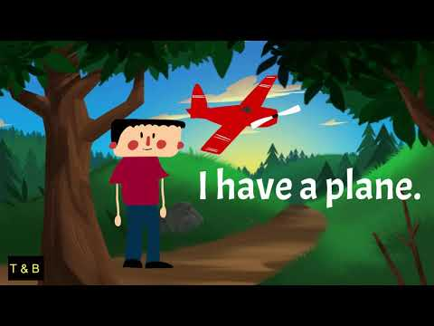](https://www.youtube.com/watch?v=KR9Vpu9mJ-g)

[[Have] Do you have pets? - Exciting song - Sing along](https://www.youtube.com/watch?app=desktop&v=U2eGhS7vVa0)

[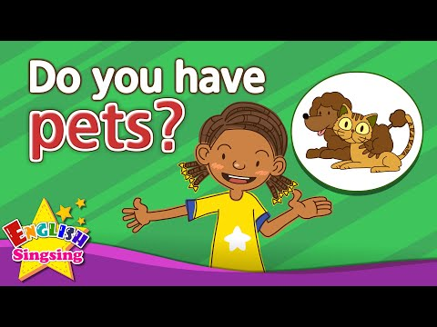](https://www.youtube.com/watch?app=desktop&v=U2eGhS7vVa0)