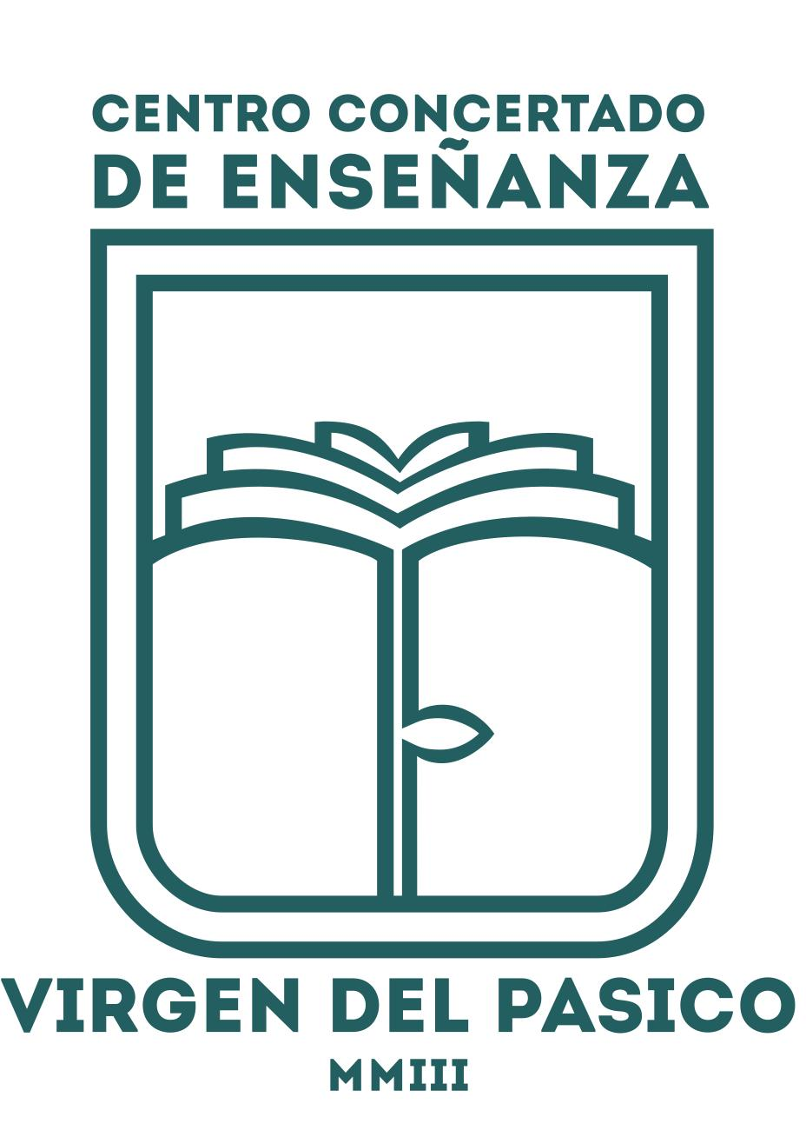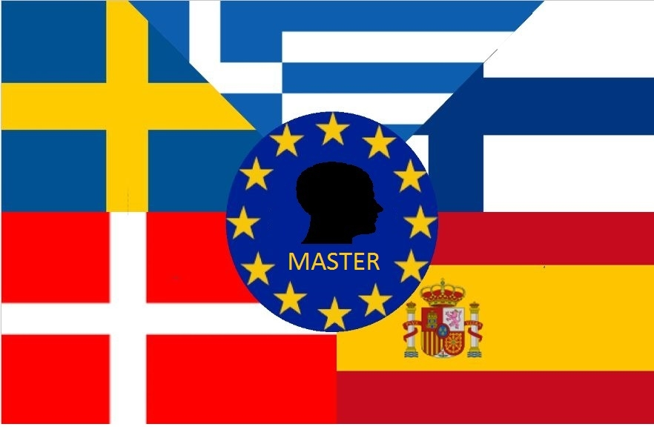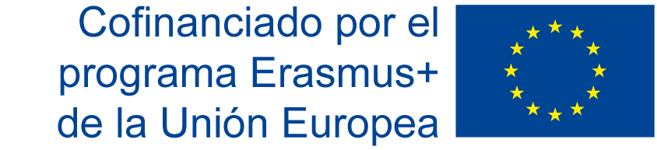

PROGRAMME FOR STUDENTS
ERASMUS + MASTER
SPANISH MEETING
19 TO 25 MAY, 2018

SÁTURDAY 19 MAY

Arrival of all the teams

SUNDAY 20 DE MAYO

Day with the familias.

MONDAY 21 MAY

  - Meeting at the Town Hall for oficial reception by the Mayor of Torre Pacheco,

10.00 Guided tour of the town.

12.00 Official Welcome in the School by the Headteacher.

13.00 Partners’ videos in classrooms 2nd A and B ESO.

14.25/14.50 Lunch and time with the familias.

TUESDAY 22 MAY

8.15 - 14.25/14.50 Project activities in the school.

14.25/14.50 Lunch and time with the familias.

WEDNESDAY 23 MAY

8.15 - 14.25/14.50 Project activities in the school.

14.25/14.50 Lunch and time with the familias.

THURSDAY 24 MAY

  - Meeting in the school. Handing in Certificates.

  - Leaving to Cartagena.
10.00 – 13.00 Visiting the City.

13.00 Leaving to Shopping Centre “Espacio Mediterráneo”. Lunch and free time for
shopping.

16.30 Leaving to Los Alcázares. Afternoon on the beach.

20.00 Dinner on the beach

21.30 Students go with the familias.

FRIDAY 25 MAY

Departure of the teams.

