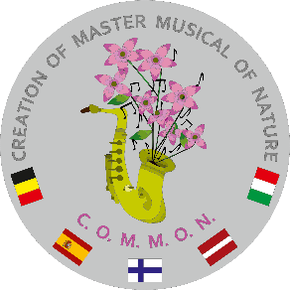
Specifications for costume sketches for Erasmus project C.O.M.M.O.N. (creation of a master musical of nature)
- Each country’s working group creates a costume sketch for the main character of its country.
- When creating the costume sketch, it has to be kept in mind that all costumes will be made of reusable materials (from dresses, shirts, trousers, jackets, blazers etc. bought in second hand shops).
- When creating the overall image of the main character consider use of appropriate accessories (belt, hat, wreath, bag etc.). Keep in mind that accessories too have to be made of reusable materials.
- When creating costume sketches, accessories and costume elements should use national and/or ethnic elements that symbolize your country.
- Draw accessories separately, next to the costume. If the costume has any specific detail, draw it separately as well. This will allow to distinguish it more easily and precisely.
- The sketches have to be drawn with black gel pen or rapidograph and coloured in with colouring pencils and/or felt-tip pens.
- The costume sketches have to be sent to ilze.cabe@ogresnovads.lv by December 1, 2025 (pdf or jpg format).
- The sketches of each country’s participants will be collected, analysed and the final version of the costume sketch will be created.

