**STUDY PACK SPAIN – BAND – LA GIRALDA**

**LESSON 1**

This work belongs to the genre of the pasodoble, originally from Spain. It developed in the 19th century as a form of military music, and is characterized by a strong rhythm and an upbeat melody. 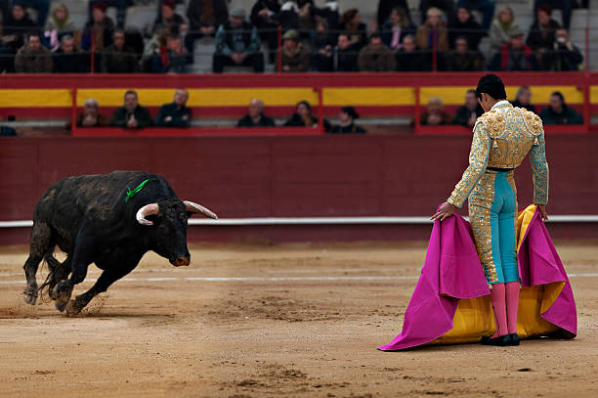

Its speed allowed troops to give 120 steps per minute (double the average of a regular unit, hence its name). This military march gave rise recently to a modern Spanish dance, a musical genre including both voice and instruments, and a genre of instrumental music often played during bullfights. Both the dance and the non- martial compositions are also called pasodoble.

The music that we are going to interpret owes its name to the bell tower of the Cathedral of Seville, capital city of Andalusia. The lower part of the tower corresponds to the minaret of the old mosque of the city, from the end of the 12th century, in the Almohad period, while the upper part is a superimposed construction in the 16th century, in the Christian period, to house the bells.

It measures 94.69 meters high and its silhouette has stood out from the rest of the nearby buildings since it was completed in the 16th century, when the city was one of the most prosperous in Europe and the main link with America.

The composer of this work is Eduardo López Juarranz (Madrid, October 13, 1844 - Madrid, January 16, 1897). From 1876 to 1894 he was the conductor of the Band of the Third Engineers Regiment of Seville. He composed various works for this type of formation, among which are several processional marches and pasodobles, of which he was a great supporter. Among his works, the most popular is La Giralda. López Juarranz defined "La Giralda" as an "Andalusian march". It was premiered at the 1889 Paris international exhibition (for which the Eiffel tower was built) by the Band of Engineers of Seville. The work was considered as an unofficial anthem of Andalusia until the premiere of the current one in 1936.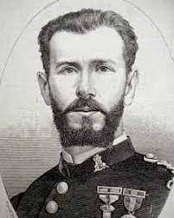

**Activities for this Lesson**

1. **Here you have some versions of the same piece, listen and note the differences between them.**LINK 1 →<https://www.youtube.com/watch?v=dGcv2l4t_KA> (Professional Band of music)  
   LINK 2 → <https://www.youtube.com/watch?v=hcy996KgqEI> (Non professional band of music)

**2. In this link you can see the Giralda of Seville, but this is not the only one in the world. Its beauty has served as a model for other towers and bell towers. Could you find on Google Earth the replica of the Giralda that is in Kansas City (Missouri) and the one in New York?** <https://earth.google.com/web/@37.3861784,-5.9926137,44.56881334a,818.81197445d,35y,0h,45t,0r/data=ChEaDwoJL20vMDg3ZHR6GAIgASgC>

**LESSON 2**

### **RHYTHM**

**Activities for this Lesson**

1. Listen to the song performed by a band:

[La Giralda - Eduardo López Juarranz [Pasodoble] - YouTube](https://www.youtube.com/watch?v=xLaJUjJWL5A)

1. Learn how to do the solfege of” these 3 rhythms patterns inspired by the different themes of the song.

**Rhythm pattern nº1 (Pasodoble)**



**Rhythm pattern nº2**



**Rhythm pattern nº3**



1. Learn to play in your instrument the rhythms of the song. You can play the same note for all, or you can play 2 differents notes (one in each barr)

1. Now, along with your teacher or another student, you can play the rhythm pattern nº 2 with a rhythm ostinato, based in the rhythm pattern nº 1.

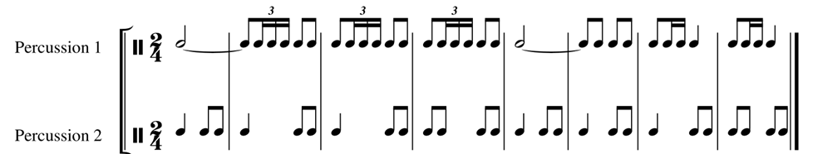

1. Play the rhythm pattern nº 2 at the same time as the rhythm pattern nº 3.

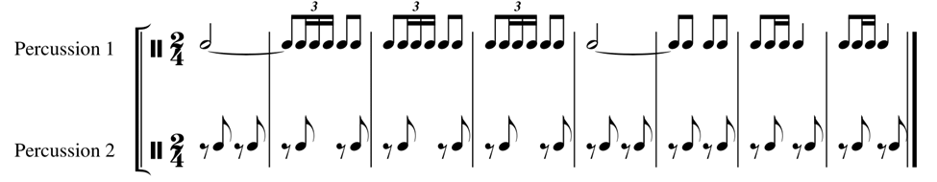

1. Repeat the process, but now, all patterns together. See how:

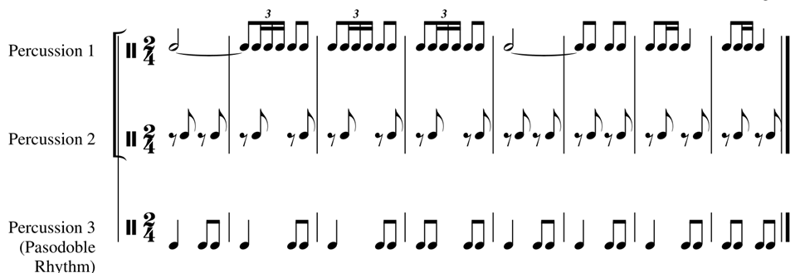

**MELODY**

The piece is in E flat major, but the melody (at the introduction) is modal, based in the Sol Phrygian mode (the most characteristic of Andalusian music).

**Activities for this Lesson**

1. Sing the melodies in A minor and C major:





1. Now let's try to sing the same melodies but in the original scale.

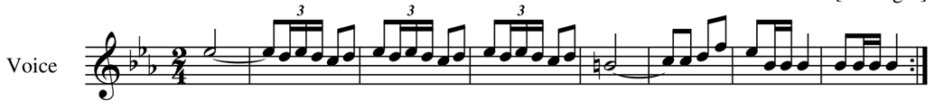

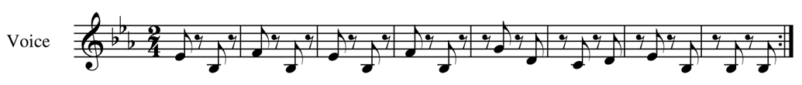

1. Now, together.

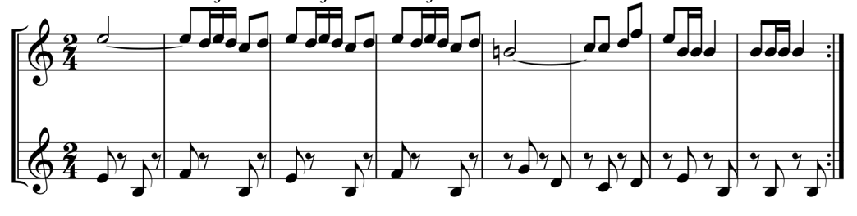

**LESSON 3**

**MAIN IDEAS FOR INTERPRETATION**

* TEMPO: All pasodobles have [**binary rhythm**](https://en.wikipedia.org/w/index.php?title=Binary_rhythm&action=edit&redlink=1) in 2/4, tempo for practicing should be the same as the ones in the recordings.
* INSTRUMENTATION: main melodies are played by clarinets, flutes and saxophones. Brass section usually plays bass line and counterpoint.
* MUSICAL VALUES: Semiquavers triplets and double triplets are especially important in this music. Work with a metronome to play fastly!
* DYNAMICS: Forte and piano contrast, especially to play *piano* in a band is difficult.