**STUDY PACK SPAIN – BAND – LA BODA Y EL BAILE DE LUIS ALONSO**

**INTRODUCTION**

**The repertoire selected for this group is framed in the second half of the 19th century and the first half of the 20th century.**

**Spanish music of this time was strongly marked by the presence of elements of traditional Spanish music. The zarzuela, the traditions, and Spanish folklore were a source of inspiration for many composers.**

**A clear example of this are the works we have selected for the wind band, through which we can get to know genres that are so acclaimed in Spain and representative of our country such as the zarzuela, the pasodoble and the procession marches.**

**We hope you enjoy it, let’s start the journey!**

-**LESSON 1**

These two intermezzos belong to the zarzuelas "La Boda de Luis Alonso" and "El baile de Luis Alonso."

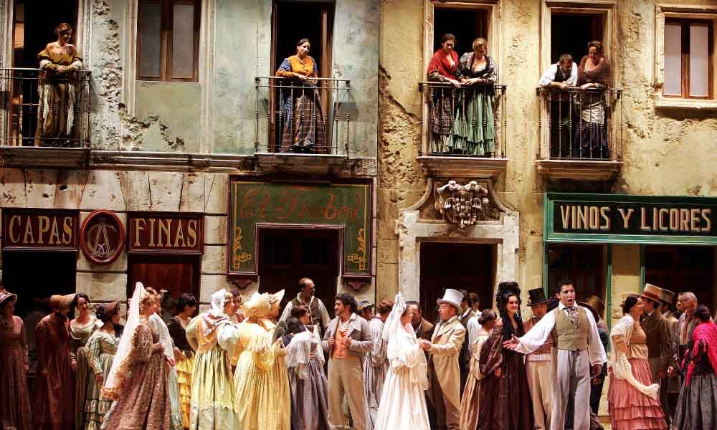

**Zarzuela** is a Spanish musical and theatrical genre that combines elements of opera, comedy, and ballet, with a mix of vocal and instrumental music, and often includes elements of traditional Spanish music, such as flamenco and bolero. Its origin is from the 17th century and it reached its peak popularity in the second half of the 19th century and early 20th century.

In the zarzuela, the **intermezzo** is an instrumental piece that is intercalated between the scenes and acts of the work. They are often an opportunity to showcase the virtuosity of the orchestra musicians and are often an occasion for the composer to show their skill in symphonic creation.

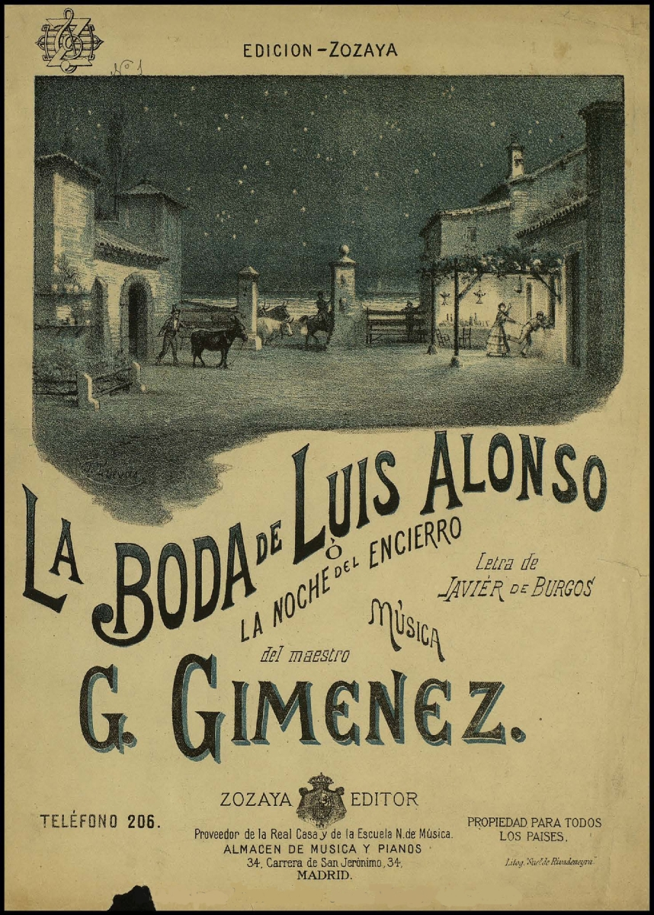

**This work** combines elements of traditional Spanish music, such as flamenco, with elements of academic European classical music, creating a unique blend of styles. Among its songs and dances are pasodobles, habaneras, jotas, and polkas.

The story represented in **"La boda de Luis Alonso ''** takes place in 1840 in the Andalusian province of Cadiz, where the wedding of the most famous dance master in the city, Luis Alonso, is about to take place. He's getting married to a woman much younger than him. The renowned dance teacher is jealous of Gabrié, a previous relationship of María Jesús, which causes Gabrié to play a heavy prank on the wedding. Taking advantage of the nearby bullfight, he starts to scream that the bulls have just escaped from the bullring and are loose in the city, hurting everyone in their way. The frightened wedding guests and Luis Alonso himself run away. In this way, Gabrié and María Jesús are left alone, at which point he reproaches her for marrying someone so old.

The action in **“El baile de Luis Alonso”** also takes place in Cádiz in 1840. Luis Alonso, the dance master, receives all kinds of characters in his home, from the highest classes of society to the most humble. He frequently organizes parties in his salons, with the corresponding feast and dance, where everyone aspires to show off their skills. Luis Alonso's wife, María Jesús, who is very young and attractive, helps her husband. The academy's guitarist is Tinoco, who is in charge of entertaining the celebrations and shows a great interest and admiration for María Jesús, making all kinds of suggestions to her, although she is not aware of it. However, she accepts a pair of earrings as a gift from the guitarist out of respect. On the other hand, Juana, Tinoco's wife, suspects her husband and the problem arises when she finds out that one of her earrings has disappeared. The conflict arises during the party and although Tinoco manages to escape from his wife, there is a general confusion that is only interrupted by the appearance of the forces of order who restore peace, expel the troublemakers, and leave María Jesús and Luis Alonso alone who, faced with various displays of jealousy, end up in an embrace, demonstrating their unique love.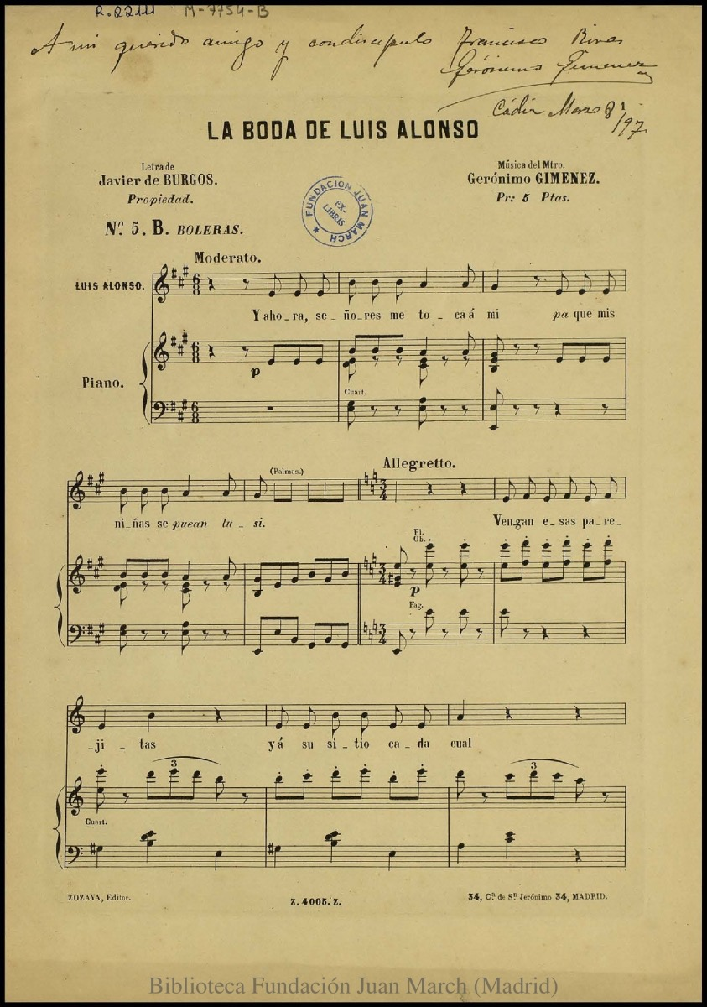

**The author** of the works we will perform is Gerónimo Giménez.

G. Giménez (1867-1923) was a Spanish composer of the second half of the 19th century and the first half of the 20th century. He began his studies in Madrid and later studied in Paris and Rome. His early works were influenced by folklore and traditional Spanish music. His most well-known work is the zarzuela "La Boda de Luis Alonso," considered one of the best zarzuelas of the time.

**Activities for this lesson**

1. Here you have some versions of the same piece, listen and note the differences between them.

Link 1: [INTERMEDIO. El Baile de Luis Alonso. Gerónimo Giménez. Enrique García Asensio. Lucero Tena.](https://youtu.be/6DAny3ccK6w)

Link 2: [**(726) El Baile de Luis Alonso (Gerónimo Giménez) / BSMM / 1997 - YouTube**](https://www.youtube.com/watch?v=Gds_nmJO5E0)

1. After reading the information and listening to the versions of the piece, ¿can you give yourself an explanation of what it is a zarzuela?
2. In the intermezzo "El baile de Luis Alonso," (link 5) musical fragments from the repertoire of the Bolera School (a variant of Spanish dance representative of the Spanish Nationalist movement of the 19th century) are cited and performed. Listen to the following links (3 and 4) and identify in which minutes of the intermezzo fragments of them can be heard.

Link 3: [**(726) El Olé - YouTube**](https://www.youtube.com/watch?v=IMQxTcIrjt8)

Link 4: [**(726) El Vito - YouTube**](https://www.youtube.com/watch?v=Q80lK_wi8t8)

Link 5**:** [El Baile de Luis Alonso (Gerónimo Giménez) / BSMM / 1997](https://www.youtube.com/watch?v=Gds_nmJO5E0)

1. In the intermezzo "La boda de Luis Alonso," (link 7) musical fragments from the repertoire of the Bolera School (a variant of Spanish dance representative of the Spanish Nationalist movement of the 19th century) are cited and performed. Listen to the following link (link 6) and identify in which minutes of the intermezzo fragments of them can be heard.

Link 6:[**(726) Jaleo de Jerez - YouTube**](https://www.youtube.com/watch?v=P29g4NGv1mw)

Link 7**:**[Giménez: Intermedio de»La boda de Luis Alonso« ∙ hr-Sinfonieorchester ∙ Pablo Heras-Casado](https://youtu.be/AMgg17jFSO4)

-**LESSON 2**

**\*La boda de Luis Alonso**

### **RHYTHM**

The time signature of the Intermezzo of “La Boda de Luis Alonso” is fast, in a 3/8. After, the time signature changes to 6/8, to allow the melodies to develop more. Spanish music has a lot of accents in their melodies.

**Activities for this Lesson**

1. Listen to the song performed by a wind band:

[La Boda de Luis Alonso BANDA FEDERAL FSMCV - YouTube](https://www.youtube.com/watch?v=kn29HvVL-dk)

2. Learn how to do the solfege of these 3 rhythms patterns inspired in the different themes of the piece.

**Rhythm patternº1**

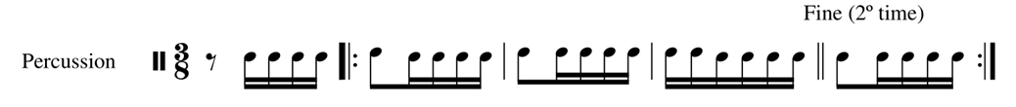

**Rhythm pattern nº2**



**Rhythm pattern nº3**



3. Learn how to play in your instrument the previous patterns. You can play the same note for the whole pattern , or you can choose 2 differents notes (one for each bar)

4. Now, you can play along with your teacher or maybe with another student. Each one of you can choose one of the patterns and play them at the same time. For example:

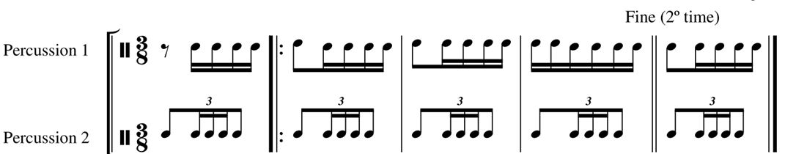

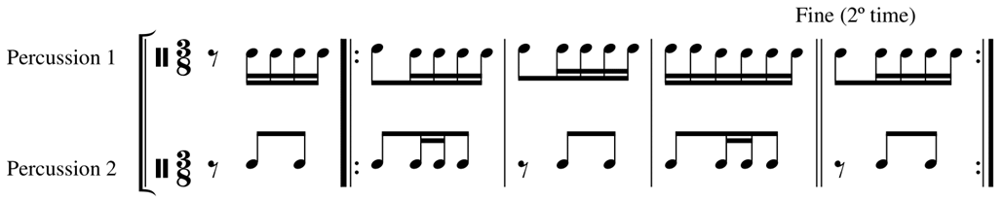

You can swap lines and combine the three patterns as you wish. That way, we create new accompaniments and all the students can learn all the patterns. Try to add a third instrumen and play the three patterns all together.

**MELODY**

The piece is in the key of G, but the melodic material is modal and is based in the D Phrygian mode (the most characteristic of Andalusian music). The melodies use to develop a lot of progressions

**Activities for this Lesson**

1. Sing the main melodies in A minor and C major:

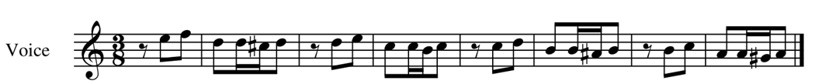



2. Now let`s try to sing the same melodies but in the original scale *.*





\**Down the last melody and octave so you can sing* it.

3. And finally, you can sing the melodies with the rhythmic patterns that we have seen before. You can take any instrument for the accompaniment (also clapping for example).

**\*El Baile de Luis Alonso**

**RHYTHM**

The time signature of the Intermedio “El Baile de Luis Alonso” is fast, in a 3/8. Spanish music has a lot of accents in their melodies.

**Activities for this Lesson**

1. Listen to the song performed by a band:

<https://www.youtube.com/watch?v=Gds_nmJO5E0>

2. Learn to do the solfege of these 2 rhythms patterns inspired by the different themes of the piece.

**Rhythm pattern nº1**

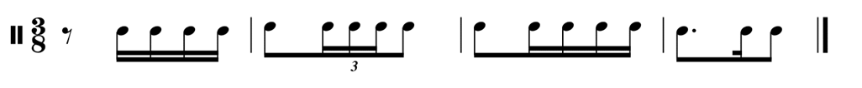

**Rhythm motiv nº2**



3. Learn how to play in your instrument the rhythms from the introduction of the song. You can play the same note for all, or you can play 2 differents notes (one in each barr)

4. Now, along with your teacher or another student, you can combine the two patterns and even develop them, as the piece we will do that from time to time. See how:

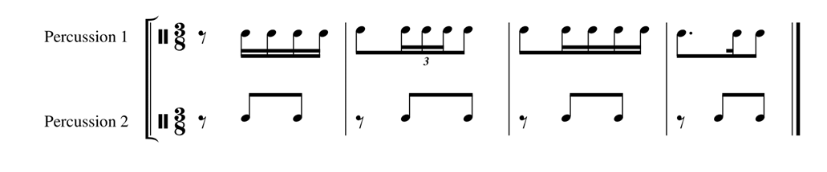

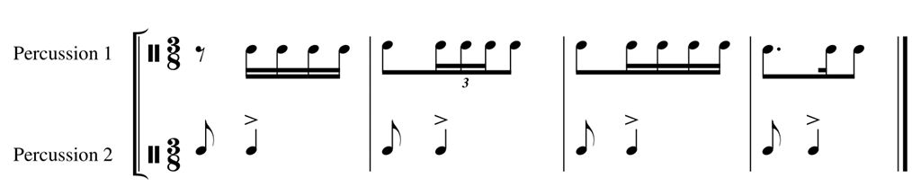

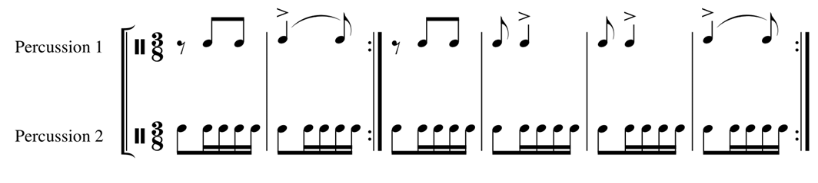

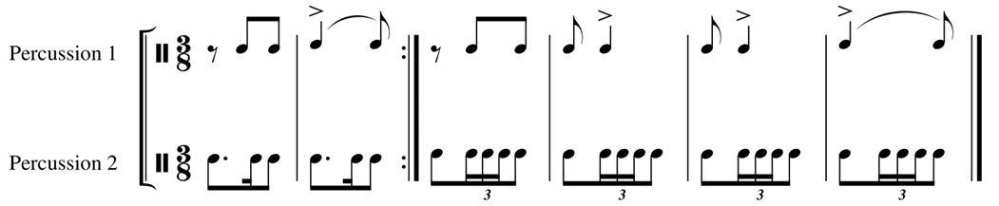

**MELODY**

The piece is in B flat minor, but the melody is modal, based in thephrygian mode (the most characteristic of Andalusian music).

**Activities for this Lesson**

1. Sing the melodies in A minor:

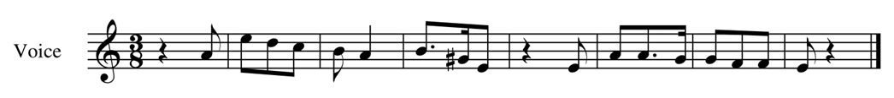

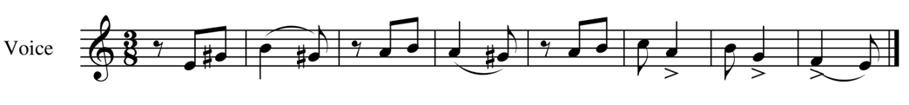

2. Now let's try to sing the same melodies but in the original scale *.*



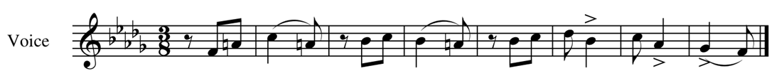

3. And finally, you can sing the melodies with the previous rhythmic patterns. You can take any instrument for the accompaniment (also clapping for example).

**-LESSON 3**

These advices and tips are the same for the two zarzuela pieces.

**MAIN IDEAS FOR INTERPRETATION**

* TEMPO: **Ternary rhythm** in 3/8. It should be played in one beat. Later, there will be a change to 6/8, and it will be played in two beats.
* INSTRUMENTATION: main melodies are played by clarinets, flutes and saxophones. Brass section usually plays bass line and counterpoint.
* MUSICAL VALUES: Semiquaver triplets and double triplets are especially important in this music. Work with a metronome to play them fast.
* DYNAMICS: Dynamic contrast should be noticed in the whole piece.
* ARTICULATION: Very fast, the student should practice the staccato and play the accents properly.