**STUDY PACK SPAIN – CHOIR – LA TARARA**

-**LESSON 1**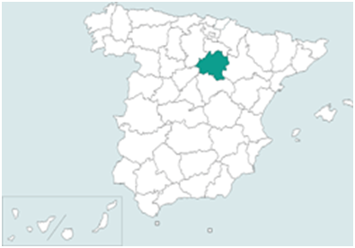

The “Tarara” is a medieval melody. It is not known whether it has its origin in the Muslim people or in the Sephardic people, as the two cultures were established in Spain until 1492, but we do know that it traveled all over the Mediterranean sea, even to the North-African coast, and it was incorporated to the Spanish popular repertoire. However, its peak occurred in the late nineteenth century, when the people from Castilla-la Vieja (actual Soria – green mark on the map), started to sing it as a *ring-a-ring-a-roses* song. The word “Tarara” is related to the verb “tararear”, which means *to hum*. A Tarara is a woman with mental issues, who wanders around the village doing meaningless things, and humming some unintelligible words. The lyrics of the song, as you will learn in Lesson 3, are an enumeration of the strange things that the Tarara does. Since the nineteenth century, a lot of versions of the song have been made by all kinds of artists and composers, from classical to urban style.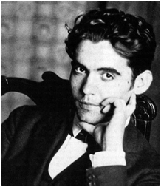

In 1931, Andalusian poet and musician Federico García (Granada 1898 - Granada 1936) re-harmonized the Tarara and some other old songs and he brought them together in a songbook. He also added a few verses to the song, to make it more romantic and less demeaning. We are going to sing an arrangement of Lorca’s Tarara made by Dante Andreo for mixed choir, but here you have another versions of the Tarara, including the one that we are performing :

[(726) La Tarara (Canción Tradicional Infantil) - YouTube](https://www.youtube.com/watch?v=ZWsAGFfZrxU) (ring-a-ring-a-roses children’s song)

[I.Albeniz: Iberia 3/12 "Corpus Christi en Sevilla" - YouTube](https://www.youtube.com/watch?v=96ZVbYau__w) (Spanish composer Isaac Albeniz’ 1905 version)

[García Lorca: Trece canciones espanolas antiguas - La Tarara - YouTube](https://www.youtube.com/watch?v=YUN3yatUXO4) – (Lorca’s 1931 version by Mezzosoprano Teresa Berganza and guitarist Narciso Yepes)

[La tarara. Arm. Dante Andreo - YouTube](https://www.youtube.com/watch?v=ADBj1wAc230) (Danteo Andreo’s arrangement, the version we are gping to sing)

[(726) La Tarara (Canción) - YouTube](https://www.youtube.com/watch?v=7Bys9f6H1ck) – (flamenco version by Camarón)

[Manuel Fernández - La Tarara (Videoclip Oficial) - YouTube](https://www.youtube.com/watch?v=l6khobDky4I) – (flamenco,jazz and latin music version by Manuel Fernández)

[(726) Las Migas - La Tarara (Videoclip Oficial) - YouTube](https://www.youtube.com/watch?v=j8nRJuRZtCI) - (flamenco and urban music version by Las Migas)

**Activities for this Lesson**

1. Listen to all the versions above and try to sing the main melody in each one of them.
2. Pay attention to the version by Camarón: can you hear something familiar from another version? Try to find it.
3. There is some relationship between Camarón and Federico García Lorca. We would like you to discover it. Here’s a hint: search for a 1979 album called “La Leyenda del Tiempo” and enjoy it while you listen to it.

-**LESSON 2**

**RHYTHM**

The time signature of “La Tarara” is 2/4

**Activities for this Lesson**

1. Learn how to do the solfege of these 2 rhythms patterns inspired by the different themes of the piece.

**Rhythm pattern nº1**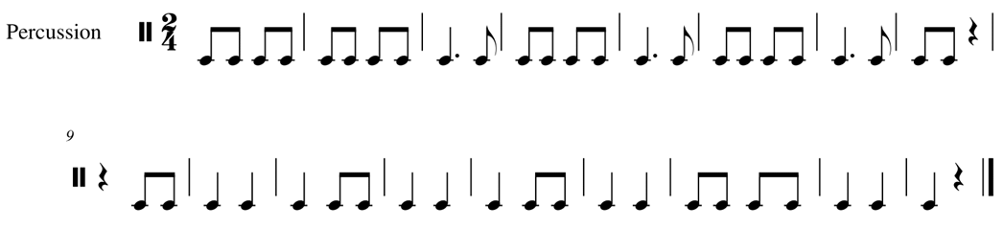

2. Learn to play the rhythm of the song on your instrument. You can play the same note throughout, or you can play two different notes (one in each bar)

3. Now, along with your teacher or another student, you can practice with rhythm pattern 1 with another pattern from the piece.

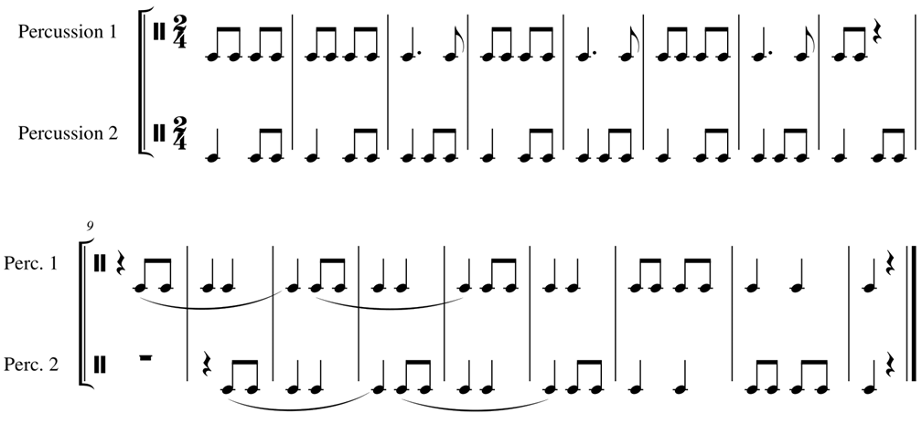

**MELODY**

The work is in G major. This work is an arrangement inspired by a traditional Andalusian song.

**Activities for this Lesson**

1. Sing G (Sol) minor scale– natural, in a 2/4 time signature



2. Try to perform just the rhythm with the lyrics

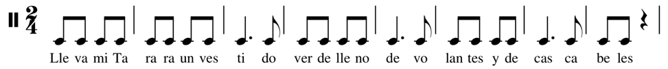

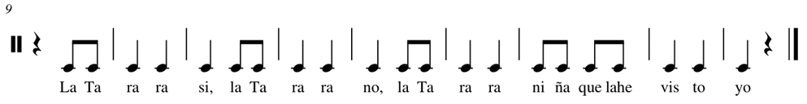

3. Sing the song with the lyrics

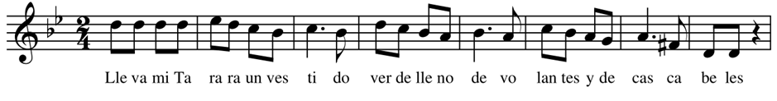

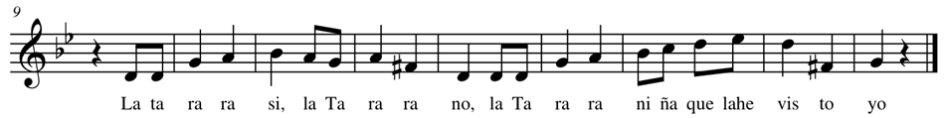

4. Listen to another arrangement of the song performed by a choir:

<https://www.youtube.com/watch?v=8waZzJtcXyk>

**LESSON 3**

Here you have the lyrics of the Tarara, both in Spanish and English.

SPANISH ENGLISH

Lleva mi Tarara My Tarara wears

un vestido verde a green dress

lleno de volantes full of ruffles

y de cascabeles. and jingle bells

La Tarara sí, la Tarara no, The Tarara yes, the Tarara no

La Tarara, niña, que la he visto yo. The Tarara, a girl that has caught my eye.

Lleva mi Tarara My Tarara wears

por el mediodía for the mid-day

jazmines helados frozen jasmine

entre la camisa. among her shirt

La Tarara sí, la Tarara no, The Tarara yes, the Tarara no

la Tarara, niña, que la he visto yo. The Tarara, a girl that has caught my eye

Luce mi Tarara Flaunt to me Tarara

sus colas de seda your tails of silk

entre las retamas over the furzes

y la yerbabuena. and the mints

La Tarara sí, la Tarara no, The Tarara yes, the Tarara no

La Tarara, niña, que la he visto yo. The Tarara, a girl that has caught my eye

¡Ay! Tarara loca, Ah, crazy Tarara

mueve la cintura moves her waist

para los muchachos for the boys

de las aceitunas. that the olives collect

La Tarara sí, la Tarara no, The Tarara yes, the Tarara no

La Tarara, niña, que la he visto yo. The Tarara, a girl that has caught my eye.

**Activities for this Lesson**

1. There are some tricky sounds that you need to practice:

-LL (as in “lleva”, “lleno”) and “Y” (as in “yerbabuena”): usually it should be a slight difference between this two sounds, but in the south part of Spain there is not such difference, and we pronunciate the two sounds like an “Y” as in “yellow”. **Say the words “lleva” and “lleno” but change the LL for an Y.**

-”CH” (as in “muchachos”): it is similar to the English “J” as in “just”. **Say the word “muchachos” but change the CH for an English J.**

-Ñ (as in “niña”): It is very similar to the sound of the letter group “gn” in words of Italian origin, such as lasagna, or “nh” in words of Portuguese origin, such as caipirinha. **Say the word “niña” as it was written “nigna” or “ninha”**

-V (as in “verde”): a long time ago, there was a clear difference between the sounds of letter “v” and letter “b”, but nowadays, we pronunciate the two sounds like a “B” as in “book”. Say the words “vestido”, “verde”

-C (as in “aceitunas”: in Spanish, the letter C+E/I is pronounced like the sound “TH” as in “thing”. **Say the word “aceitunas” but change the C for a TH as it was written “atheitunas”.**

-C (as in “cascabeles”): in Spanish, the letter C+A/O/U is pronounced like the sound “K” as in “kilo”. **Say the words “cascabeles”, but change the C for a K as it was written “kaskabeles”.**