**STUDY PACK SPAIN – CHOIR – LA CANCIÓN DEL COLUMPIO**

-**LESSON 1**

The song that we are about to sing is “La canción del columpio” (the song of the swing). It is a song that has an old origin and many versions, so it is going to be a long journey to our final version. First of all we want to give some little explanations about how a swing can be related to some kind of music. Please read this two texts :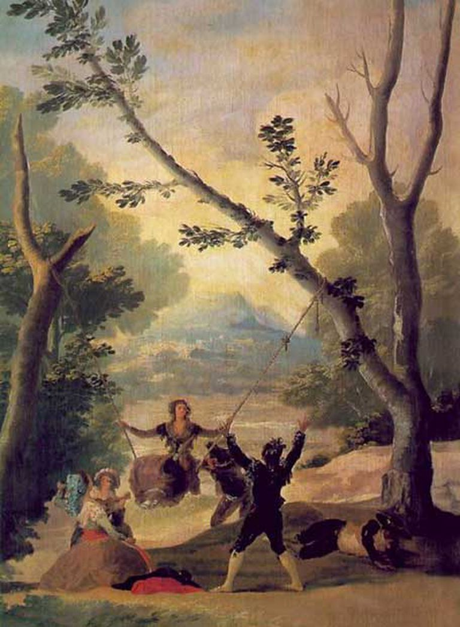

*―COLUMPIO: es una soga fuerte y doblada que se echa sobre una viga del techo y subiéndose en ella una persona, las demás la bambolean de una parte a otra parte, y en Andalucía es juego común de las mozas, y la que se columpia está tañendo un pandero y cantando. Es juego muy antiguo, del cual hacen mención algunos autores, y en especial Julio Pólux. /—SWING: It is a strong and bent rope that is thrown on a beam of the ceiling and while one person climbs on it, the others wobble it from one side to another, and in Andalusia it is a common game of the girls, and the one that swings is playing a tambourine and singing. It is a very old game, which is mentioned by some authors, especially Julius Pollux. [Tesoro de la lengua castellana, Sebastián de Covarrubias, 1611]*

*―Las Bambas son un doble columpio que se suspende de un corpulento árbol, por lo ordinario nogal, y se atraviesa con una tabla bastante resistente; colócase en ella la pareja que se mece mientras le hacen el corro y cantan e impulsan la bamba. Regularmente cada copla de uno de los del corro es contestada por otra de los del columpio; pero lo original es que para estas ocasiones guardan los amantes todas sus quejas, sus celos, desdenes, y, con una imaginación viva y perspicaz, improvisan expresivas canciones, de un momento en que median reconvención y ternezas, galanterías o resentimientos, desaires o desahogos de contenida pasión/ — A Bamba is a double swing that is suspended from a corpulent tree, usually walnut, and is crossed with a fairly resistant board; The couple that rocks is placed in it while the others make the run and sing and promote the bamba. Regularly each couplet of one of the corro is answered by another person of the swing; But the original thing is that for these occasions the lovers keep all their complaints, their jealousy, disdain, and, with a lively and insightful imagination, improvise expressive songs, of a moment in which there are counterclaims and tenderness, gallantry or resentments, slights or vents of contained passion. [Crónica de la provincia de Sevilla, José Bisso, 1869]*

So, now we know that at least at the beginning of the seventeenth century, in Andalusia was common for the girls and couples to play with a swing and sing some songs, so it is right to say that there was a kind of folkloric spanish music called “Cante de columpio” o “Bamberas” (Swinging songs). Let’s begin our journey:

In 1867, Spanish composer Lázaro Nuñez Robres published 50 popular songs, one of them a swinging song, but it didn’t become popular at the time. In 1941, another composer called Eduard Toldrá also published a songbook of popular spanish songs, and he included exactly the same melody and lyrics of the Nuñez Robres’ song, only with a different key and piano accompaniment. Versions by Nuñez Robres and Eduard Toldrá are still in a folkloric style, but the most famous versions of the song are in flamenco style. How did it happen?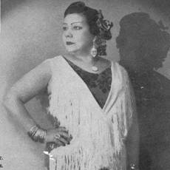

It was, first of all, thanks to sevilian flamenco singers Pepe Pinto and Pastora Pavón Cruz, also known as “La niña de los peines”, that recorded some Bamberas but with guitar accompaniment, a different lyric and the usual flamenco melismas to the melody. Then, when Pastora died, flamenco singer Naranjito de Triana and guitarrist Paco de Lucía, made a tribute song called “Aires de Bambera”, again with flamenco melismas and a different lyric, closer to the ones by Toldrá. In 1979, famous flamenco singer Camarón de la Isla published an album called “La Leyenda del Tiempo”. The album was a tribute to Federico García Lorca, as all the songs had Lorca’s lyrics. The first song of the album is also called “La Leyenda del tiempo”, and it has the typical rythm of the Bulerías, the most famous *palo (word that means “category”).* It turns out that the melody of the song is the same that in the swinging song that we have been talking about. The first part of the melody would be closer to Toldrá’s version and the second part would be closer to the Pastora’s version. 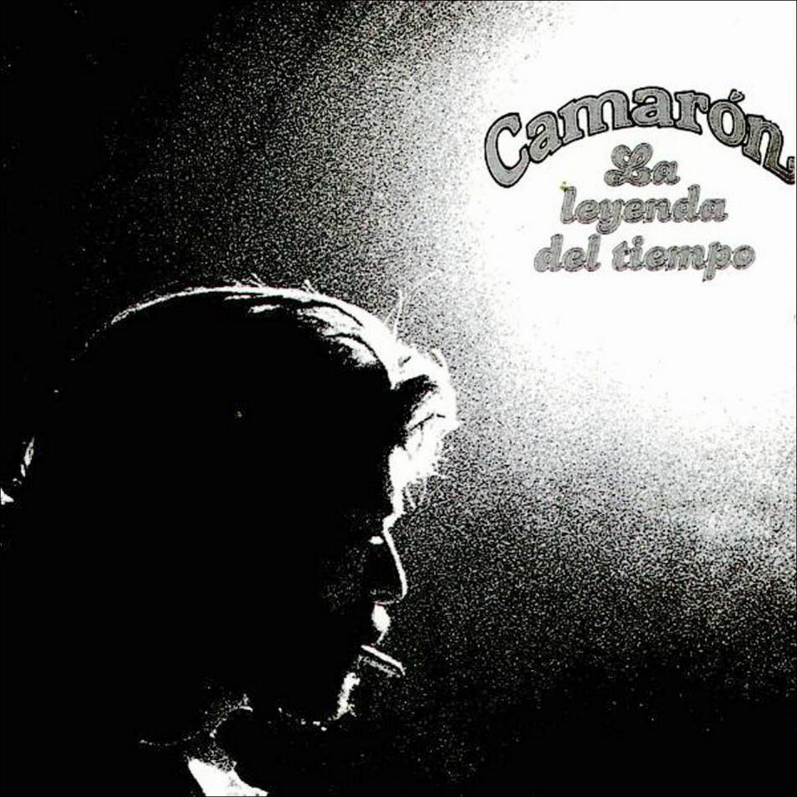

The last stop of our journey will be Manuel Castillo (1930-2005).. He was a sevilian composer and headmaster of the Superior Conservatory of Music of Seville, which was later renamed after him. He created a choral work called “La canción del columpio” in which he used the lyrics of Nuñez Robres and Toldrá, but the harmonies and rhythm of Camarón’s version, turning the piece into an absolute wonder. That is the version that we are going to sing.

**Activities for this Lesson**

1. Here you have all the versions that we have talked about, but they are not chronologically ordered. Your task is to order them to create the right journey.

[Seo BAMBERA La niña de los peines ente sabanas de Holanda - YouTube](https://www.youtube.com/watch?v=5IYIsszysxQ)

[Joaquín Díaz, obra completa - Canciones (funjdiaz.net)](https://funjdiaz.net/joaquin-diaz-canciones-ficha.php?id=155)

[10 CANCIÓN DEL COLUMPIO - YouTube](https://www.youtube.com/watch?v=ISn6MjgFHoE)

[Doce Canciones Populares Españolas: V. La "Bamba" - YouTube](https://www.youtube.com/watch?v=nHIgpBtgehg)

[La Leyenda Del Tiempo (Jaleos) - YouTube](https://www.youtube.com/watch?v=0usfxEYijXY)

| Chronological Order | Name of the author | Link |
| --- | --- | --- |
|  |  |  |
|  |  |  |
|  |  |  |
|  |  |  |
|  |  |  |

-**LESSON 2**

### **RHYTHM**

The time signature of “Canción del columpio” is 6/8 and 3/4.

**Activities for this Lesson**

1. Learn how to do the solfege of these 2 rhythms patterns inspired by the different themes of the piece. The rhythm of this pattern is called “Bamba”, and it belongs to the Soprano part..

**Rhythm pattern nº1 (Bamba)**

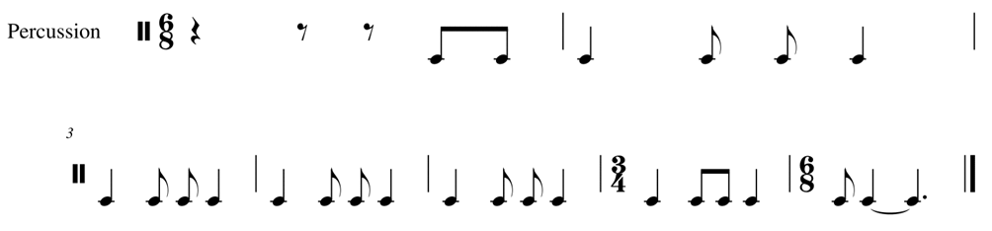

2. Learn to play the rhythm of the song in your voice. You can play the same note throughout, or you can play two different notes (one in each bar)

3. Now, along with your teacher or another student, you can practice rhythm pattern 1 and the pattern of the Alto part..

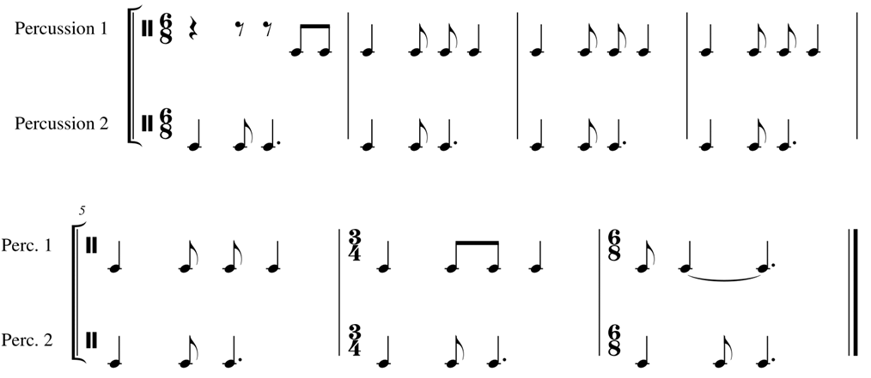

**MELODY**

The piece is in G major and is an arrangement inspired by a traditional Andalusian song.

**Activities for this Lesson**

1. Sing G (Sol) major scale– natural, in a 6/8 time signature



2. Try to perform just the rhythm with the lyrics

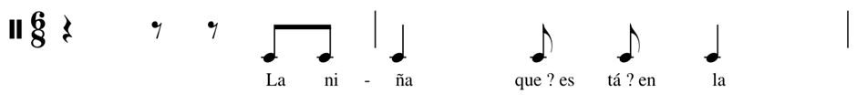

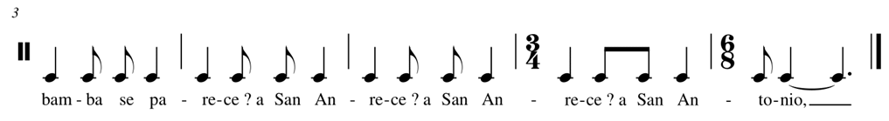

3. Sing the song with the lyrics.

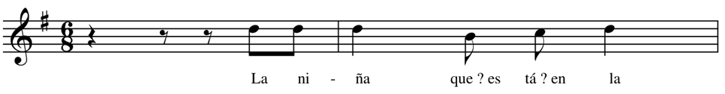

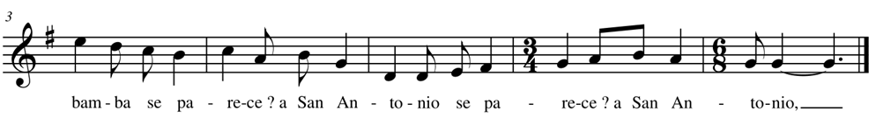

4. Listen to another arrangement of the song performed by a singer alone:

<https://www.youtube.com/watch?v=k7fgL8HcliQ>

**LESSON 3**

Here you have the lyrics of the Canción del Columpio, both in Spanish and English.

SPANISH ENGLISH

La niña que está en la bamba The girl on the swing

se parece a San Antonio, looks like Saint Anthony,

y la que la está meciendo and the one who is rocking her

al mismísimo demonio. look like the devil himself.

La niña que está en la bamba The girl on the swing

se lo quisiera decir, would like to ask her,

que se baje del columpio to get off the swing

que yo me quiero subir because I want to get on it.

No me bajo del columpio I am not getting off the swing

porque no me da la gana. just because I don’t want to.

La que quiera otro columpio The girl that wants one swing

vaya a su casa y lo haga. can go home and build it.

**Activities for this Lesson**

1. There are some tricky sounds that you need to practice:

-Ñ (as in “niña”): It is very similar to the sound of the letter group “gn” in words of Italian origin, such as lasagna, or “nh” in words of Portuguese origin, such as caipirinha. **Say the word “niña” as it was written “nigna” or “ninha”**

-C (as in “parece”: in Spanish, the letter C+E/I is pronounced like the sound “TH” as in “thing”. **Say the word “parece” but change the C for a TH as it was written “parethe”.**

-Q (as in “qué”): in Spanish, the letter Q is pronounced like the sound “K” as in “kilo”. **Say the word “qué”, but change the C for a K as it was written “ké”.**