**STUDY PACK SPAIN – CHOIR – A LA FUENTE DEL OLIVO**

-**LESSON 1**

For this song, we will travel to the beautiful city of Córdoba, which is 140 km away from Seville, with which it shares a river. It has one of the most interesting histories and its monumental architecture makes it one of the most visited cities of the country. 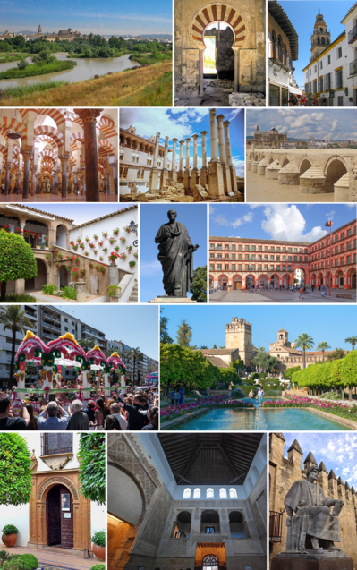

Founded in the second century BD by the Romans, It had its peak during the Muslim domination of the Iberian Peninsula, started at 711 AD, becoming the capital of the Kingdom and the second most inhabited city in Europe, second only to Constantinople During the Middle Ages, Córdoba helped to set the basis of the Spanish Renaissance, as it was plentiful of universities, along with mosques, libraries, baths and souks. Nowadays, it is the city in the world with the most buildings considered as “World Heritage”, being the “Mezquita-Catedral” and “Medina Azahara” the most known.

Actually, our song “A la fuente del Olivo” (*To the fountain of the olive tree*) makes reference to a fountain placed at the Mezquita’s patio. Legend has it that if a person drinks water from the fountain, she or he will soon find true love, and even a Sultan tried and drank the water but, instead of finding one love, he found 33 (this is a little joke, as the Sultans used to have more than one wife). The author of this song is the granadan but based in Córdoba composer Luis Bedmar Encinas (1932-2021), choir teacher at 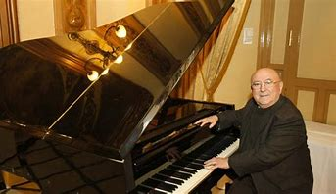

the Superior Conservatory of Music of Córdoba and founder of the Orchestra “Ciudad de Córdoba”, one of the most relevants at the actual andalusian orchestral panorama. He created, among other things, many choral songs that always had some relationship with the folclore and the flamenco music of Andalusia. The lyrics of the song are older, but he took it and re-harmonized it to create a song that not only relates to the andalusian folclore, but also with the Spanish Renaissance itself. Here you have the song:

[A la Fuente del Olivo - Luis Bedmar - Coral Polifónica de Baeza - HD - YouTube](https://www.youtube.com/watch?v=gs_aBiy2n38)

**Activities for this Lesson**

1. Here’s a link to Google Earth. You will see the Mezquita’s Patio. Try to find the Olive Tree and the fountain, and don’t forget to pay a virtual visit to the entire Mezquita.

[Google Earth](https://earth.google.com/web/@37.87962925,-4.77959177,103.01806459a,221.73483176d,35y,56.5655441h,60.00016928t,0r)

1. In Spain, there are a lot of songs that speak about magical fountains. Is there a song in your country that tells a story about a fountain? Search for them and tell us!

-**LESSON 2**

### **RHYTHM**

The time signature of “A la fuente del olivo” is 6/8.

### **Activities for this Lesson**

1. Learn how to do the solfege of these 2 rhythms patterns inspired by the different themes of the piece.

**Rhythm pattern nº1 (Petenera)**

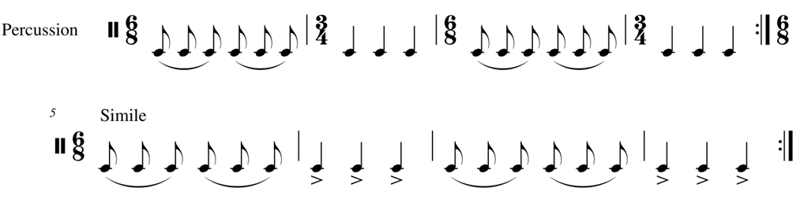

**Rhythm pattern nº2**



2. Learn to play the rhythm of the song on your instrument. You can play the same note throughout, or you can play two different notes (one in each bar)."

3. Now, along with your teacher or another student, you can play the rhythm pattern with the ostinato.

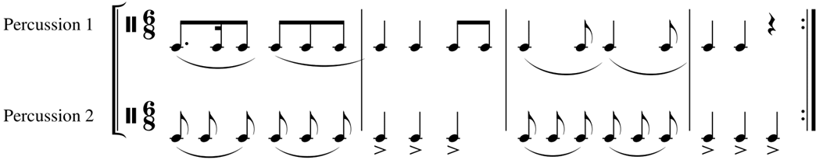

**MELODY**

The work is in F minor. This work is an arrangement inspired by a traditional Andalusian song.

**Activities for this Lesson**

1. Sing F (Fa) minor scale– melodic, in a 6/8 time signature

2. Try to perform just the rhythm with the lyrics



3. Sing the song with the lyrics

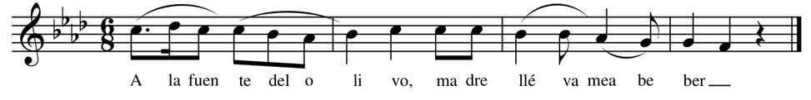

4. Listen to another arrangement of the song performed by a chorus:

<https://www.youtube.com/watch?v=SrwVhOpRJIU>

**-LESSON 3**

Here you have the lyrics of “A la fuente del olivo”, both in Spanish and English.

SPANISH ENGLISH

A la fuente del Olivo To the fountain of the olive tree

madre llévame a beber, take me, mother, to drink

a ver si me sale novio let’s see if I get a boyfriend

que yo me muero de sed. as I am dying of thirst.

El patio de los naranjos The patio of the orange trees

de la Mezquita es jardín is the garden of the Mosque

y la fuente del Olivo and the fountain of the olive tree

lo que más me gusta a mí. is the part that I love the most.

A la fuente quiero ir. To the fountain I want to go.

A la fuente del Olivo To the fountain of the olive tree

llegó un sultán a beber a Sultan came to drink

y en vez de salirle novia and instead of getting a girlfriend

le salieron treinta y tres. he got himself thirty-tree.

Válgame San Rafael. Bless my soul, Saint Raphael.

**Activities for this Lesson**

1. There are some tricky sounds that you need to practice:

-LL (as in “llévame”) and Y (as in “yo”): in the south part of Spain we pronounce the LL and the Y sounds like an “Y” as in “yellow”. **Say the word “llévame” but change the LL for an Y.**

-J (as in “naranjos” and “jardín”): in the south of Spain, we pronounce the letter J like an English H (as in “ham”). **Say the words “naranjos” and “jardín” as if they were written “naranhos” and “hardín”.**

-V (as in “ver”, “novio”): a long time ago, there was a clear difference between the sounds of letter “v” and letter “b”, but nowadays, we pronunciate the two sounds like a “B” as in “book”. **Say the words “ver” and “novio” as if they were written “ber” and “nobio”.**

-Z (as in “mezquita”): in Spanish, the letter Z is pronounced like the sound “TH” as in “thing”. **Say the word “mezquita” but change the Z for a TH as it was written “methquita”.**

-Q (as in “qué”): in Spanish, the letter Q is pronounced like the sound “K” as in “kilo”. **Say the word “qué”, but change the C for a K as if it was written “ké”.**