**Finnish folk song “On suuri sun rantas autius”**

“Great Is the Desolation of Your Shore”

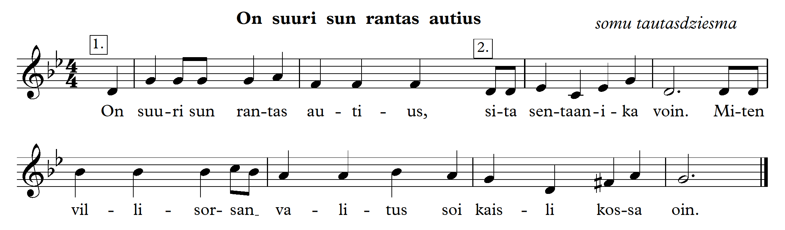

1. Listen to the Finnish folk song.

<https://www.youtube.com/watch?v=DqsOq3BcZVM>

<https://www.youtube.com/watch?v=OLfjfXMqziM>

* What is the character of the song?
* What is the tempo of the song?
* What type of minor scale is used? (Natural and harmonic.)
* What creates the sad mood? (In the first period, the downward movement along the second tetrachord. In the second period, the minor sixth (m6) leap is an attempt to get out of the sad mood, but the melody continues downwards. Harmonic scale degree 7 is like a ray of hope in measure 7.)
* What is the rhythm symbol the song begins with? What is the rhythmic value of the last measure?
* We don’t know the lyrics. What could this song be about? Listen to the music! (Children share their emotions about the content of the song.)

1. The song is in G (Sol) minor. Sing the types of scale:

Example from theory lesson:

<https://youtu.be/BfkwMMz5Xl4>

* natural, harmonic, melodic.
* ↑ natural, ↓ harmonic
* ↑ melodic, ↓ harmonic
* ↑ harmonic, ↓ natural
* A scale with a rhythmic accompaniment. 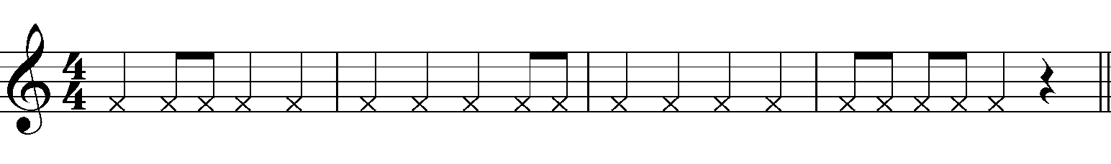

1. Clap the rhythm of the song, slightly accenting the first beat.

Example from theory lesson:

<https://youtu.be/G9UVcXNiuUs>

* Pulse with your left hand and play the rhythm with your right hand.
* Play the rhythm with your feet.
* Play the following rhythm with your hands 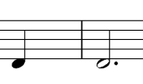, with your feet.

1. Sing the melody and pulse.

Example from theory lesson:

<https://youtu.be/SNx4ZY2kuCo>

* Sing the melody and conduct in 4/4.
* Sing the melody with a rhythmic accompaniment.

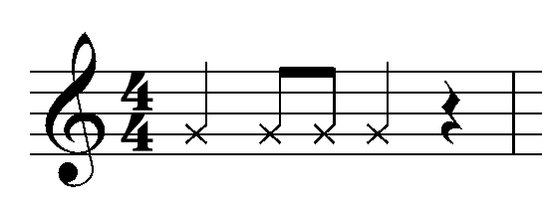

* In the melody, sing only perfect fourths (t4), minor sixths (m6) and minor thirds (m3).

Example from theory lesson:

<https://youtube.com/shorts/99J6QhPFqRQ>

* Divide the class into 2 groups – Group 1 sings , Group 2 sings 

**Lesson 2**

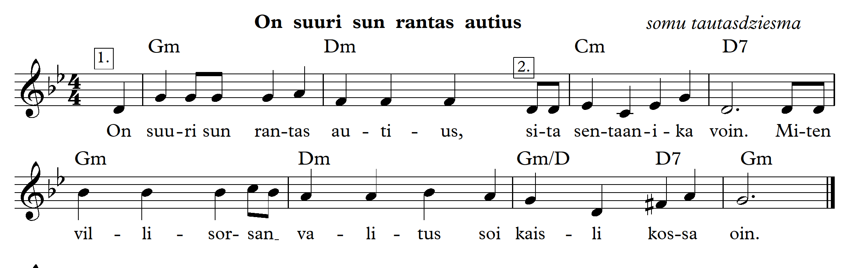

The song in two voices

Example from theory lesson:

<https://youtu.be/WMKq5y0bbkQ>

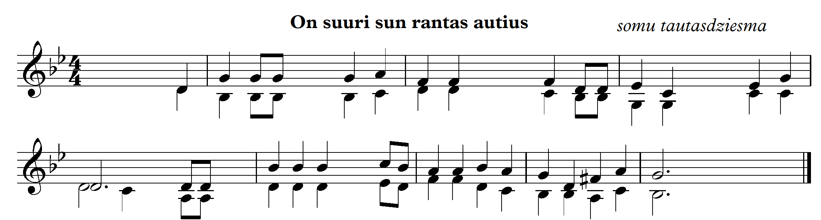

1. Sing the Finnish folk song acquired previous lesson with note names.

2. Sing only thirds, fourths and sixths.

Example from theory lesson:

<https://youtube.com/shorts/99J6QhPFqRQ?feature=share>

3. Sing only seconds.

4. Sing in canon.

6. Sing with an accompaniment.

Example from theory lesson:

<https://youtu.be/bWtuJ0Jopso>

7. Sing in two voices.

8. Sing in two voices with percussions.

9. Listen to the song arranged in a different style.

<https://www.youtube.com/watch?v=QoZwHkYu6aM>

10. Sing in different styles (with accompaniment).