**Spanish folk song “El Vito”**

**Lesson 1**

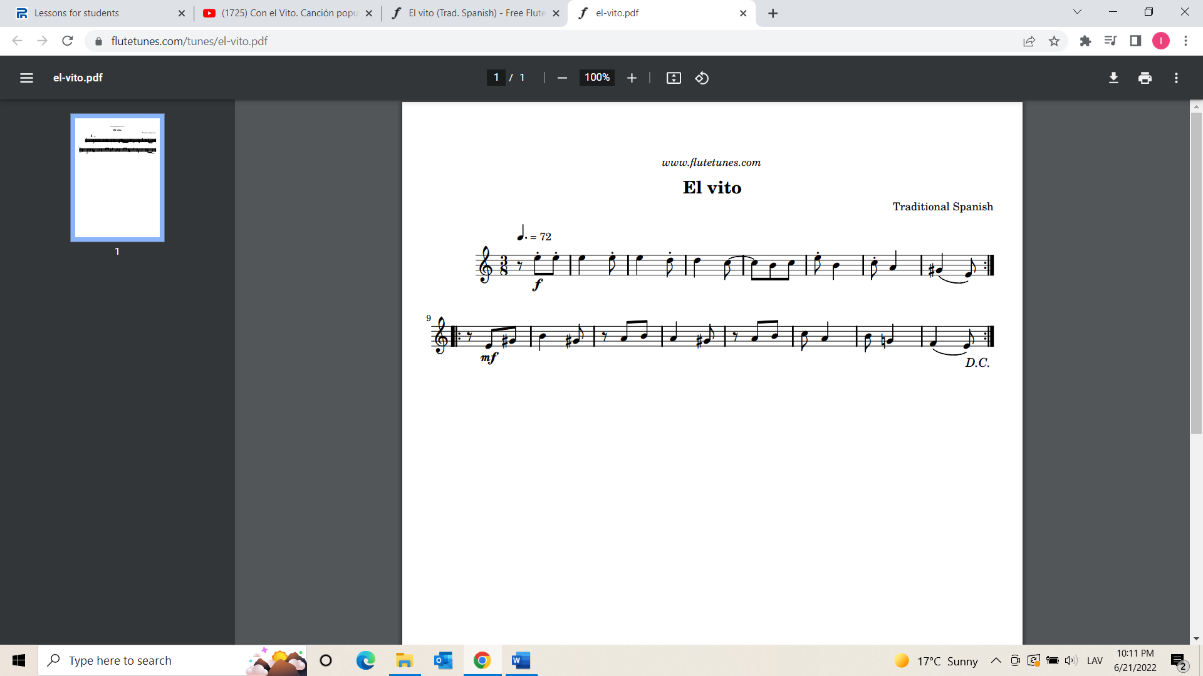

**Information about the song** (for teachers)

**“El Vito”** is a 16th century traditional folk song and dance of [Andalusia](https://en.wikipedia.org/wiki/Andalusia). Its name refers to Saint [Vitus](https://en.wikipedia.org/wiki/Vitus), patron of dancers. It includes steps of the art of [bullfighting](https://en.wikipedia.org/wiki/Bullfighting) and is usually played by women. The typical costume includes jacket and a brimmed hat.

The melody of “El Vito” is fast, in a 3/8 time signature, and it uses the harmonic [minor scale](https://en.wikipedia.org/wiki/Minor_scale), and the [Phrygian mode](https://en.wikipedia.org/wiki/Phrygian_mode), which is the most characteristic of Andalusian music. It is also sung with different lyrics, humorous or serious.

1. *Discussion about Spain and Spanish music $-$* what are the typical Spanish musical instruments? (*a guitar and castanets*)
2. Listen to “El Vito” $-$ a traditional folk song and dance of [Andalusia](https://en.wikipedia.org/wiki/Andalusia). You will hear a guitar and castanets.

<https://www.youtube.com/watch?v=TuHHUDnFSO0>

1. 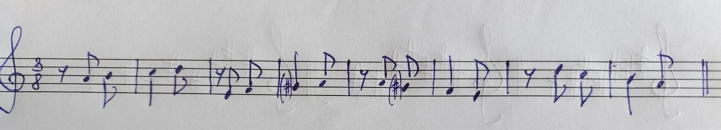Sing A (La) minor scale (a moll) – natural and harmonic, in a 3/8 time signature:
2. 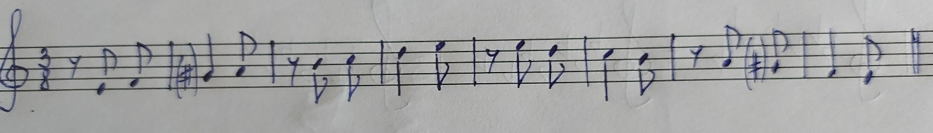Now let`s try to sing the same scale but starting and ending with the note *E (Mi).*
3. Look at the melody – it is written without any accidentals (alterations). Listen to the melody played by the teacher or from a recording (<https://www.youtube.com/watch?v=TuHHUDnFSO0> – from 1`07). Pay attention to harmonic minor and add an accidental (a sharp), where necessary.

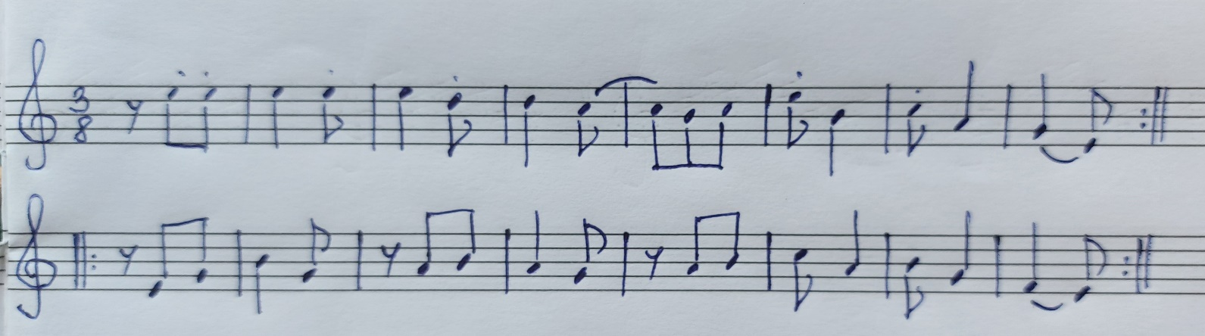

1. Learn to sing the melody with the note names.
2. Try to sing “El Vito”with lyrics:

*Refrain*  
Con el vito vito vito  
con el vito vito va. (repeat)

Yo no quiero que me miren  
que me pongo colorá.  
Yo no quiero que me miren  
que me pongo colorá.

*Refrain*With the vito*, vito, vito,  
With the vito, vito, it goes.  
With the vito, vito, vito,  
With the vito, vito, it goes.

I don’t want them to look at me  
Because I blush,  
I don’t want them to look at me  
Because I blush.

*vito – popular dance of Andalusia

1. Sing it again and try to do it in Spanish. Listening to these recordings might help to understand the character better:
2. <https://www.youtube.com/watch?v=FgdaFukX1LQ>
3. <https://www.youtube.com/watch?v=S3jnI8O_8Ss>

**Spanish folk song “El Vito”**

**Lesson 2**



1. Sing the Spanish folk song acquired previous lesson.
2. Listen to another arrangement of the song performed by a choir:

<https://www.youtube.com/watch?v=AVWyoGVwaso>

1. Learn to clap the rhythm from the introduction of the song.

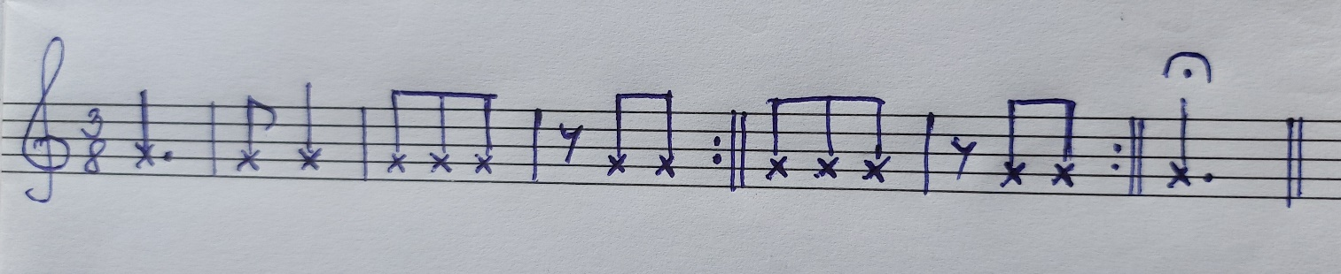

1. 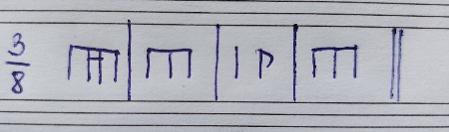Each student comes up with his/her own rhythm ostinato formula: 4 bars in 3/8 time signature, for example,

and chooses any percussion instrument.

1. Now we can make the rhythm rondo with aquired elements:

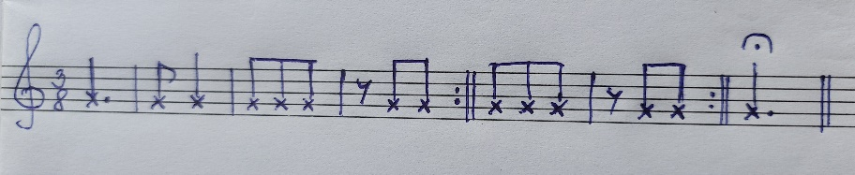

* Refrain:

Refrain is played by all the students, clapping their hands.

* Episodes: each student plays his/her rhythm ostinato formula twice (8 measures) using percussion instrument (students pick it up and put it down during fermata in the refrain).

1. Change the song to ¾ time signature.

Result:

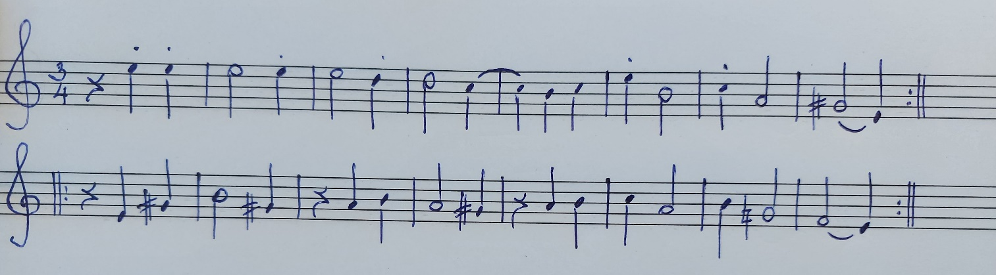

1. Fun exercise:

<https://www.youtube.com/watch?v=-Ho8HUMTEGU>