Lullabies

1st lesson:

Theme: The Italian lullaby„ Dormi mia bella, dormi” and the Latvian lullaby„ Aijā žūžū lāča bērni”.

Please study the first map and get familiar with the location of Latvia at the Baltic Sea between Estonia and Lithuania.

Then look at the two maps of Italy and learn about the location of the Toscana region in Italy. Enjoy the view!











Please learn and sing the melody of the Latvian lullaby „ Aijā žūžū lāča bērni”

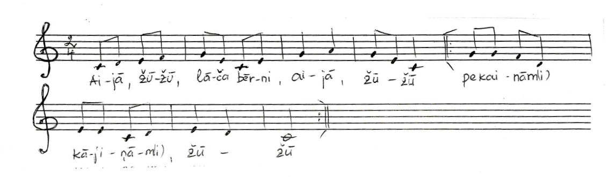

Then sing this melody in two voices (arranged by Jēkabs Graubiņš). As Your home work try to transponate the second voice from G major to C major

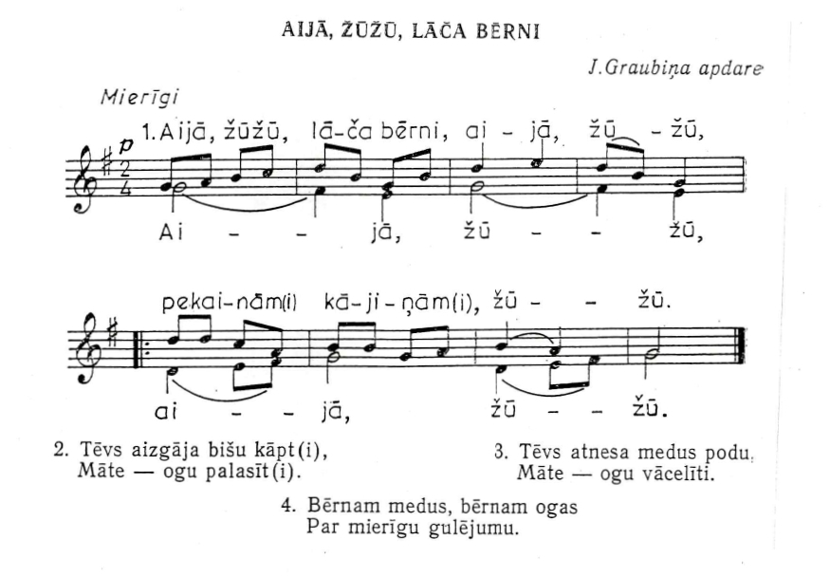

Maintain the number of bars but change the time signature of the lullaby from 2/4 to 4/4 meter! Write it down.

Sing the C major scale in the following rhythms (also in canon ):

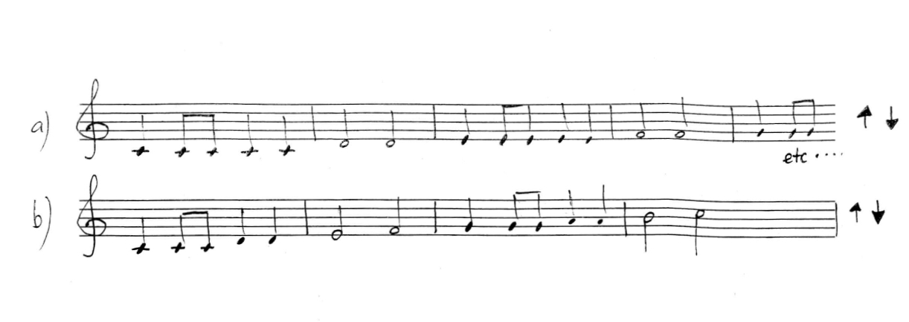

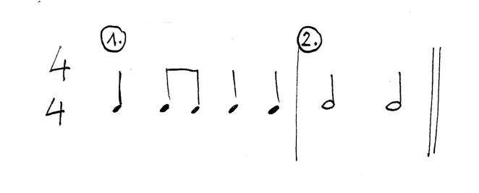

Listen to the talian lullaby „Dormi mia bella, dormi”. After listening to it for a couple of times, tey to write it down it by heart:

<https://youtu.be/CdxUQctDzk4>

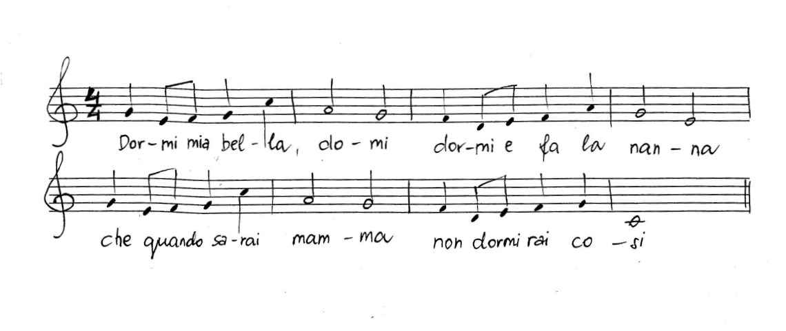

Then write down the Italian text, imitate the pronunciation and sing.

Translation:

Sleep my beautiful sleep!

Sleep and fall asleep, that when you are a mother, you won't sleep like that.

Sleep, my beautiful sleep! Sleep and rest, that when you have the bridegroom, you won't sleep like that.

Sleep, my beautiful sleep! Tell me – who ever made you such a beautiful face – he used a brush in a hand of a painter.

In your bed of lilies, that when you have children, you won't sleep like that.

All lovers pass, but you never pass; I love you so much, I want to die with you.

Try to name the instrument accompanying the melody! ( guitar )

Try to mix these Latvian and Italian lullabies together (One group sings the Latvian lullaby and the other group – the Italian lullaby)

As an interlude sing the Latvian lullaby „ Aija zūžū lāča bērni” ( it will sounds a little bit like jazz music).

Create the suitably harmony on piano or playing another instrument and sing the Latvian lullaby in Italian language! ;-D

2nd lesson:

Recall again the Italian lullaby „Dormi mia bella, dormi”. Read the music and then sing with adding the Italian text.

Introduce with 2 voices arrangment :

First sing and learn each voice separately (by notes, then adding the words). Read, understand and internalise the meaning of the text. Sing in 2 voices.

Pay attention to the 9th and 14th bars, where the melody is changing .

Play the accompaniment on guitar (or on another instrumet) and sing in two voices, including the Latvian lullaby as an interlude*.*

