Latvian folk song „ The little, little apple tree”

**Four lessons about the interval “third”.**

**1st lesson:**

An introduction song to use the interval „ **third**” :

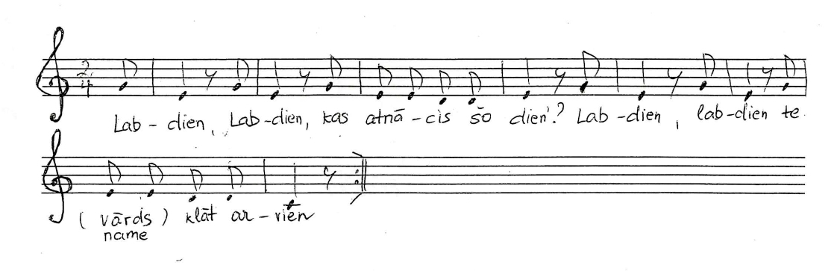

„ Good day, good day, who came today?

Good day, good day, here **Evita** came today.”

Sing the C major scale starting with an upbeat (also in canon):

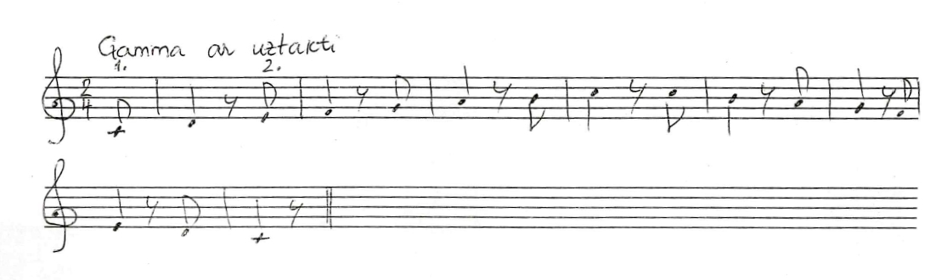

Sing and play „ **the stairs of thirds**” and then note which intervals are Major

thirds and which minor thirds

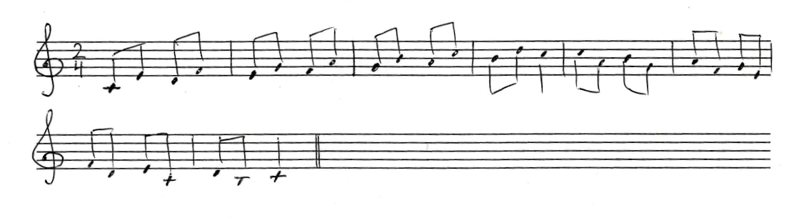

Sing the same „stairs of thirds” in a minor key. What notes should be changed?

Ask help from your teacher, if needed!

Fresh your memory about intervals:

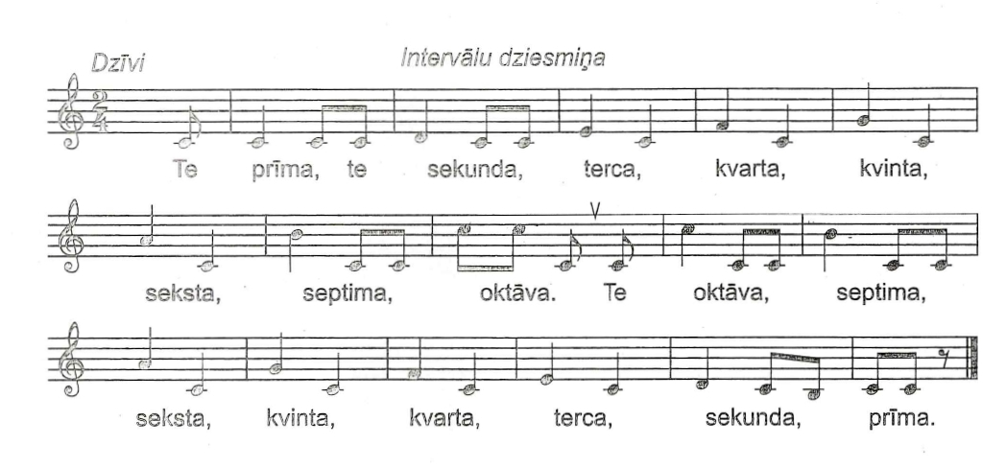

Then connect each interval with a certain movement:

unison – touch your nose with your index finger

minor/major 2nd – rub your palms together

minor/major 3rd- swing your hands like carrying a handful of water in them

perfect 4th – put your thumb and ring finger together (like making a ring )

perfect 5th – put your thumb and little finger together (like making a ring )

minor/major 6th – raise your hands above your head

minor/major 7th - extend your arms to the sides

perfect 8th (octave) – show “the long nose” according to the drawing below

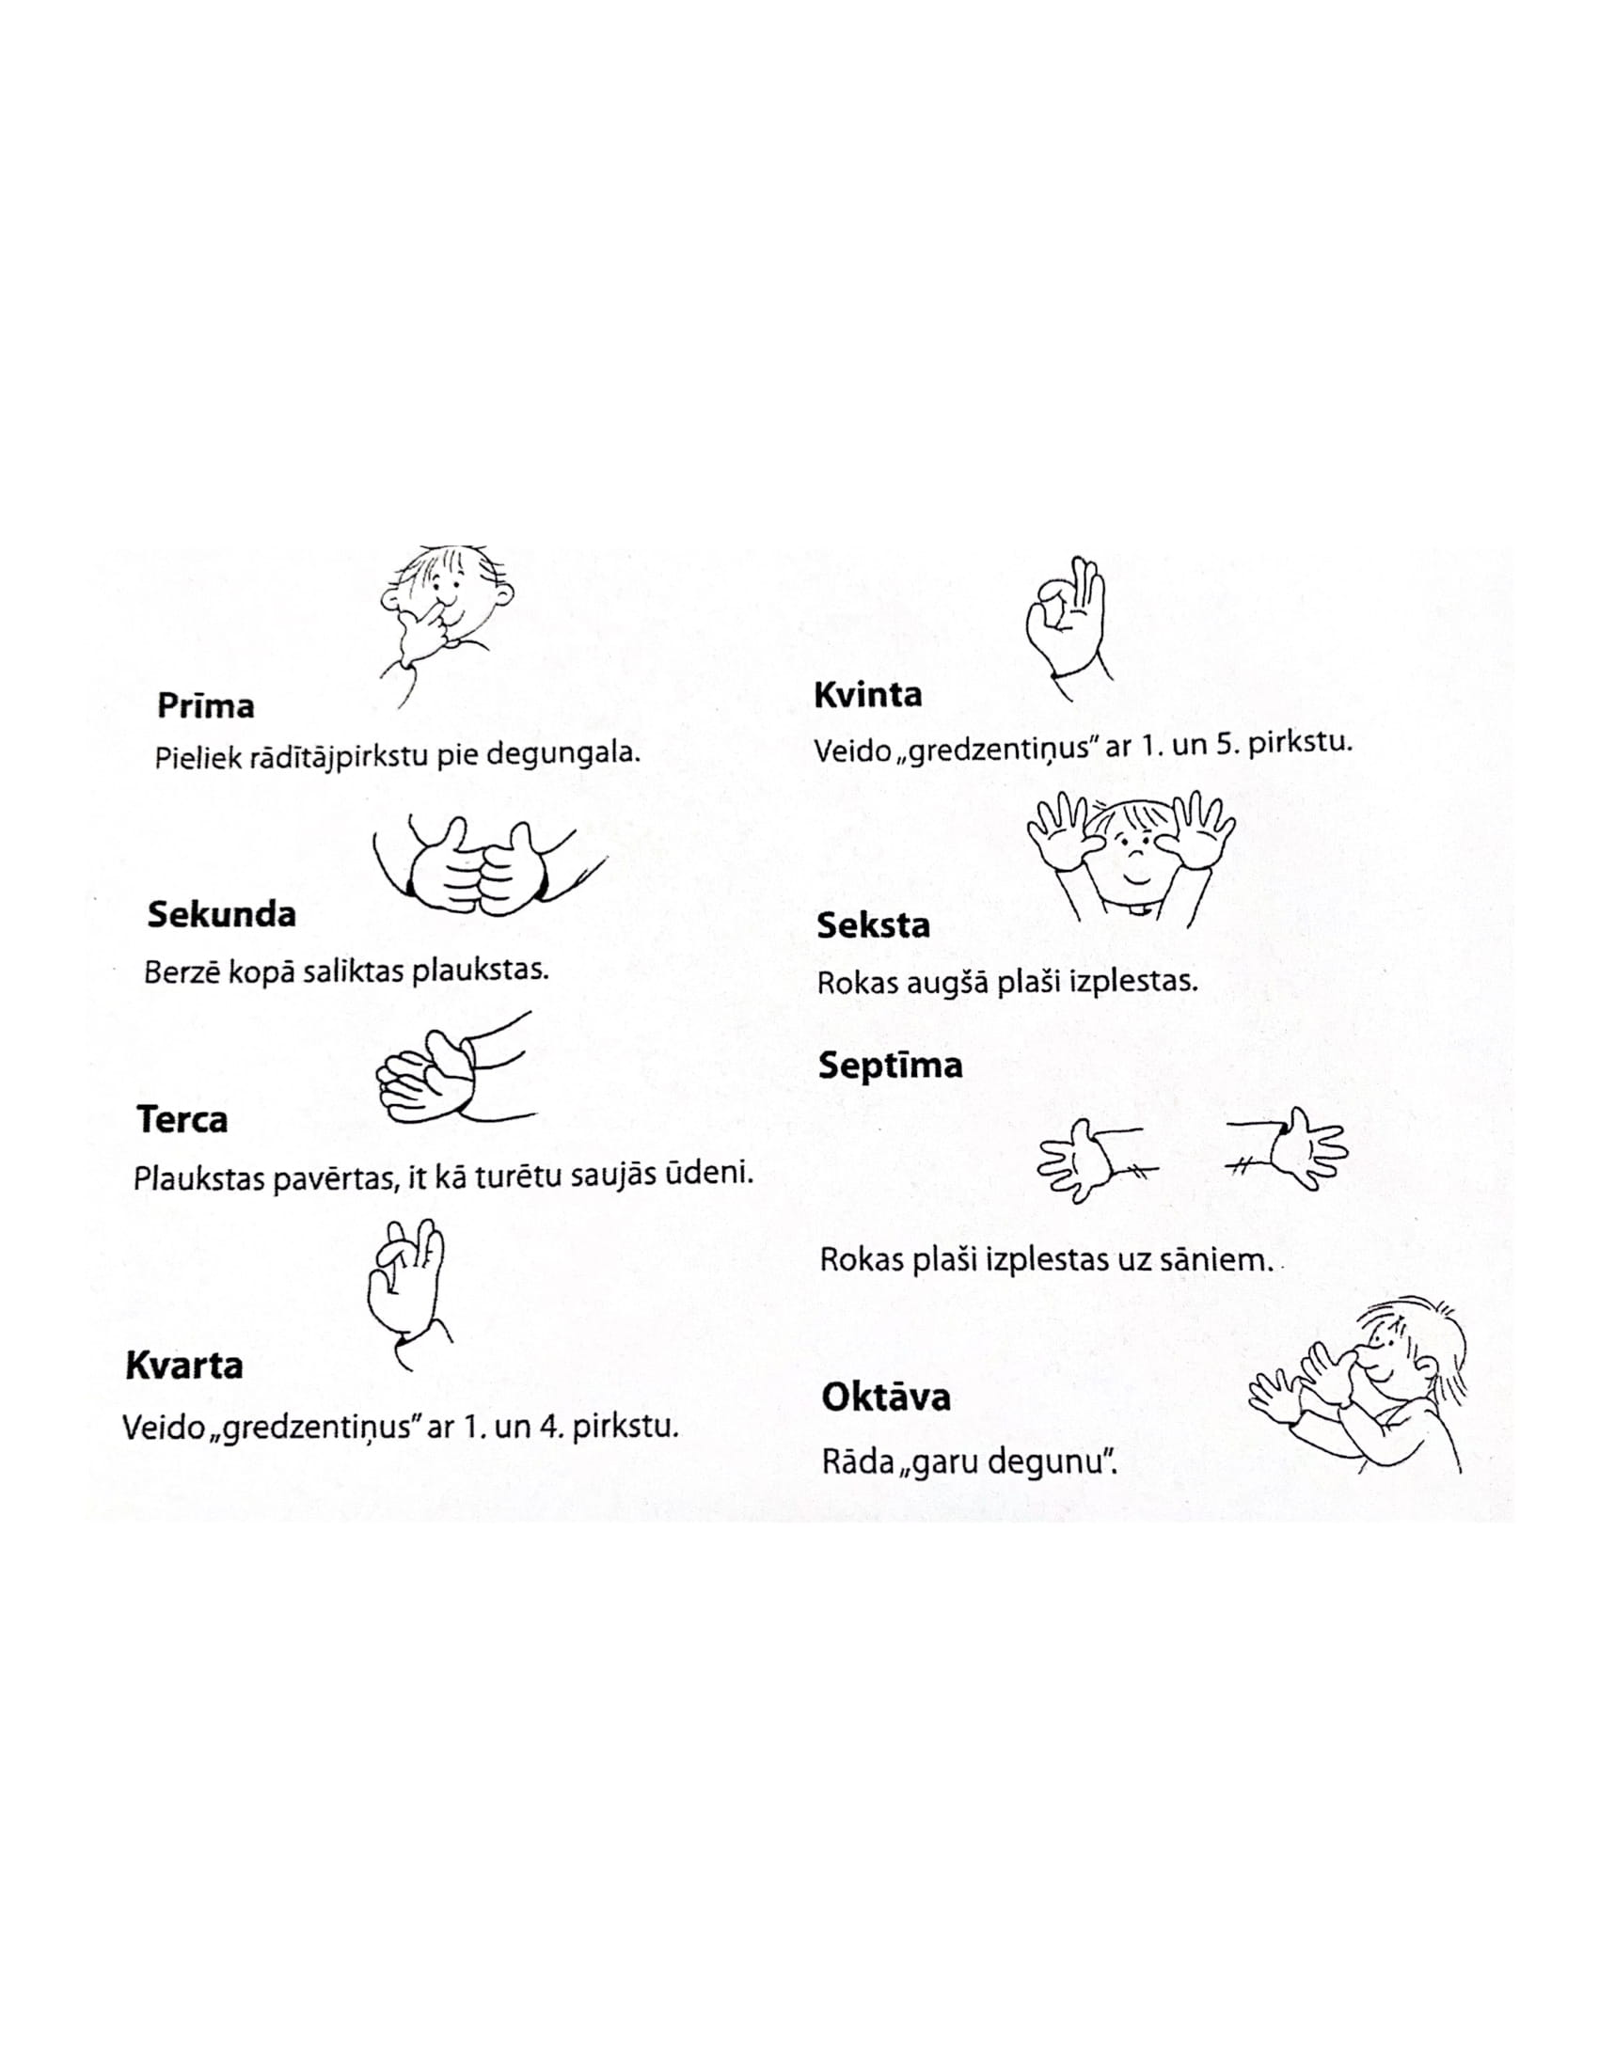

Or maybe the next picture will help you to understand the movements:

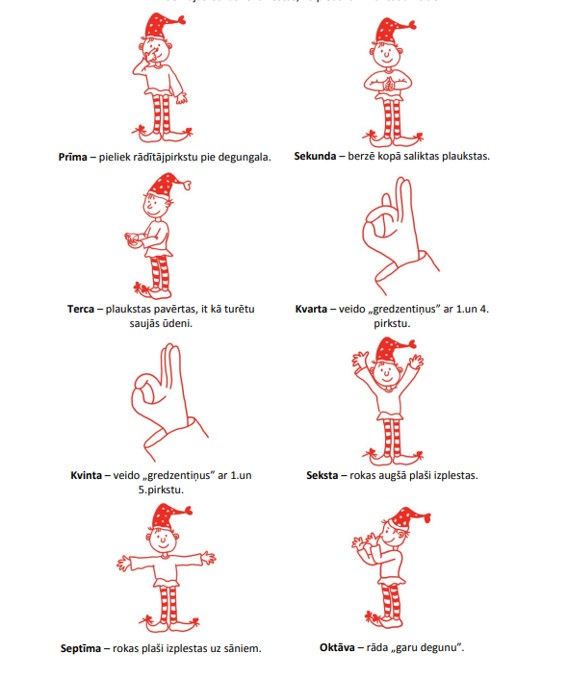

Sing „ a voice – echo -exercise” using **thirds:**

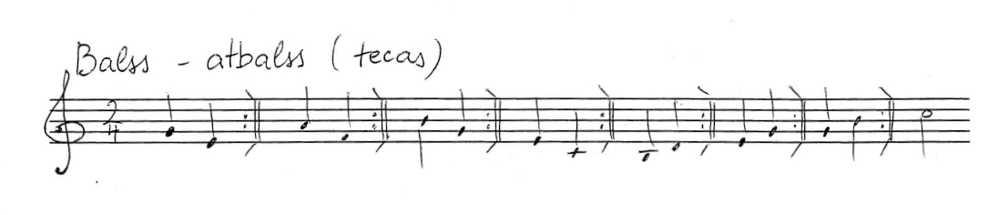

Which of the thirds are Major and which minor?

**2nd lesson:**

The interval **„third”,** second part

Please sing the song „ Maza, maza ābelīte” using the note names.

Create the second voice.

Get inspired by these examples!

<https://youtu.be/zfBtlbEFr98>

<https://youtu.be/C-aEr017FpY>

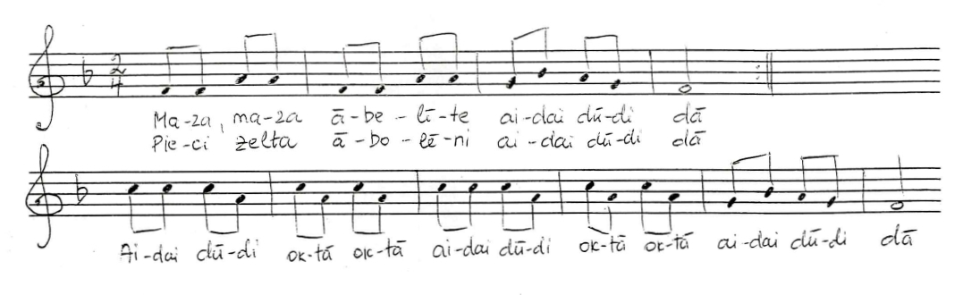

1st verse:

„ Maza, maza ābelīte *Little, little apple tree*

Pieci zelta abolēni” *with five golden apples*

2nd verse:

„Divus devu brālīšami, *two of them I gave to my brother*

Trīs es pati paturēju.” *three I kept for myself*

3rd verse:

„ Trīs es pati paturēju T*hree I kept for myself*

Ar ko daiļi rotāties.” *To make myself more beautiful ☺*

4th verse:

Par to vienu zirgu pirku, *For one apple I bought a horse*

par otro novadiņu” *for the second I bought land*

Par trešo sev maizītes arājiņu *by third I bought for myself boyfriend😉 who will help me to work on the field*

Analyse the intervals and quality of them.

Sing this song in two voices with piano accompaniment and percussions.

<https://youtu.be/ttDs6ISvG3E>

Try to sing the 1st voice and play the 2nd

<https://youtu.be/cT8PEfm7XeU>

Try to sing the 2nd voice and play the 1st:

<https://youtu.be/HexYHKuyiP8>

Learn all the 3 verses by heart and write down the same melody in your exercise book using another key signature: Two flats!

**3rd lesson:**

Recall the song „ Maza, maza ābelīte” (The little, little apple tree)

<https://youtu.be/nX5p13yWres>

Ask your kids to sing or play it like soloists!

Introduce them with another melody for the same text

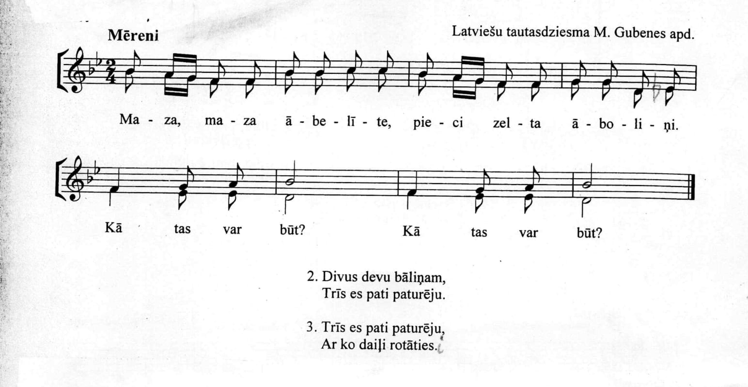

Analyse the intervals on the second line.

Learn each voice separately, then sing together.

Find the **thirds** and analyse their quality

**4th lesson:**

Start this lesson with singing the G major scale, in a canon form, too:

<https://youtu.be/KleuLoaNqdc>

<https://youtu.be/NIuV5W1kGe8>

Use body percussions!

Kn = Snap your fingers!

Kr = Beat your chest!

Pl = Clap your hands! (Back of the palm agains palm.)

<https://youtu.be/Mz6IKfV6v5Q>

Learn all three voices separately

Pay attention the the note change in the melody line both in the 1st bar and in 5th bar!

Train the *glissando* technique! Choose different intervals and try!

