Italian folk song “La capra bruca i rami” - The goat grazes the branches
Lesson 1

Or:

The topic $-$ UPBEAT. The main goal is to understand the rhythmic relationship between the upbeat and the last measure.
UPBEAT + LAST MEASURE = COMPLETE MEASURE

- Finish the rhythm examples. You can use notes and/or pauses.
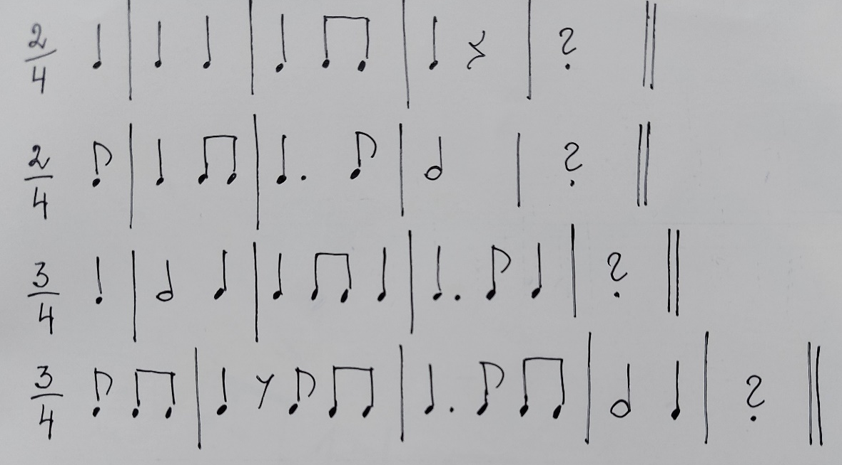

- Clap the rhythm examples.

- Listen to the Italian folk song.
https://www.youtube.com/watch?v=ydwOQ2tj94A

- Listen to the song played a little slower (the teacher plays the tune on the piano) and write the rhythm of this song (as a rhythmic dictation).

- The song is in F (Fa) major (F dur). Sing the scale.

- Sing the melody and beat time.

Example from theory lesson:
https://youtu.be/mYRjJDiKI_g​

Lesson 2

or

- Sing the Italian folk song acquired previous lesson with note names.

- Highlight the stable tones of the song.

- Sing the melody without tendency tones, instead clap your hands.
Example from theory lesson:
https://youtu.be/7udJuM6RqC4

- According to the given intervals, add a second voice to the melody. Remember to point the stems downwards!

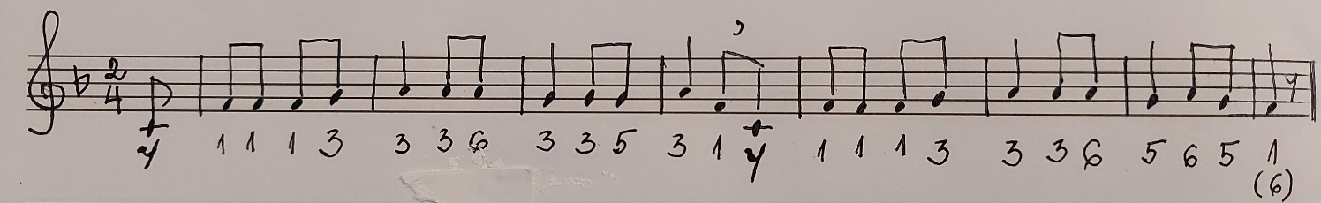
Result:
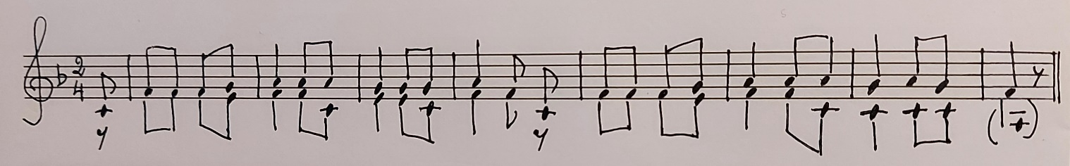

- Sing in two voices.

Lesson 3

or

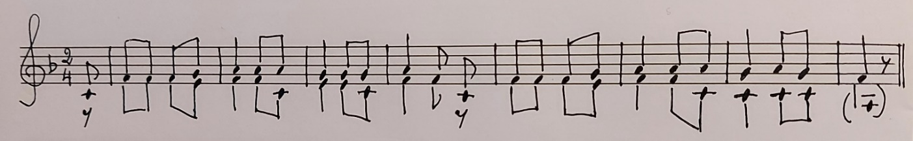

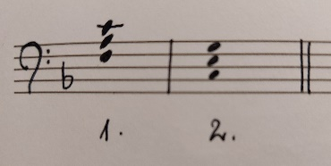
- Sing the Italian folk song acquired in previous lessons with note names and in one and/or two voices.

- Remember the bass clef. There are 2 chords:

- Play the accompaniment by ear using the given chords. Sing the melody with note names.

The task can be made more difficult by using chord figuration, for example:
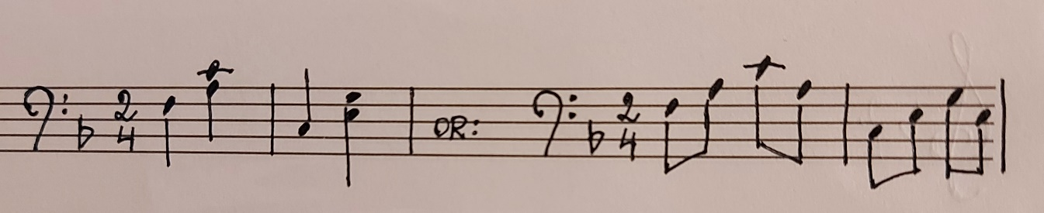

- Create the final performance of the Italian song using the elements acquired before.
Ideas:
- add instrumental introduction and coda, for example,
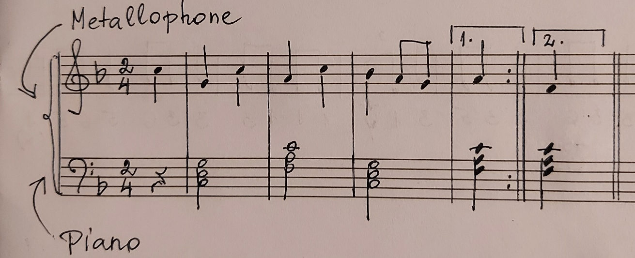

- sing in groups (the second phrase as an echo),
- sing solo + the group,
- use different percussions for accompaniment etc.

