Finnish folk song „ Keitä tee ootta te nuoret poijat”
1. Keitä te ootte te nuoret (pienet) poijat,
kun en mä tunne teitä,
piupali paupali piupali paupali,
kun en mä tunne teitä.
2. Ootteko tulleet, ootteko tulleet
kenkiänne hakemahan,
piupali paupali piupali paupali,
kenkiänne hakemahan.
3. Suutari on mennyt koko viikoksi
kylälle neulomahan,
piupali paupali piupali paupali,
kylälle neulomahan.
4. Tulkaa sitten ensi viikolla
kenkiänne hakemahan,
piupali paupali piupali paupali,
kenkiänne hakemahan.
5. Älkää kaatako maitohinkkiä
eteisessä mennessänne,
piupali paupali piupali paupali,
eteisessä mennessänne.
6. Hyvästi, hyvästi, hyvästi, viekää
Miinalle terveisiä,
piupali paupali piupali paupali,
Miinalle terveisiä.

Piupali paupali is Finnsh nonsense, which doesn’t mean anything. ;-D
1. Who are you, young lads,
As I do not know you,
Piupali paupali piupali paupali,
As I do not know you.
2. Have you come, have you come
To fetch your shoes,
Piupali paupali piupali paupali,
To fetch your shoes.
3. The shoemaker has gone for the whole week
To knit in the town,
Piupali paupali piupali paupali,
To knit in the town.
4. You may come next week
To fetch your shoes,
Piupali paupali piupali paupali,
To fetch your shoes.
5. Do not overturn the milk churn
When you pass through the vestibule,
Piupali paupali piupali paupali,
When you pass through the vestibule.
6. Goodbye, goodbye, goodbye, take
My greetings to Miina,
Piupali paupali piupali paupali,
My greetings to Miina.

1st lesson:
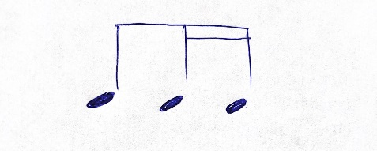

Theme of the lesson: rhythm

Sing the Eb major scale in the following rhythm ( also in canon):
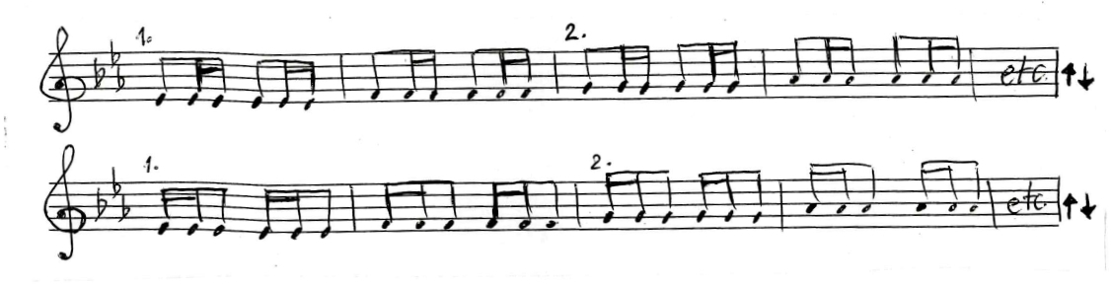
Continue by singing the same Eb major scale in this rhythm ( also in canon):
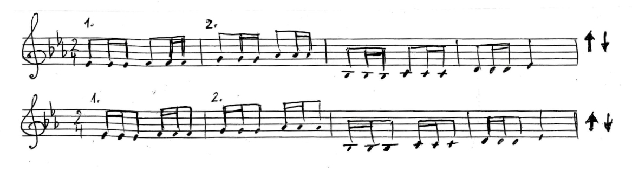
Add the bar lines:
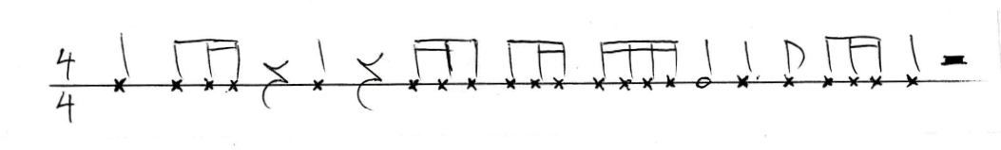
Listen to the rhythm clapped by your teacher and and write down it.
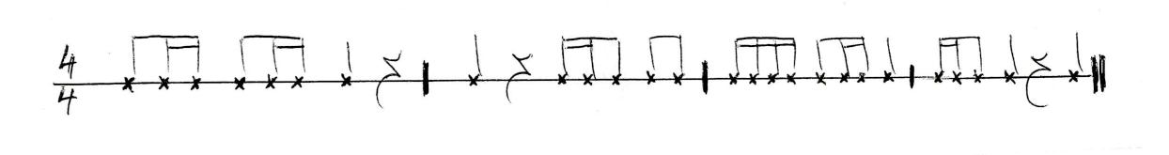
Please sing the song using the note names:
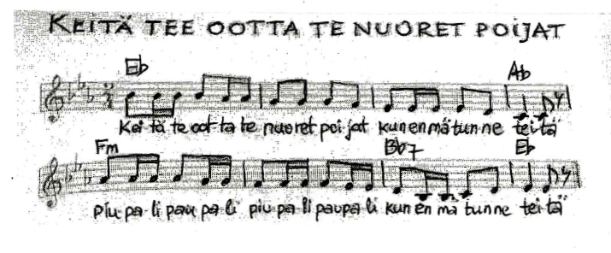
then
1. Sing the song in a canon form.
2. Clap your hands in the rhythm of this song.
3. Use body percussions according to your own choice (hands, chest, feet and fingers).
4. Create another voice and sing in two voices from the 5th bar till 8th bar Clap your hands in the rhythm of this song.
5. Listen carefully and write down the song by heart.
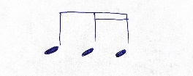
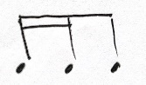
6. Analyze the line of melody. Where the melody goes up or down like a scale and where it jumps upwards or downwards creating an interval?
7. Change the rhythm group from to and sing.
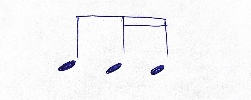
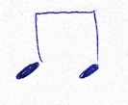
8. In 2nd, 3rd and 7th bar change rhythm to
9. Listen to the recording and practice the Finnish text (at least in the first verse!) with right pronunciation and sing the 1st version in Finnish

Pekka Kuusisto Performs 'Piupali Paupali' (Finnish folk song) - YouTube

10. Listen the song in different versions:
Piupali paupali - YouTube

https://youtu.be/u1TL91uppN8
https://youtu.be/djIJ-2MbxT8

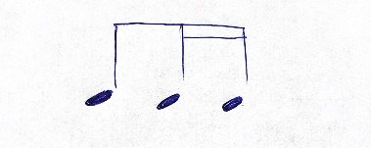
Attention task:
• =
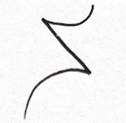
- = pause

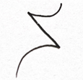
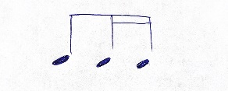
- • • – =

- – • •

- – • –

- • – •

- • • •

- • • – –

- – • • –

- – • – •

- • • • –

- • – • –

Finnish folk song „ Keitä tee ootta te nuoret”
2nd lesson:
Theme of the lesson : multipart singing
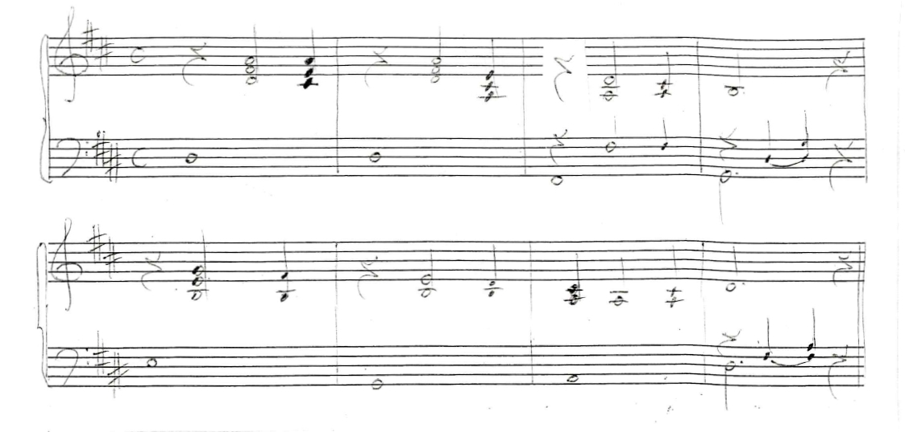
Present and analyze the harmony of the music by naming the chords (G, A, D, em) and creating the harmony and accompaniment to the music. (Pay attention to another key!)

Please name the intervals between the notes on the first line.

Sing the song by tasting the the intervals on the first line.
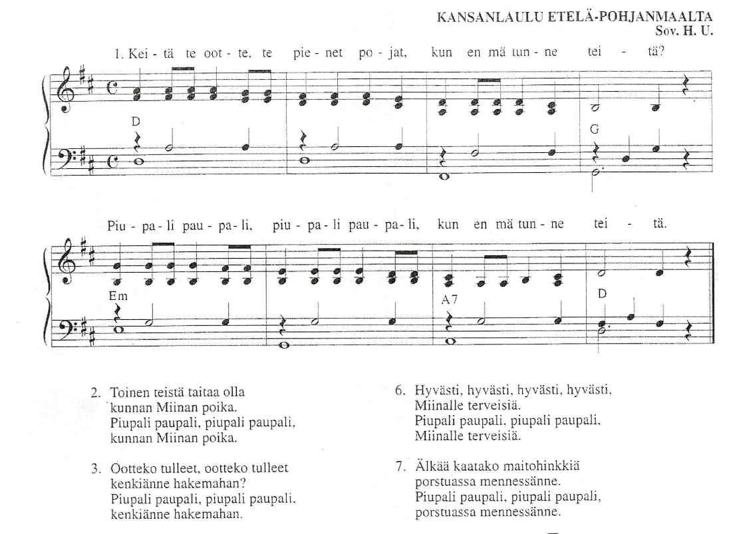Please play the second line on an instrument (Violin, cello, trombone etc.– your choice!)
Try also to play this piece in another key, in Eb major

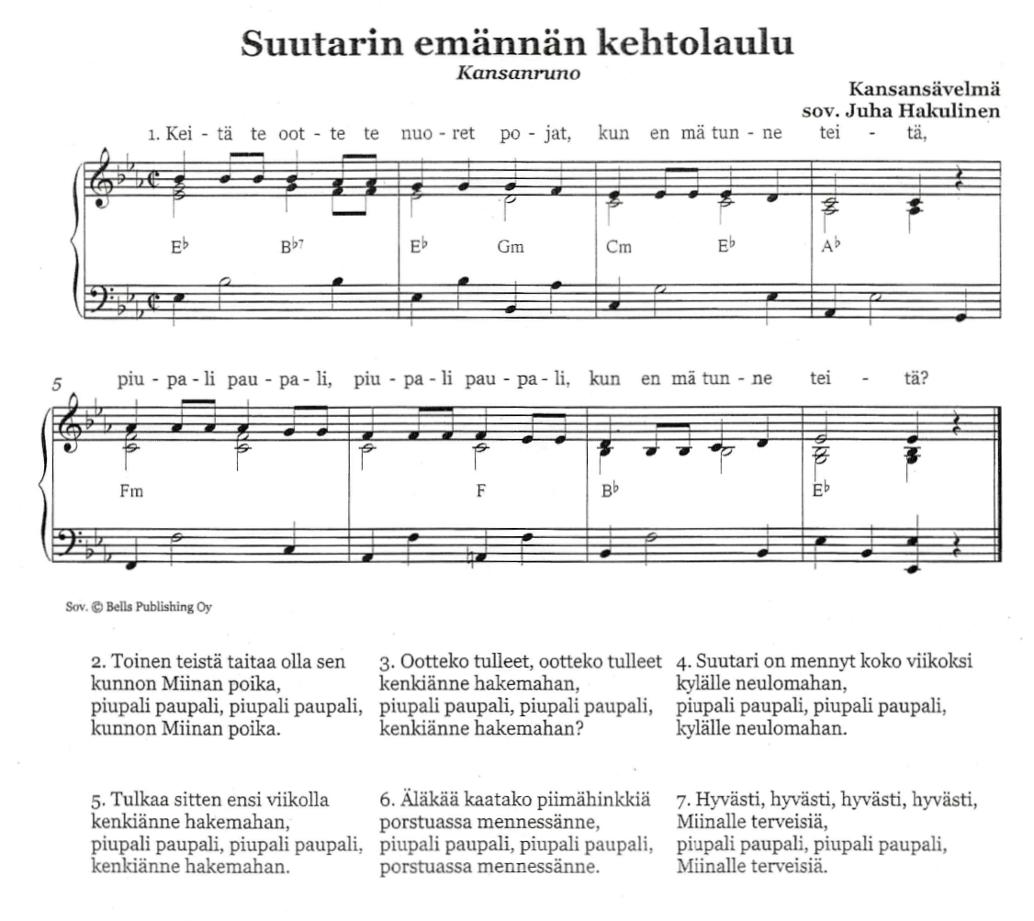
Pay attention to the syncopated rhythm in base line. Accompany yourself playing piano and sing the song in Finnish language!

