**Belģu tautasdziesma “Komt, vrienden, in het ronde“**

**„Friends in the round“**

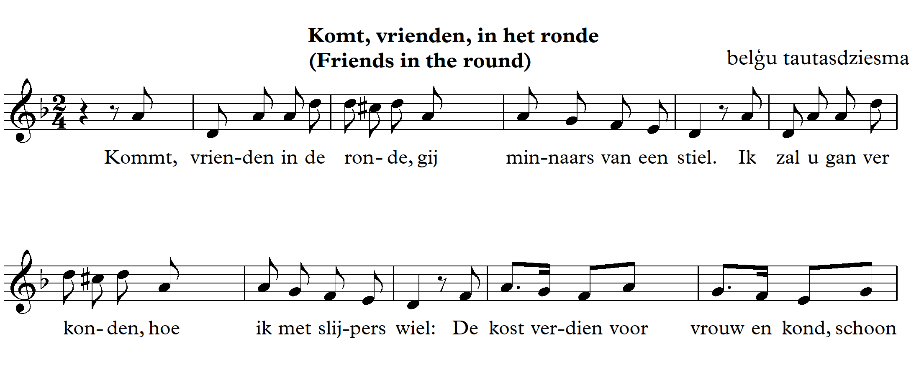

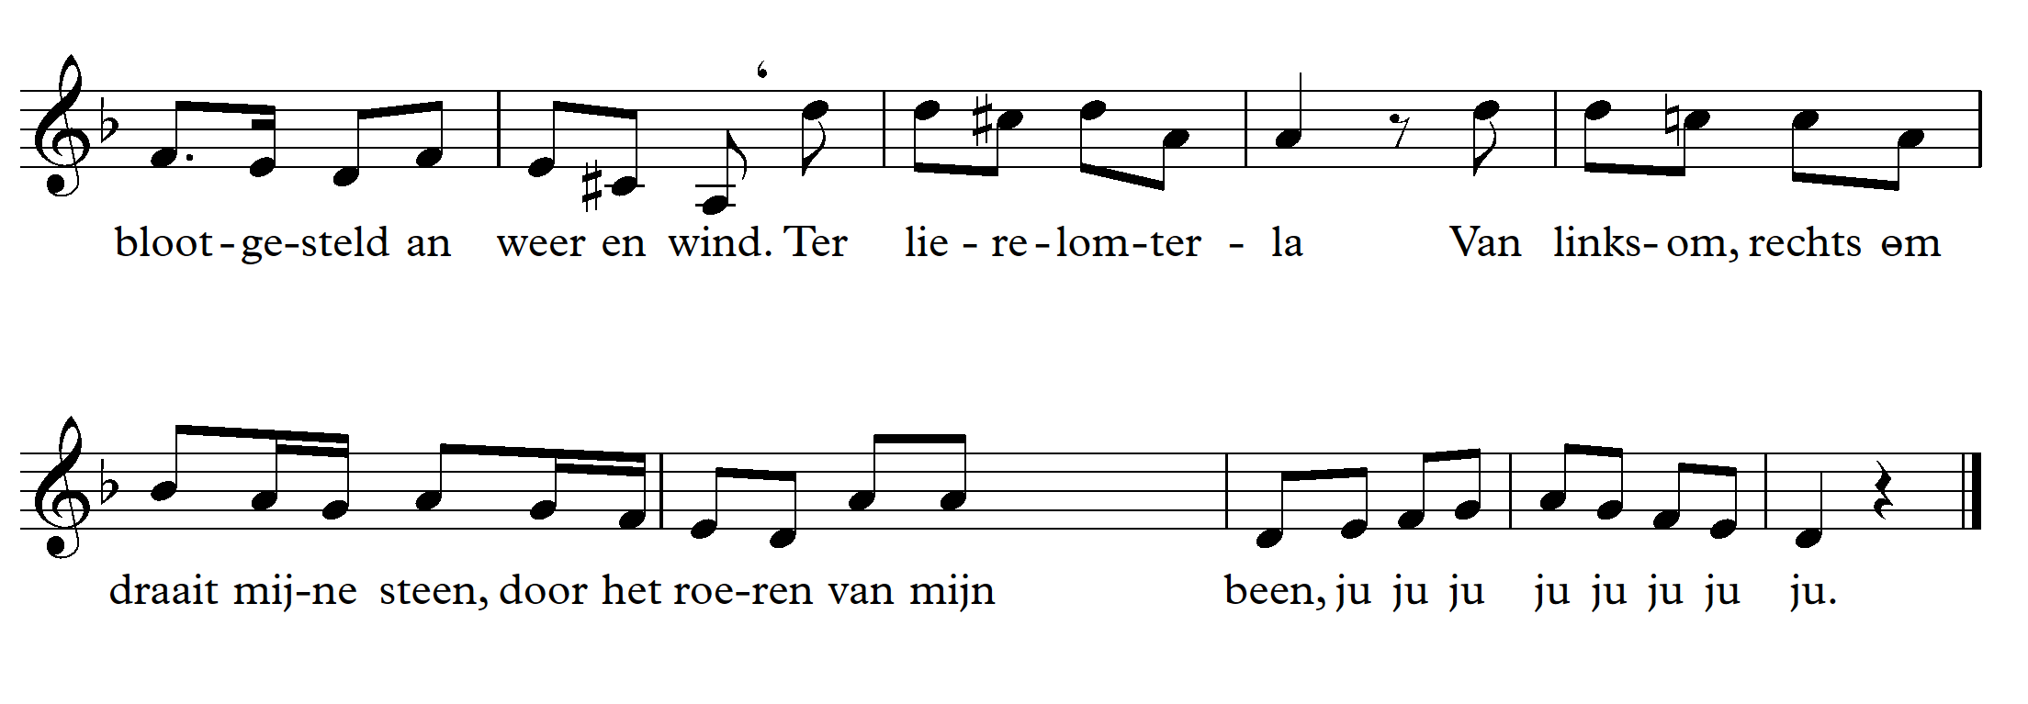

1. Ritmizējam

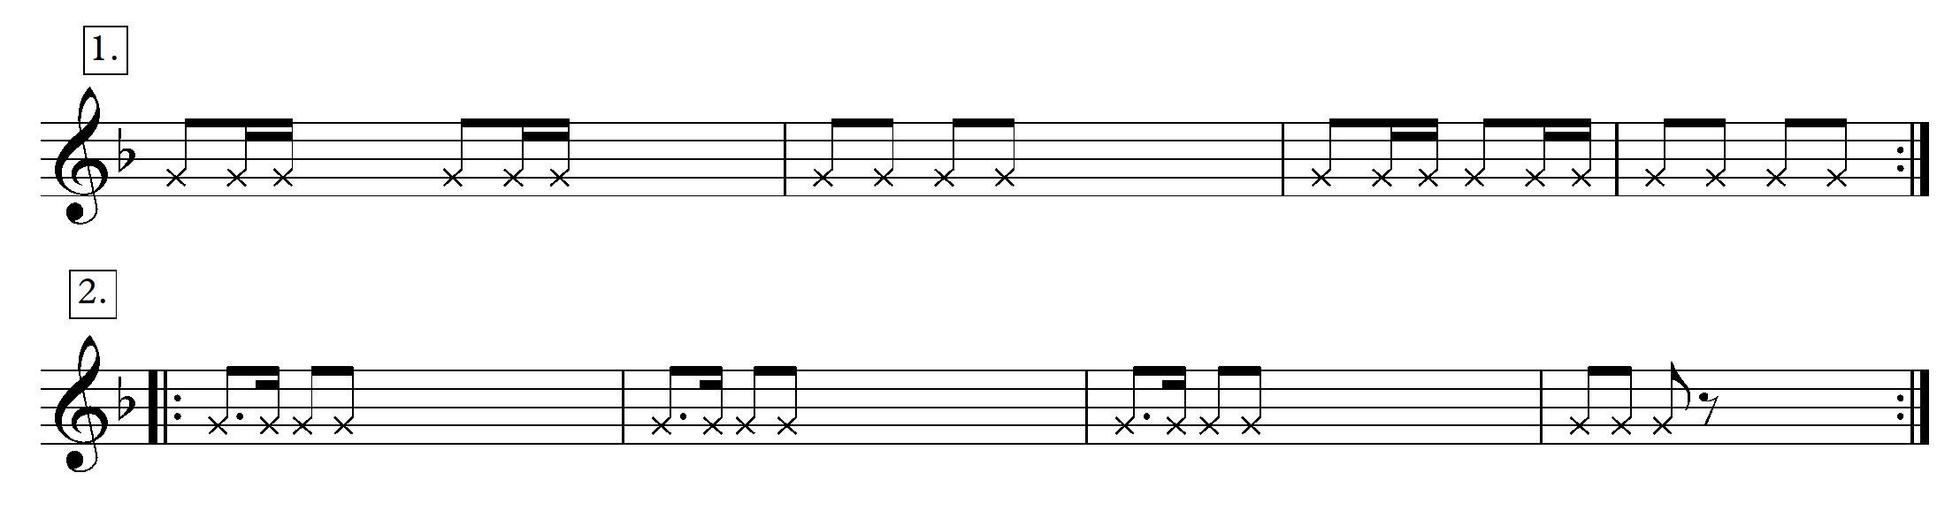

1. Dziedam dziesmu ar nošu nosaukumiem.
2. Klausāmies dziesmu.

<https://www.youtube.com/watch?v=bn4P5GLqnnI>

<https://www.youtube.com/watch?v=g7eYqacZGMU>

<https://www.youtube.com/watch?v=bn4P5GLqnnI>

<https://www.youtube.com/watch?v=TnSE4939mx8>

1. Kāds ir dziesmas raksturs?
2. Par ko dziesma varētu būt?
3. Kāds ir temps?
4. Kāda ir skaņkārta (priecīga, bēdīga)?
5. Melodijas diapazons? Ko diapazons liecina par laiku, kad tā sacerēta?
6. Sākumā melodija ir lēkajoša. Pa kādiem intervāliem melodija lēkā?
7. Nodziedi noturīgos intervālus re minorā (uz I, uz V pakāpes)
8. Dziedi re minoru (dabisko, harmonisko)
9. Dziedi re minoru ar doto ritmu.
10. Dziesmas 9., 10. 11. taktis – turpini sekvenci.
11. Dziesmas 16.takts – sekvencē.
12. Pēdējās divas taktis – dziedi 2-balsīgi, dziedi 3-balsīgi.
13. Uztakts – dziedi uztakti katrai taktij (katras takts pēdējā skaņa un nākošās takts pirmā skaņa)
14. Divas grupas (1.grupa dzied melodijas augšējos ritmus, 2.grupa – apakšējo)

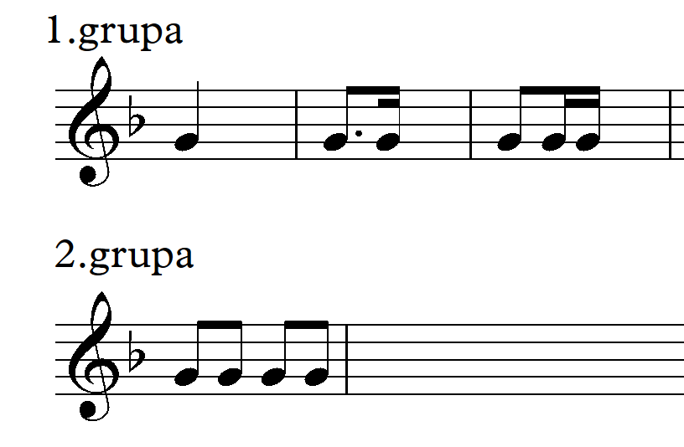

**2. stunda**

1. Dziedam dziesmu 1-balsīgi ar notīm.





2. Dziedam ar ritma pavadījumu.

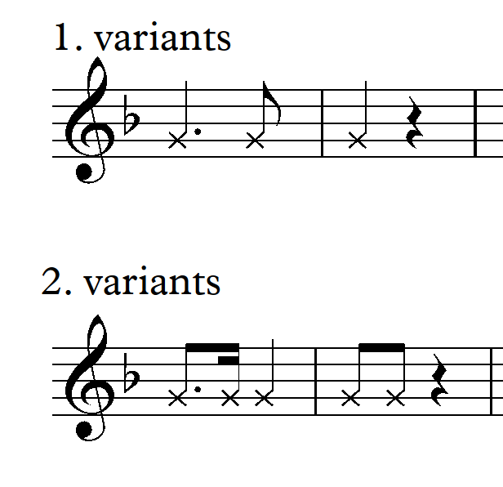

3.Ritmizējam 1.variantu ar kājām.

4. Dziedam 2-balsīgi (pēdējās 3 taktis – 3 balsīgi, vidējā balss – skaņu „re” uz vietas)

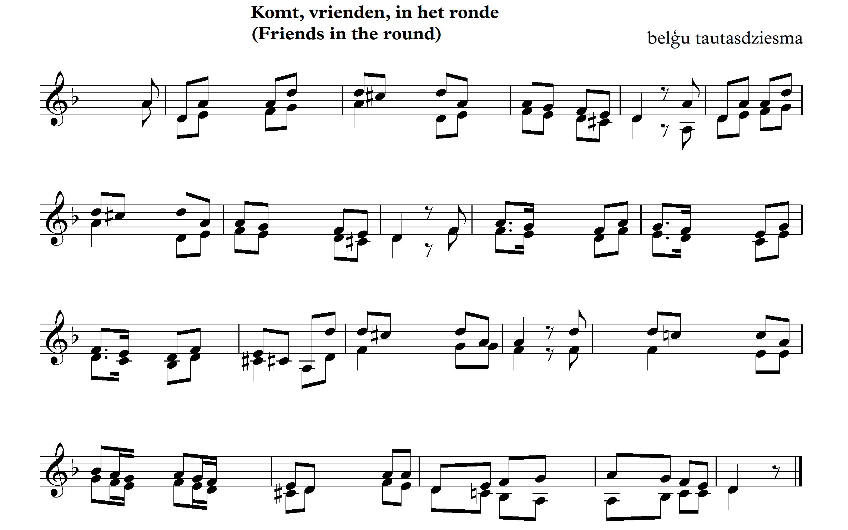

5. Pievienojam pavadījumu.

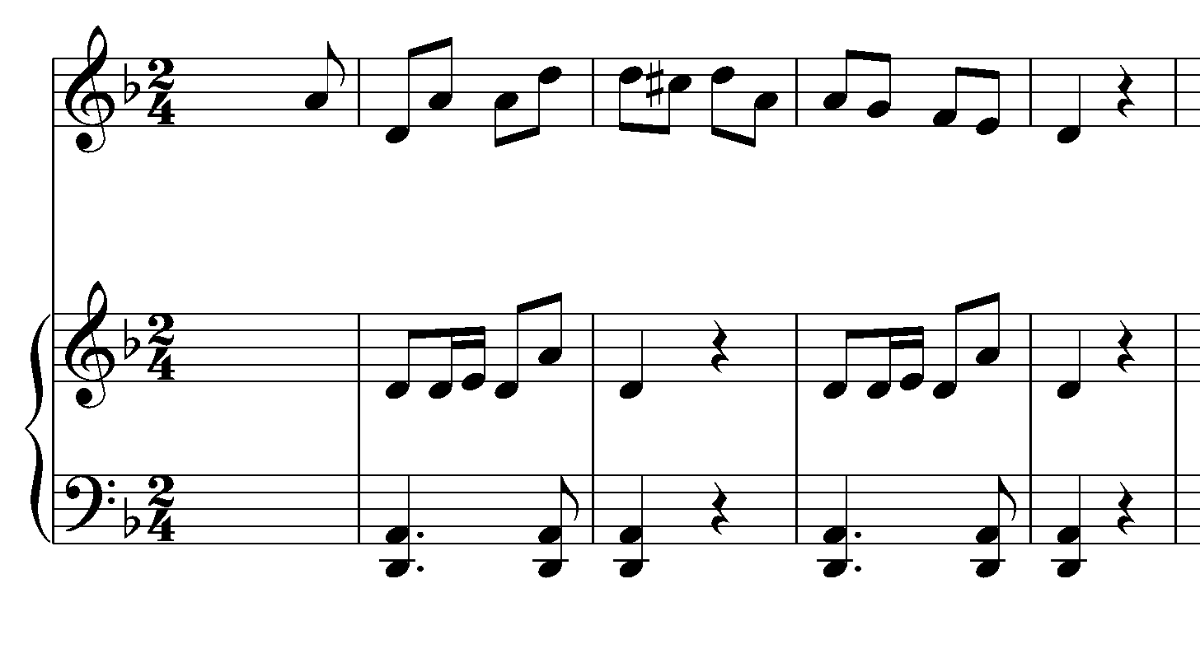

6. Dziedam dziesmu 2- balsīgi – pievienojam ritma un klavieru pavadījumu.

Lai labi skan!

Pielikumā dziesmas teksta izklāsts angļu valodā

**FRIENDS IN THE ROUND**

The song is about the craftsman who went past the doors with a cart to sharpen the knives and explains why his profession is the best. The current text about the scissor sharpener was recorded in 1895 by Jan Bols from Lubbeek,Flanders. Two years later it was included in the collection Hundred old *Flemish songs.*

1.Come friends in the round Lovers of a craft! I will tell you How I get through the grinder's wheel Earning a living for wife and child Cleanly exposed to weather and wind

(Refrain)

Terlierelom terla! From the counter clockwise my stone turns By stirring my leg Ju jujujujujujujuju!

2. The blacksmith who has to work hard, Steady for the four, He does not dare to strengthen himself, With one can good beer, While I go at ease, Sometimes also with an empty bag.

(Refrain)

3. The shoe pick stiff seated, On a pitch chair, May cheese and dry beer eat, But if I feel need, Then I sharpen until the evening, And so I never have poverty.

(Refrain)

4. My wife who calls victoria, About the grinder's stall, She finds the biggest gloria, In the turning of my wheel, My children have no discomfort, They walkwith the begging bag!

(Refrain)

5. Sa, friends, for the last, All' crafts are good, But mine is still the best, Clean I sometimes have to sleep, On hay and sprinkle in one stable, There I have a cost for nothing.