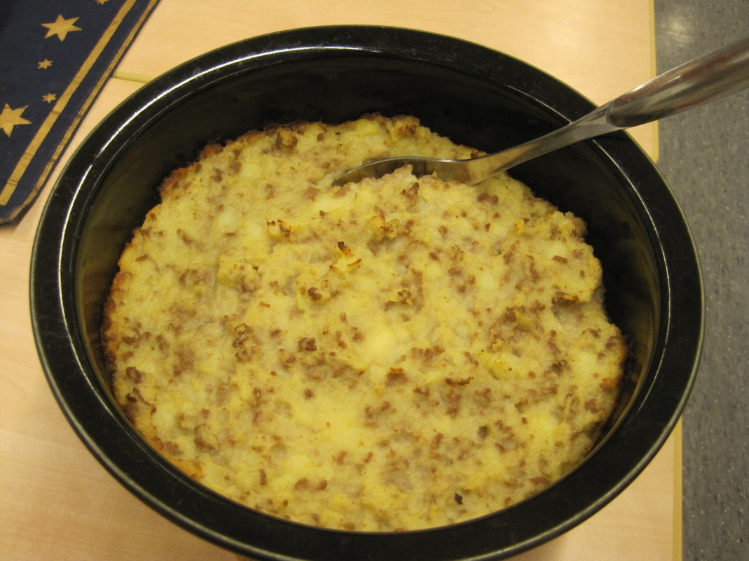

MASHED POTATOES WITH MINCED MEAT CASSEROLE

(Lihaperunasoselaatikko)

1 liter leftover mashed potatoes
400 gram minced beef

- Mix leftover mashed potatoes and fried minced beef.
- Grease a baking dish with butter and pour the mixture into a baking dish.
- Bake in the oven at 200 degrees at the lowest level about 30 minutes.

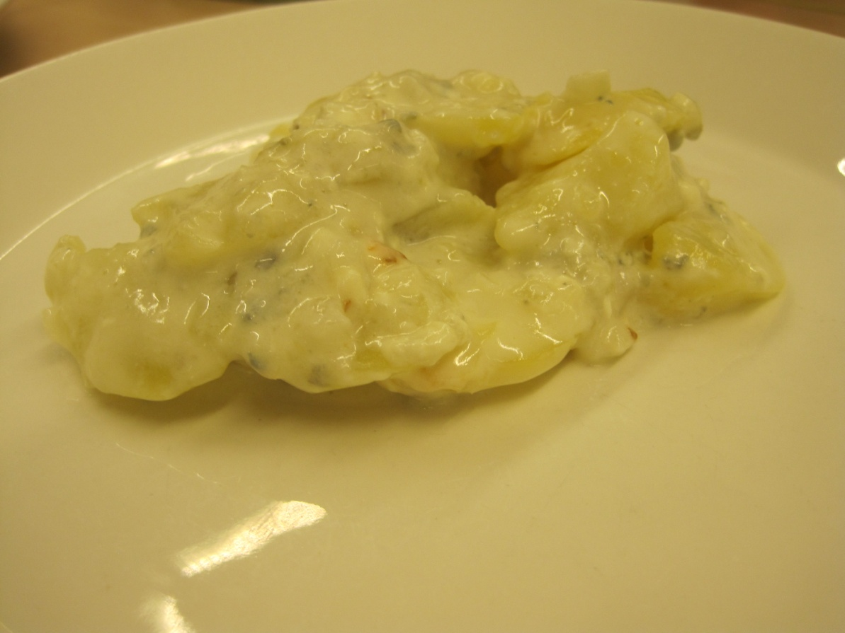

BLUE CHEESE POTATO CASSEROLE

(Homejuustoperunavuoka)

10 big potatoes

1 onion
5 cloves of garlic
2-4 deciliter cream
a pinch of salt
50 gram blue cheese

- Slice potatoes and spread them in layers to a pan with chopped onion. Put blue cheese, salt and garlic between layers and pour cream on it.
- Bake casserole in the oven at 200 degrees about 30 minutes.

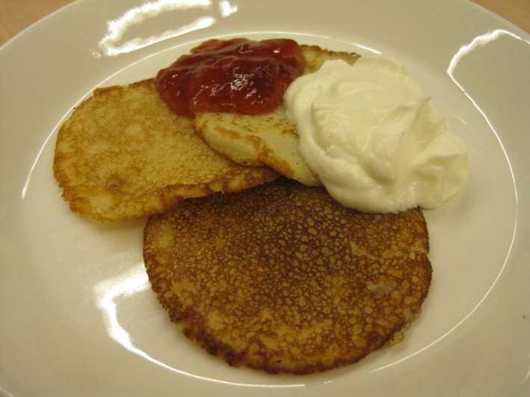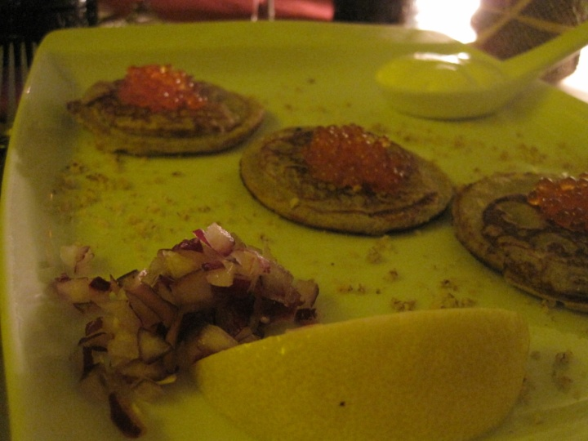

PANCAKES

(Letut)

4 eggs
1 liter milk
5 desiliter flour
1 teaspoon salt
1 teaspoon sugar
little glob cooking oil

For baking:

Butter or Margarine

For serving:

Whipped cream and jam or caviar and chopped onion

- Broke the eggs in the bowl. Whip the eggs so that their structure will be broken. Add the milk.
- Add to dry ingredients and the little glob of cooking oil.
- Let the pancake batter to swell about 30 minutes.
- Fry large or small pancakes in a frying pan or griddle pan on the both sides. Add little bit of butter or margarine each time you start to fry new pancakes so they don’t stick to the pan.
- Serve with whipped cream and jam or with caviar and chopped onion.

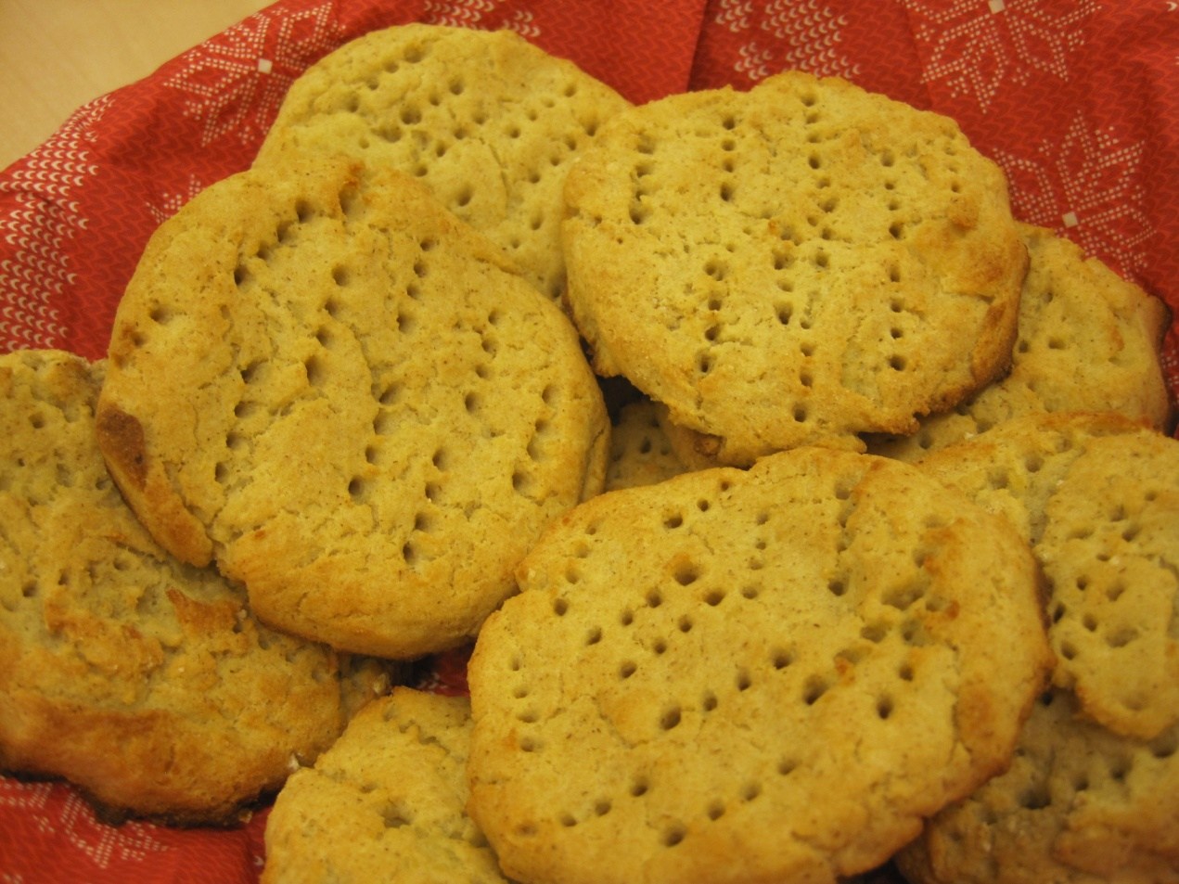

POTATO FLATBREAD

(Perunarieska)

3 deciliter potato flakes or 1½ dl mashed potato flour mix
4 deciliter water
50 gram margarine or butter (melted)
½-1 teaspoon salt
1 deciliter barley flour
2 deciliter wheat flour

- Heat the oven to 225 C.
- Mix the potato flakes with warm water. Add the melted butter, salt and flours.
- Knead the dough into a bar shape and slice into 7-8 pieces. Tap the pieces into ½ cm thick flat breads and put them to the baking tray.
- Tick the bread few times with a fork before baking.
- Bake in the oven for about 15 minutes. The flatbreads tastes the best when they are still warm.

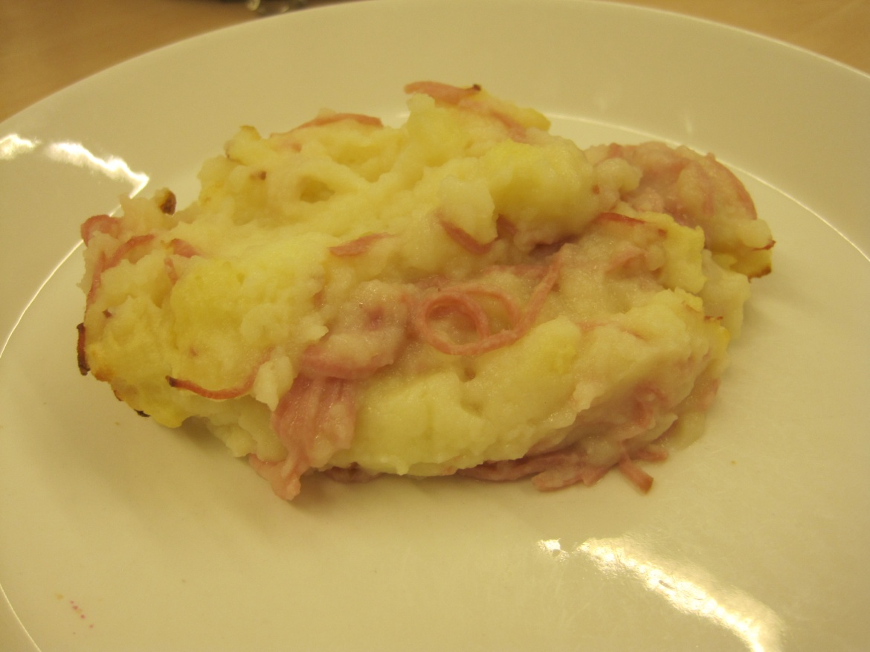

HAM AND POTATO CASSEROLE

(Kinkkuperunasoselaatikko)

8 potatoes
150 gram ham slices

1 onion
25 gram cooking oil
½ teaspoon salt
0,25 teaspoon black pepper
½ teaspoon mixed pepper spice
1½ - 2 deciliter milk

1 egg

- Wash, peel and chop the potatoes. Boil the potatoes in lightly salted water until they are soft.
- Peel and chop the onion. Fry the onion in cooking oil in a frying pan.
- Mash the cooked potatoes and add the milk to the extent that the mashed potatoes will be loose enough.
- Add salt, onion, ham slices and spices. Add whipped egg mixture and mix carefully until smooth.
- Pour into a buttered casserole dish.
- Fry at 200 degrees for about 30 minutes.

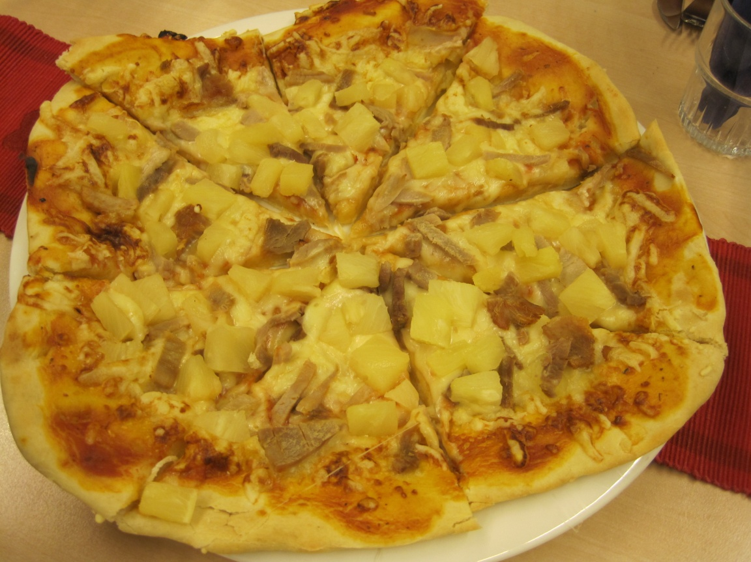

PIZZA

Pizza base:
1½ deciliter water
15-20 gram fresh yeast
about 3 deciliter wheat flour
2 tablespoon cooking oil
- Warm the water to hand warm (+37 degrees). Crumble the yeast into the water and stir until it’s smooth.
- Add other ingredients and knead the dough by hand.
- Roll out the dough on a baking tray and leave it to rise under a cloth for about 10-15 minutes.
- Place the oven heat up to 250 degrees and cook the tomato sauce and stuffing.

Tomato sauce:
1 little can tomato paste
1 teaspoon bazil or pizza spice
- Stir and add onto the pizza base.

Stuffing:
300 gram leftover ham
200 gram pineapple pieces
2 decilitre grated cheese
- Add fillings on top of the pizza base.
- Bake the pizza in the median plane of the oven for 15 minutes.
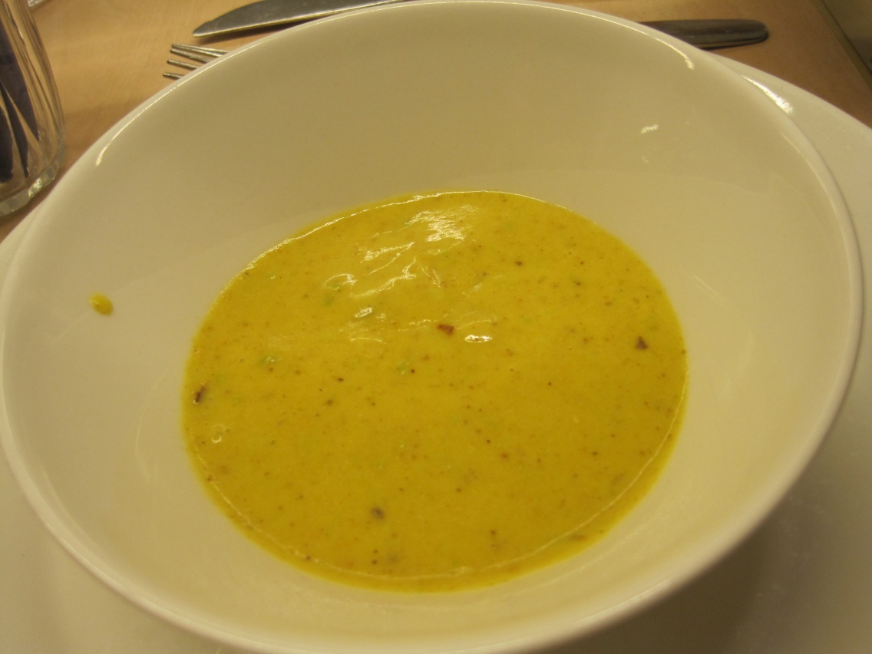

VEGETABLE SOUP

(Kasvissosekeitto)

2 carrots (about 160 gram)
500 gram leftover mashed potatoes
about 8 deciliter water
1-2 vegetable stock cubes
2½ deciliter sour cream
touch black pepper
1 teaspoon seeds of coriander of touch of nutmeg

For serving
1-2 tablespoon chopped parsley
the cottage cheese
ryebread
Lomakkeen yläreuna
Lomakkeen alareuna
- Wash and grate the carrots.
- Boil the grated potato and onion mix in vegetable broth until it’s done, about 10 minutes.
- Add the cream, black pepper and the chopped coriander seeds. Bring to a boil.
- Puree with a hand blender and check the salt.
- Chop the parsley and mix it to the cottage cheese. Add on the soup portions.
- Serve with rye bread.
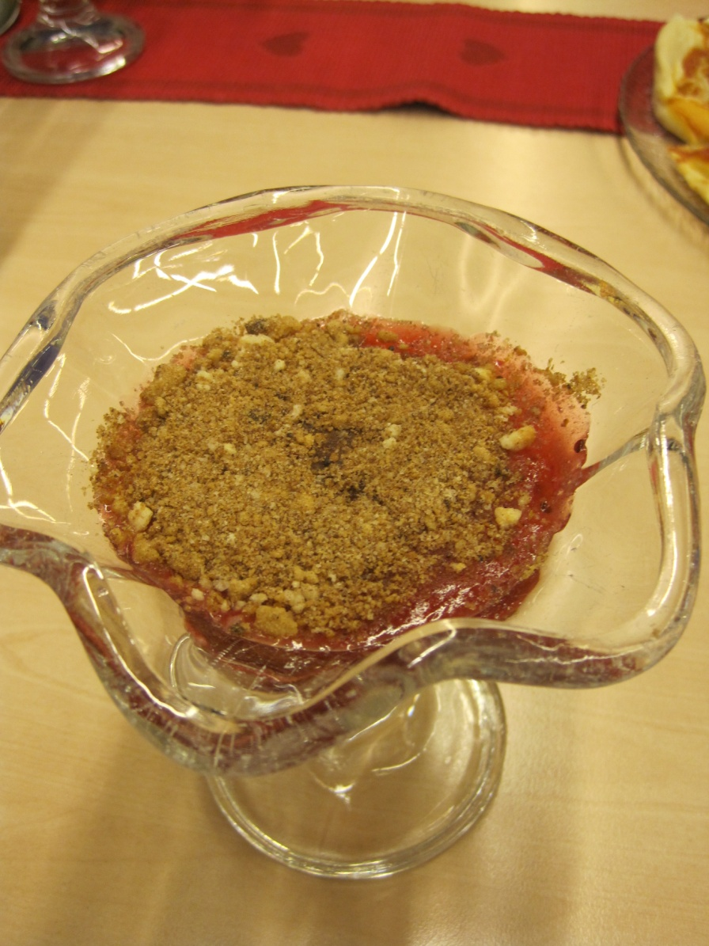

GOOSEBERRY FRUIT SOUP (6 portions)

(Tallimestarin kiisseli)

10 desiliter water
5 desiliter gooseberry
2 deciliter sugar

4 tablespoon potato flour
½ deciliter water
1 teaspoon vanilla sugar

On top:
3 slices dry/old ryebread in grated form
3 tablespoon butter
½ deciliter sugar
2 tablespoon cocoa powder
whipped cream

- Boil the water and add gooseberries. Cook until the berries are completely softened.
- Strain the juice. Add the sugar and bring to boil again.
- Dissolve the potato flours in cold ½ dl water. Remove the pan from the heat and pour in the potato flour mixture as a thin string to the juice, stirring constantly.
- Put the pot back on the stove and let it bubble up a few times, don’t boil. Lift the soup to cool and season with vanilla sugar.
- Heat the butter in a frying pan. Include grated ryebread and let brown lightly. Season the mixture with sugar and cocoa powder.
- Pour the fool in dessert dishes and sprinkle with bread mixture and briskly whipped cream.
