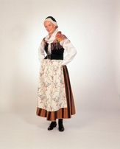

Women’s traditional national costume in Central Finland

Nowadays someone uses these in familyparties.

Photo: Kari-kuva

Original wind suit made in Finland. Finnish people wear this outdoors.

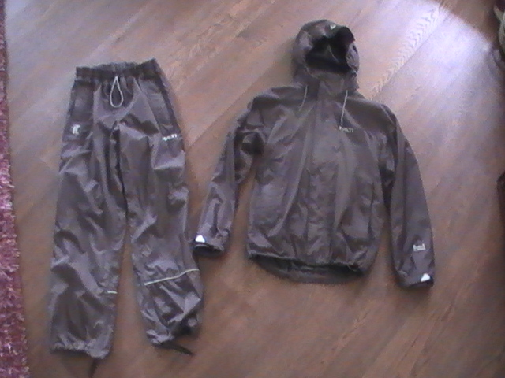

Jussishirt is a sweater from Pohjanmaa

Jussishirt ”Jussipaita”

