Where is plastic?

Plastic is a part of your everyday life. It can be found in obvious places like food packaging or plastic bags, but it can also be in places you wouldn’t expect like gum.

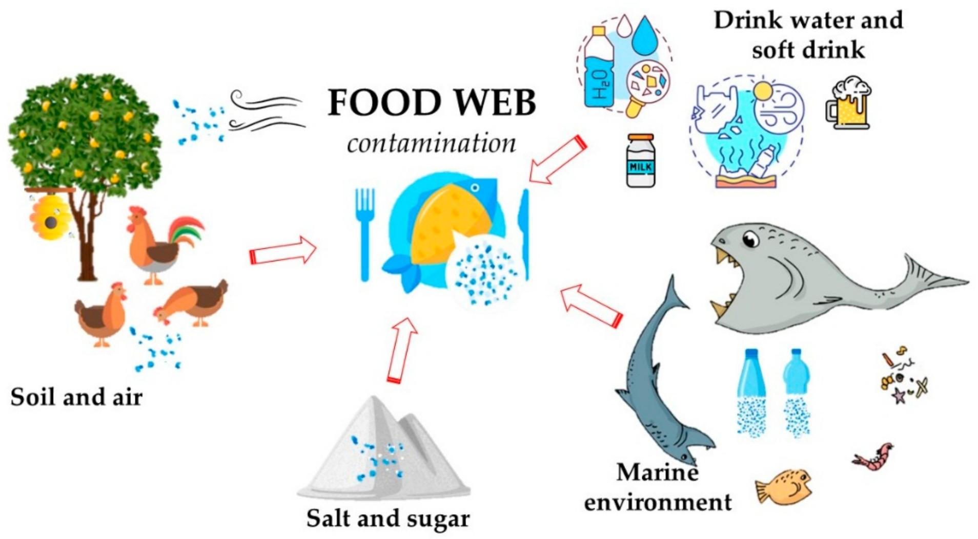
Most commonly you will find plastics in different types of packaging. For example, cereal, tea, coffee, cheese and meat are usually packed in plastic. Milk cartons are also approximately 20% plastic. Metal cans are also lined with plastic.
Also, personal products like shampoo, gels, creams, moisturizers and makeup contain plastics and some may even contain microbeads.

Places where you wouldn’t necessarily expect plastics to be found are, for example, gum, cardboard cups, clothes, glitter and cigarettes. Even humans have plastic inside of their bodies, because they consume things that contain plastics. Plastics make their way into the human body through the food chain.

Plastic is harmful to ecosystems, so plastic in products should be replaced with other substances.

