Best alternatives to plastic

Stainless steel
Tough and easy to clean, stainless steel options for reusable food and beverage storage have multiplied in recent years. You can replace single-use cups, kitchen storage, lunch boxes, and more with this durable metal.


Glass
While not biodegradable, class is inert, inexpensive and infinitely recyclable. And since many food items come packaged in glass, upcycling glass jars into food storage is a no-cost way to give your food packaging new life. Jars from jam, honey, pickles, nut butters, and so much more can be added to your no-waste toolkit for shopping from the bulk bin. They can also be repurposed to store leftovers and homemade drinks or decorated and turned into homemade gifts.
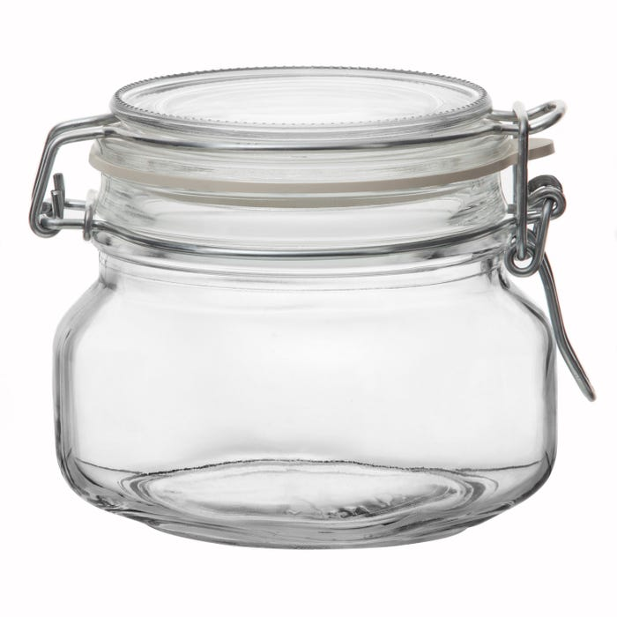

Silicone
Made primarily of sand, food grade silicone is flexible and durable. It is also heat tolerant, so you can boil, bake and cook in these products without danger of denaturing. Look for products without plastic fillers.
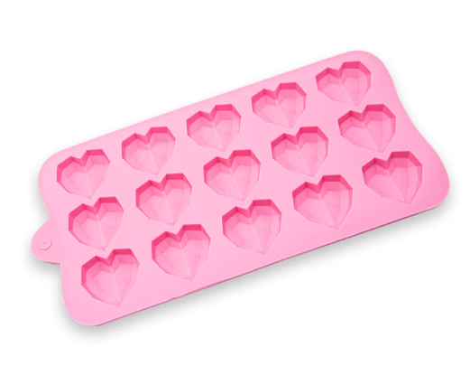

Beeswax wrap
Beeswax wrap is a food wrap material consisting of a coated fabric, most commonly cotton. It is used primarily as a replacement for plastic wrap and plastic bags. Beeswax wrap is easy to use and easy to clean. It also smells great.
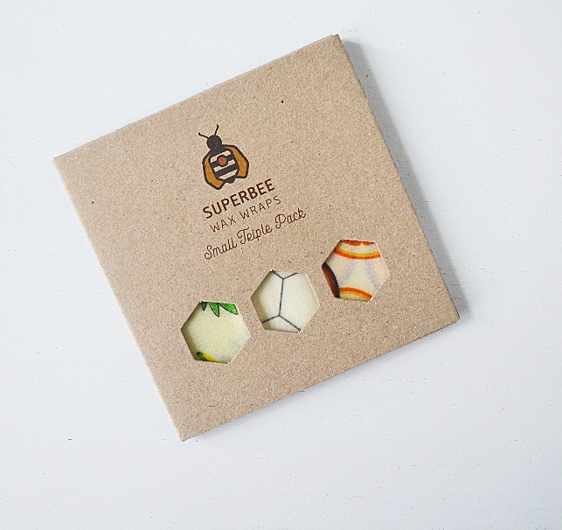

Natural fiber textile
Bags made of natural fiber textile can replace plastic bags. Sustainably clothes made from organic cotton, wool, hemp, or bamboo won´t shed plastic fibers when washed. Felted or recycled wool is a versatile, safe, and compostable material for children´s toys, household containers, and more.
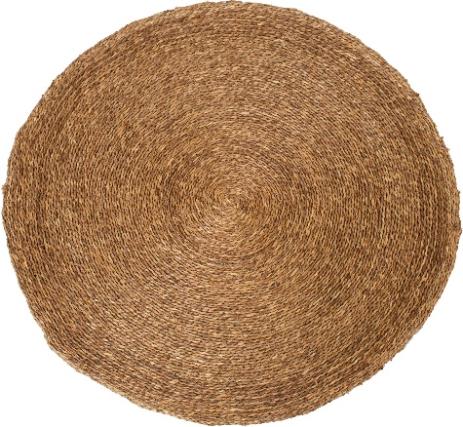

Wood
A renewable resource, wood from sustainably managed forests can replace plastic in household items like cleaning brushes, fabrics, kitchen utensils, and cutting boards.

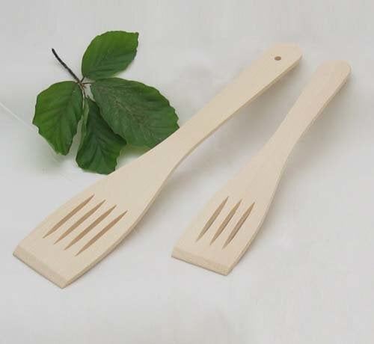

Bamboo
This fast-growing renewable resource, bamboo, can replace plastic in items like tableware and drinking straws. It is lightweight, durable, and compostable.
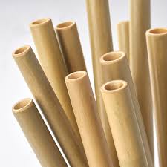

Pottery and other ceramics
Around for millennia, pottery and other fired ceramics offer a stable, waterproof alternative that´s good for food storage and tableware. Look for non-toxic glazes.
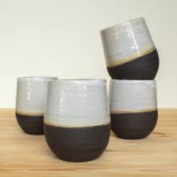

Paper
In days gone by, many things were packaged in plain paper. Paper can’t be recycled infinitely because every time it’s reused, the fibers get shorter. All paper except the glossy kind is safe to put in your home compost.
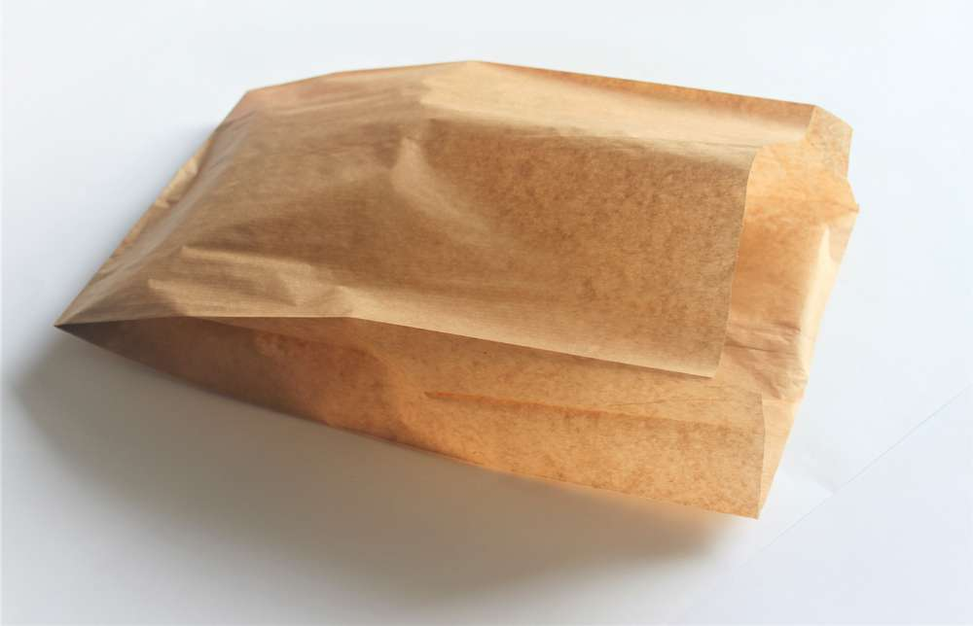

Cardboard
Cardboard is fully compostable at home if it’s not coated in, plastic. Many companies are now packaging their products in plain cardboard to cut down on waste. You can also use cardboard boxes to replace storage containers in your home.
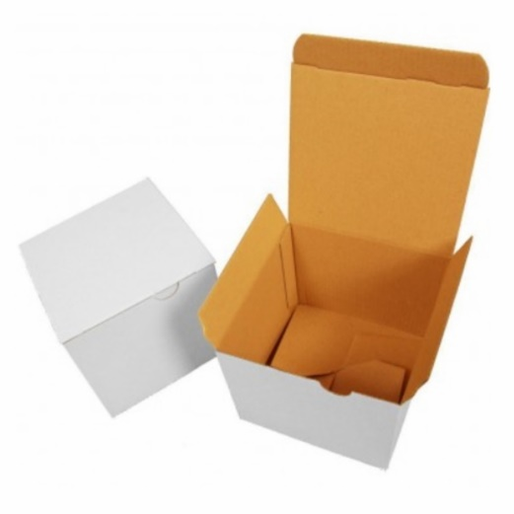
Keep in mind that anything you buy has an environmental footprint. Though longer lasting than plastic, things made from glass, metal, and so on still take energy to make and for transport. Buying well-made, durable products will help ensure you get the most use from whatever you choose.

