- Scott has had ten girlfriends, but he hasn´t got married
- Bradley has been married five times, but he hasn`t been happy
- Kimberly has lost her memory three times, but hasn’t forgotten her big love.
- Alison and Ethan have known each other all the time, but they haven´t fallen in love.
- New shampoo has come to the market
- I haven´t bought it yet.
- I have washed my hair with Fairy
- It has given natural look to my hair.
- And it has been cheap.
- Have you ever tried it.
- No, I have never believed in commercial.
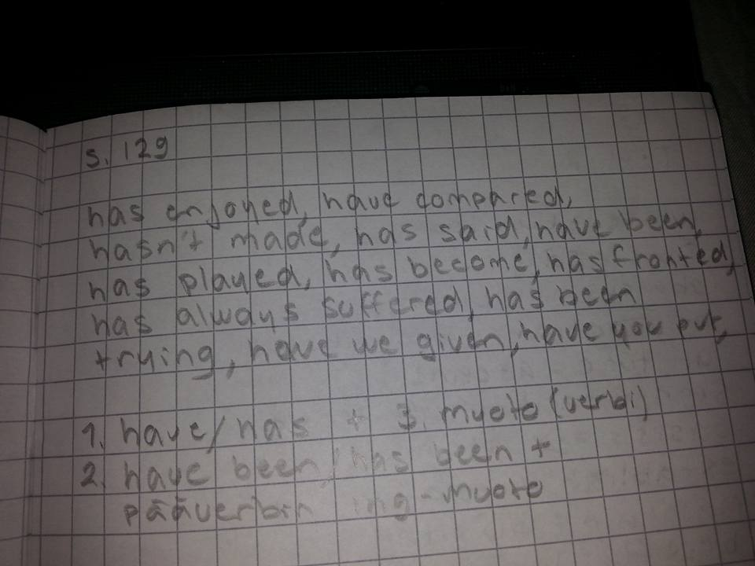
- Where have I met you before?

