Peace & Conflict, Power, Human Rights:

The causes of this recent wave of dissent across the globe — and consider the question, why do people protest?

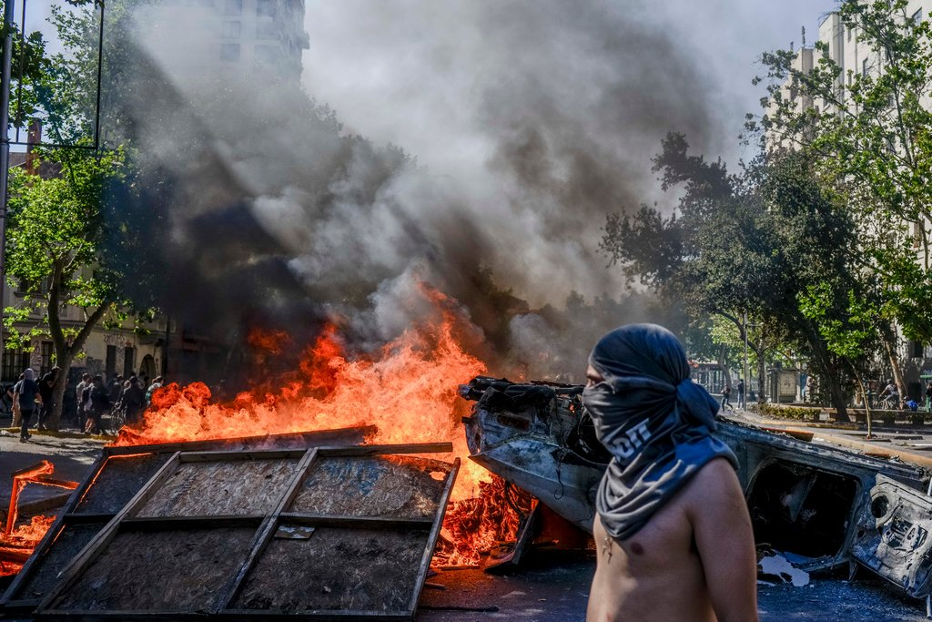

Protesters in Santiago, Chile, on Tuesday. Demonstrations over increased subway fares devolved into deadly violence.

* + **Lesson Overview**

*Featured Article: “*[*From Chile to Lebanon, Protests Flare Over Wallet Issues*](https://www.nytimes.com/2019/10/23/world/middleeast/global-protests.html?module=inline)*”*

Pocketbook items have become the catalysts for popular fury across the globe in recent weeks. In this lesson, students will explore why people protest, examine the factors and causes of this recent wave of protest, and finally choose one protest movement to research further.

**Warm Up**

1. Have you ever participated in a protest, march or demonstration? If yes, what motivated you to participate? If not, what might convince you to join one?
2. Before reading, consider protest movements from the past — such as the civil rights movement — or examples from more recent history.
3. Then, make a list of reasons people protest.
4. Next, find a partner and share and discuss your lists.
5. Finally, reflect together: Which reasons would most likely lead *you* to protest? Do you think protests can bring about meaningful change?

**Questions for Writing and Discussion**

*Read the article, then answer the following questions. As you read the article, add to or amend your list from the warm-up:*

1. What have been the catalysts in the recent wave of “unexpected protests” in Chile, India, Lebanon and Saudi Arabia? Which do you find most interesting or surprising? How do these reasons for protesting compare to your list from the warm-up activity?

**2.** Why were many of the leaders surprised by the outbreak of protests in their country? In particular, why did President Sebastián Piñera of Chile think he was immune to this type of public dissent?

1. While many of the protests have occurred on different continents across the globe, what “patterns” have experts recognized? What roles do economic inequality and changing youth demographics play in these movements?
2. Why do some like Michael Ignatieff, president of Central European University, warn against finding a common theme or category to these protests?
3. The article notes, “But as protest movements grow, their success rates are plunging.” Explain this paradox.

**E**

1. What factors contribute to the success or failure of a protest, according to the article? Why do many social media fueled protests “rise faster, but collapse just as quickly”?
2. What is your reaction to the article? Which quotation or image stands out most? Explain why. Does the article change any of your ideas about the value and role of protests?

**Going Further**

Choose one protest movement discussed in the article to research further. Use the following questions as a guide:

* - What events or factors led to the protests?
* - Who is participating in the protests? Are there any leaders or organizations directing them?
* - What are the goals of the protests? What strategies and tactics are (or were) being used to achieve them?
* - If the protests have ended, in what ways were they successful? If the protests are still continuing, what predictions do you have about their ultimate success or failure?

Then, write about or discuss with your classmates: *What additional insights did you gain about why people protest?

*If you were in the country you chose to research, would you consider joining the protests? Why or why not?

*Over all, do you believe protests are an effective way to bring about meaningful change in society? Explain why you think the way you do