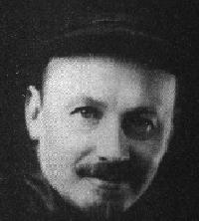

**BUKHARIN, Nikolai Ivanovich** (b. 1888)

* Member of the party since 1906
* One of the leaders of Comintern
* Member of the Central Committee since 1917
* Candidate member of the Politburo since 1919
* Editor-in-chief of ‘Pravda’ since 1917
* Member of the Industrial Supreme Council since 1917

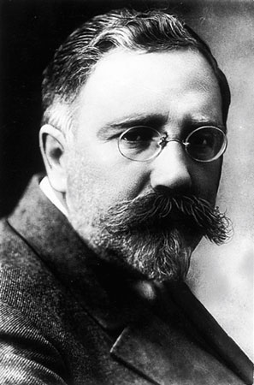

**KAMENEV, Leo Borisovich** (b. 1883)

* Member of the party since 1901
* Member of the Central Committee since 1917
* First chairman of the All-Russian General Executive Committee after the October 1917 revolution (Committee was exercised general control over Soviets)
* Chairman of the Moscow Soviet since 1918
* Debuty chairman of Sovnarkom of the USSR since 1922

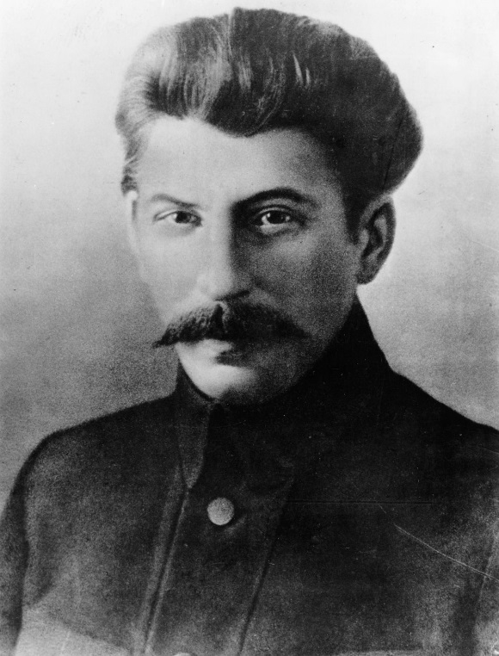

**STALIN, Joseph Vissarionovich** (b. 1879)

* Member of the party since 1898
* Member of the Central Committee since 1912
* Member of the Politbyro since 1917
* People´s Commissar for Nationalities since 1917
* Liaison Officer between Politburo and Orgburo (=organizational office of the Central Committee) since 1919
* General Secretary of the Central Committee since 1922
* Head of the Workers’ and Peasants’ Inspectorate since 1922

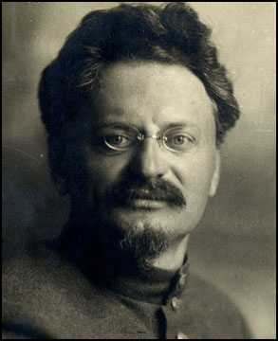

**TROTSKY, Lev Davidovich** (b. 1879)

* Member of the party (SD’s) since 1897, the Menshevik until 1917
* Cahairman of St Petersburg Soviet 1905-1906
* Exiled in Siberia and abroads 1898-1905, 1906-1917
* Member of the Central Committee since 1917
* Pricipal organiser of the October Revolution
* Chairman of the All-Russian Central Executive Committee 1917
* Commissar for foreign affairs since 1917
* Commmissar for War affairs since 1918 (creator of the Red Army)
* Negotiated the Treaty of Brest-Litovsk (which formally ended the war with Germany)1918

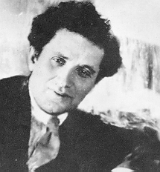

**ZINOVIEV, Grigori Yevseevich** (b. 1883)

* Member of the party since 1901
* Member of the Central Committee since 1912
* Member of the Politbyro since 1917
* Chairman of Petrograd Soviet since 1917
* Chairman of Comintern since 1919

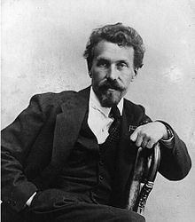

**RYKOV, Aleksei Ivanovich** (b. 1881)

* Member of the party since 1898
* Member of the Central Committee 1905-1907, 1917-1918 and since 1920
* Member of the Politbyro since 1922
* Commissar for internal affairs since 1917
* Chairman of the Supreme Concil of Natiomal Economy 1918-1921 and since 1923
* Chairman of the Sovnarkom since 1923

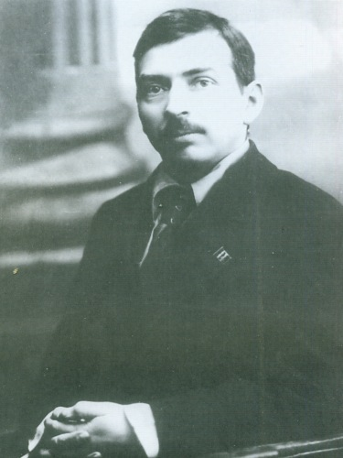

**TOMSKY, Mihail Pavlovich** (b. 1880)

* Member of the party since 1904
* General Secretary of the International Trade Union Council 1920-21
* Member of the Orgburo since 1921
* Member of the Central Committee and Politburo since 1922
* Secretary of the Central Executive Committee of the All-Russian Congress of Soviets 1921-22
* Chairman of the Presidium of the All-Union Central Council of Trade Unions since 1922