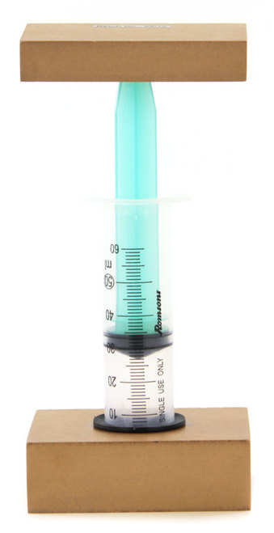

Picture: <https://www.homesciencetools.com/product/boyles-law-apparatus-kit/>

**Boyle’s law**

Boyle’s law describes how pressure and volume vary when the temperature is held constant. When you slowly compress a gas the pressure is increased without increasing the temperature.

In this lab we will investigate how pressure is affected by the volume.

Equipment

Pasco pressure sensor

Apparatus with syringe specifically created to test Boyle’s law **(*attached to woodblocks to increase stability, equipment is bought but the instructions can probably be modified to work without the apparatus or with a modified apparatus*)**

Weights

Instructions

1. Find out the normal pressure in the room.
2. Setup the volume of air in the syringe to 20 ml.
3. Enclose the air in the syringe by attaching the pressure sensor to it.
4. Start the Capstone program
5. Add 100 g to the top of the apparatus.
6. Record the values for p and V in a (V,p)-graph.
7. Repeat steps 5-6 five times.

Questions & Tasks

1. Analyze the graph
2. What is the process called when volume and pressure are varied, but temperature is constant?
3. What would the graph look like if the temperature of the air was lower?***(Extension, if you do this during the winter, go outside and try the same experiment)***
4. If you did not have a Pasco meter that could analyze the pressure. Could you get the pressure for each repetition by some other measure? How?
5. Calculate the pressure caused by the weights and see if the calculated value corresponds to the values received with the Pasco sensor

**For the teacher to evaluate**

Pressure can be calculated as $p=\frac{F}{A}$ and determined with digital instruments as done in this investigation. Since this lab is about thermodynamics it could be good to revise and remind the students about mechanics at the same time.

The laws of thermodynamics can also be tested by using the PHET simulations: <https://phet.colorado.edu/en/simulation/gas-properties>

Discuss the importance of changing the temperature slowly

**Self-evaluation**

|  |  |
| --- | --- |
| I was able to create the graph | Yes/No |
| I was able to interpret the graph | Yes/No |
| I waited for the pressure stabilized before recording the pressure from the Capstone program | Yes/No |
| I know how to get the pressure from the mass and the cross-sectional area of the cylinder. | Yes/No |
| I participated actively together with my group during the investigation | Yes/No |
| This is the main point I learned from this investigation |  |

**Evaluation between students**

Compare your results to those of another group, what differences can you find?

|  |
| --- |
|  |
|  |
|  |
|  |