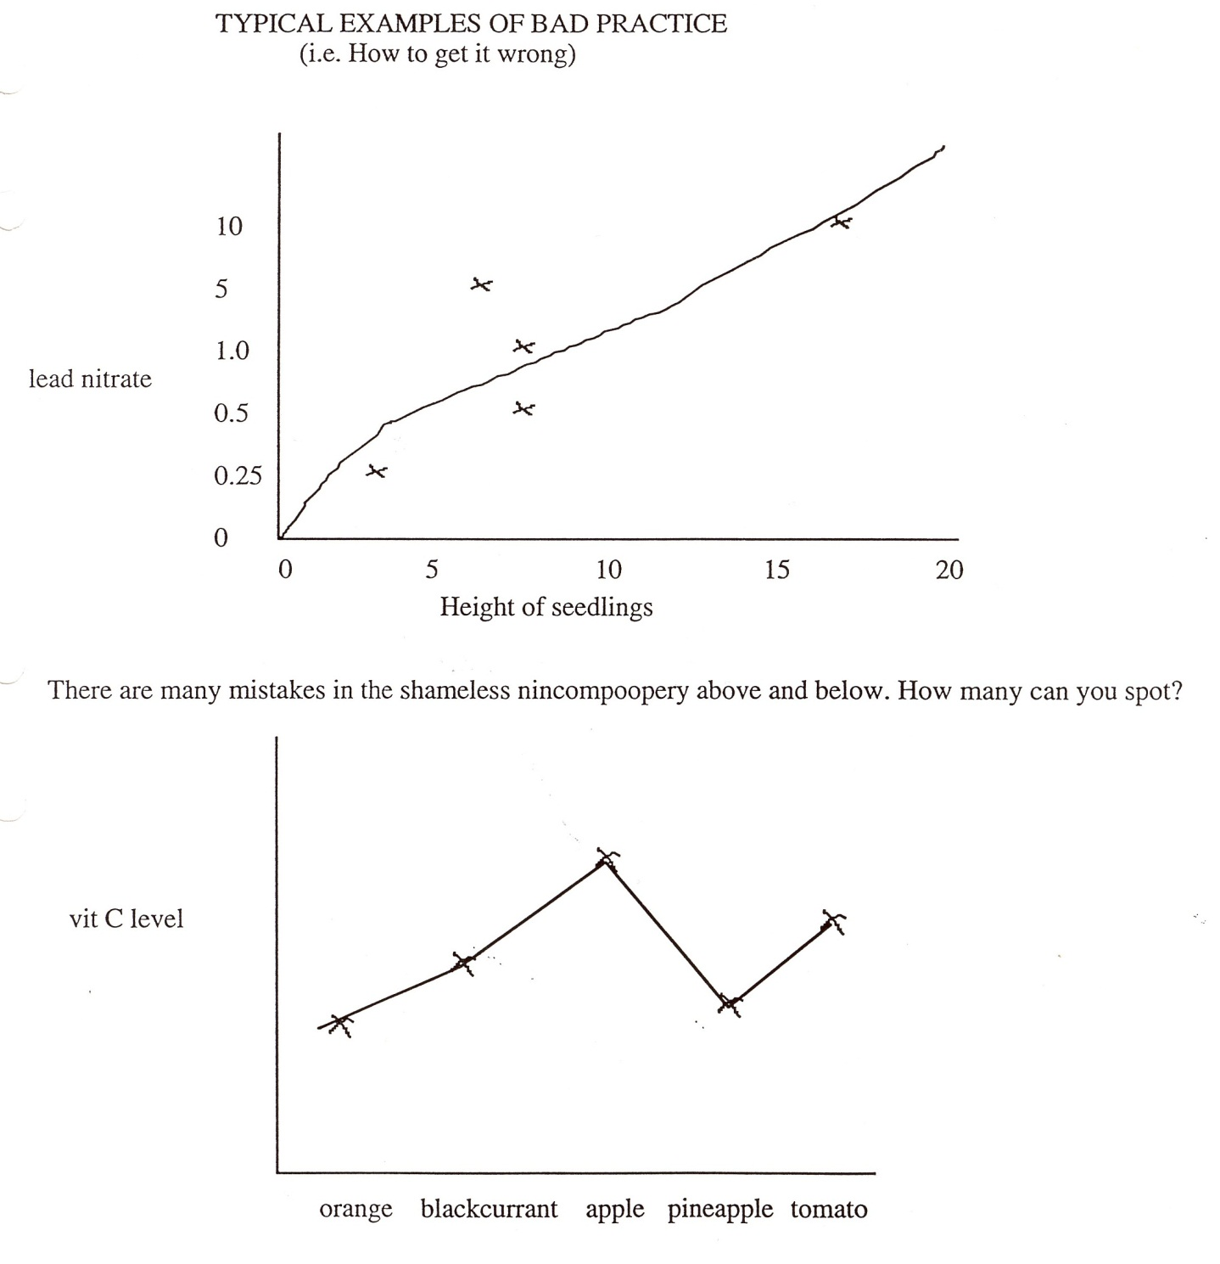

How many mistakes in the graph below can you spot?