The 1H NMR spectrum of ibuprofen, an over the counter mild analgesic. The structure of ibuprofen is given in Section 37 of the data booklet.

[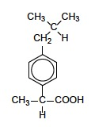](http://www.youtube.com/watch?v=FtkV7sZGses&feature=player_embedded)

ibuprofen

How many signals would be expected? what is the integration trace ratio for each signal? Predict the splitting pattern they would expect for each signal.

If we ignore the four hydrogen atoms attached to the aromatic ring (which will give signals in the 7 ppm region) then we should be able to predict that the 1H NMR should show six separate signals with integration trace areas of 6, 2, 1, 3,1 and 1.

The actual spectrum looks like this:

[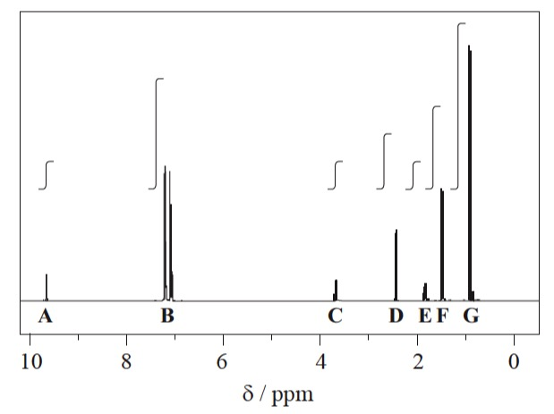](http://www.youtube.com/watch?v=FtkV7sZGses&feature=player_embedded)

1H NMR spectrum of ibuprofen

The signals at **B** (integration ration of 4) are due to the aromatic hydrogen atoms. The remaining six peaks are labelled **A**, **C**, **D**, **E**, **F** and **G** and it can be seen that the integration traces give the expected ratios of 1, 1, 2, 1, 3, and 6.

The next diagram shows the splitting patterns that can be seen when the signals are expanded.

[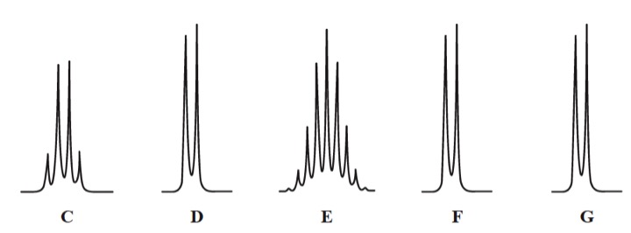](http://www.youtube.com/watch?v=FtkV7sZGses&feature=player_embedded)

From this it is easy to assign each signal to particular hydrogen atoms.

[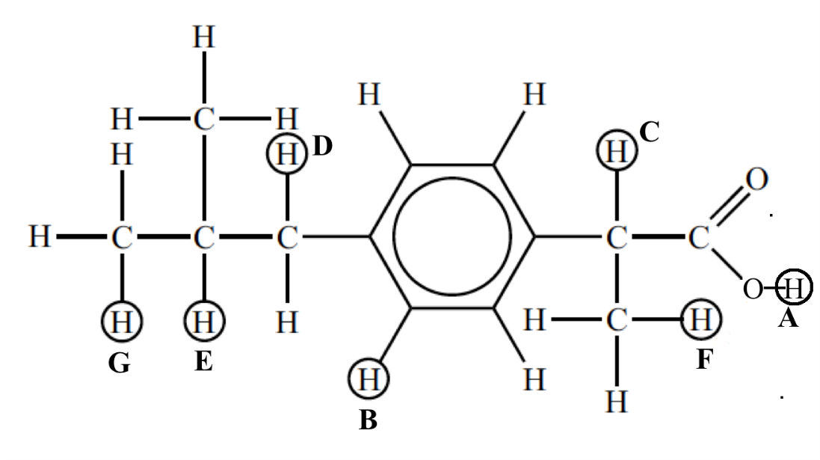](http://www.youtube.com/watch?v=FtkV7sZGses&feature=player_embedded)