Hess’s Law (Taken from InThinking Chemistry, Neuss 2020)

The enthalpy change for the dimerization of two mol of nitrogen dioxide to form one mol of dinitrogen tetroxide is – 57 kJ.

2NO2(g) → N2O4(g)  ∆*H*https://www.thinkib.net/img/icons/underground.png = – 57 kJ

The enthalpy change for the formation of one mol of NO2(g) from its elements is + 33 kJ

½ N2(g) + O2(g) → NO2(g) ∆*H*https://www.thinkib.net/img/icons/underground.png = + 33 kJ

What is the enthalpy change for the formation of one mol of dinitrogen tetroxide from its elements?

N2(g) + 2O2(g) → N2O4(g)

**1. Solution using simultaneous equations.**

To get N2 on the left hand side start with the second equation and double it:

N2(g) + 2O2(g) → 2NO2(g) ∆*H*https://www.thinkib.net/img/icons/underground.png = + 66  kJ

To get rid of 2NO2 and to get N2O4 on the right hand side add the first equation:

N2(g) + 2O2(g) → N2O4(g) ∆*H*https://www.thinkib.net/img/icons/underground.png = + 66 + (– 57) = + 9 kJ

Easy - but it does not really involve any chemistry.

**2. Solution using an enthalpy diagram.**

The problem is that you need to put the reactants and products in the correct places on the diagram.

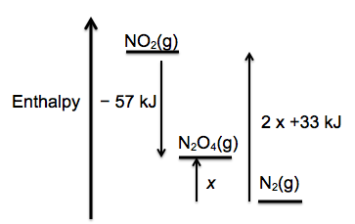

Personally I do not find it very obvious from the information given even though there is no need to include the oxygen (as you do not know the answer beforehand) and students certainly do not find this easy.  
Once the diagram has been drawn correctly it is easy to see that *x* is positive and is the difference in value between 66 and 57 kJ.

**3. Solution using an energy cycle.**

Use the idea of **A** going directly to **B** or via **C**. In this case **A** is N2, **B** is N2O4 and **C** is NO2.  
In chemistry terms nitrogen can either be oxidized directly to N2O4 or first to NO2 which then dimerizes  
to N2O4. (Again there is no need to include the oxygen in the cycle.)

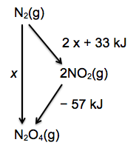

From the diagram (i.e. applying Hess’s Law) it is easy to see that *x* = (2 x 33) + (– 57) = + 9 kJ

All three methods are correct but I think the energy cycle method is the easiest, the most elegant and demonstrates the best understanding of chemistry.