BBC News, February 2, 2022
Why teenagers aren't what they used to be


By Richard Fisher
2nd February 2022
There's childhood, adulthood, and the messy bit in between. Here's how we've defined adolescence throughout history - and why it's time for a new category.
Y
You know the trouble with young people these days? The younkers think they're better than the rest of us, the ephebes are growing up too fast, and the backfisch? Well, they are far too precocious.
If you don’t recognise these words, you wouldn't be alone. They are all old terms for adolescents that have fallen out of common usage.
A younker was a word used pre-1900 stemming from the Dutch and German terms for a young nobleman – a little lord – and was also used to describe a junior sailor. An ephebe was a young Athenian in Ancient Greece, aged 18 to 19, who was training to be a full citizen. And a backfisch – literally "baked fish" – is a German word that popped up in coming-of-age novels published around the turn of the 20th Century. It described a giddy, spontaneous, adventurous girl who had an adult's independence paired with a child's reckless approach to risk.
Across history, the words and categories we use to describe young people have evolved significantly, driven by transformations in culture, work, education and scientific insight. How have these factors shaped the terms we use for adolescents today – like "teenager"? And as societal norms shift and new discoveries are made, how might our categories for the young change again in the future?
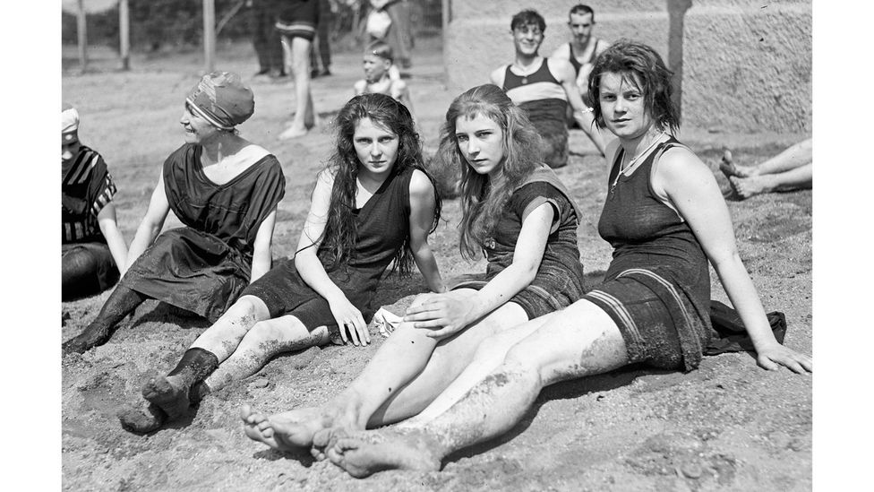
Teenagers were more rebellious in the past, studies show (Credit: Getty Images)
One of the most culturally significant inventions of the past century was the teenager. It's difficult to imagine that we ever existed without our adolescent years as we experience them now, but if you could time-travel back a few centuries, people would find the modern idea of the teenager to be something of an alien concept.
Back in the 1500s, for example, most Western adolescents would have been workers, recruited into the world of adult labour from as early as seven years old, according to the historian of childhood Hugh Cunningham of the University of Kent.
In rural economies, this may have involved farm work to support the family's agricultural income, but as industrialisation spread in the 18th and 19th Centuries, many teens became factory workers, grafting alongside their adult peers. In the late 1800s, writes Cunningham, children in the US were contributing around a third of family income by the time their father was in his 50s. There was no universal schooling, and only the wealthiest could tap into a "bank of mum and dad" to provide food and shelter.
As developed-world living standards and education policies began to change in the early 20th Century, however, young people were increasingly able to live fully under the wings of their parents or guardians for longer, supported financially and emotionally. But even then, the invention of the modern teenager wouldn't happen immediately.
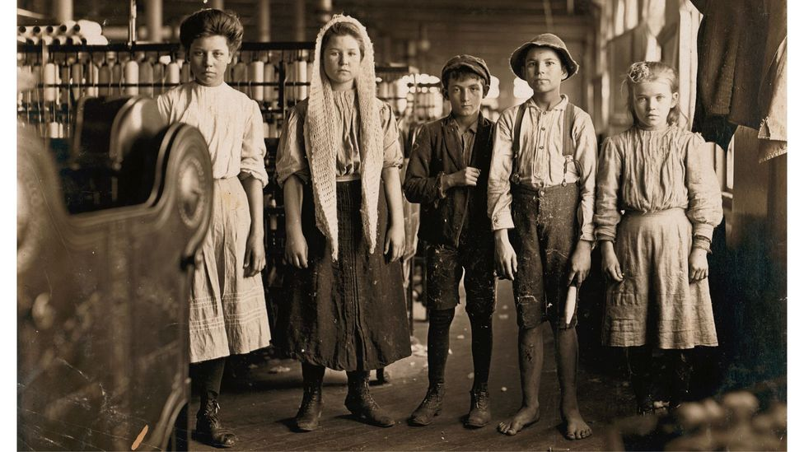
The place of young people in society has changed hugely, driven by shifts in culture, work, education, and scientific insight. (Credit: Getty Images)
Before World War Two, the term teenager (or teen-ager) had occasionally been used, but it was only in the late 1940s and 1950s that it became more common. Around this time, a number of different forces converged to make that happen.
In rich countries, it became much more likely for a young person to stay in school for their teenage years. In the late 1940s, schooling in the UK was made compulsory up to the age of 15. And in the US, high school graduation rates grew from less than 10% at the start of the century to around 60% by the mid-1950s.
Post-World War Two, historians also note that social attitudes towards the rights of young people shifted in many Western nations: the sense that young people had a duty to serve their parents weakened, and their own wishes and values began to be listened to more.
And one sector of society that was listening to these needs the most? Commerce. In the 1950s, companies realised that teenagers could also be influencers. They were capable of setting trends and spreading fashions, and therefore could be marketed to for great profit. As a writer for the New Yorker noted in 1958: "To some extent, the teenage market – and, in fact, the very notion of the teenager – has been created by the businessmen who exploit it."
Back then it was all about capitalising on rebellion, hot-rods and rock n' roll. Today it's TikTok and… well, I wouldn't know, since I'm 41 years old. But the point is that the perception of teenagers as cool, trend-setting and influential was – and still is – just as much a creation of commerce and media as a reflection of reality. Teenage music, fashion and language ripples across the rest of society, supercharged by industries established to profit from them.

In the 1950s, teenagers emerged as trendsetters in fashion, music, film and dance (Credit: Getty Images)
Around the 1950s, you can also find anecdotal evidence that cultural perceptions of teenagers as painfully adolescent were becoming more widely known, with complaints about the trials of parenting pubescent children. In 1955, for example, a woman called Mrs G wrote to Mary Brown, an agony aunt for the UK Daily Mirror newspaper, complaining about her son: "He's cheeky and he's sulky… why should a boy change like this?" she wrote. "He resents any questions. The best I get is a polite yes or no, the worst an angry look which clearly tells me to mind my own business."
All this means that the teenager as we know it was very much a 20th-Century invention. The question is, will these cultural perceptions shift again in the future?

A 17-18-year-old in the US is now less likely have tried alcohol, have had sex, or acquired their driver's licence, than teens 20 years ago - Jean Twenge
Over the past decade or two, there have been some intriguing changes in the attributes of the teenager. The psychologist Jean Twenge of San Diego State University notes that teens are growing up more slowly by many measures, compared with their 20th-Century counterparts. A typical 17-18-year-old in the US, for example, is now less likely have tried alcohol, have had sex, or acquired their driver's licence, compared with similarly-aged teens only 20 years ago. A 13-14-year-old is less likely to have a job or to have gone on dates. Meanwhile other measures of early adulthood, such as teenage pregnancy, have reached historic lows in the US and Europe.
Twenge points to a number of reasons why growing up is slowing down. There's little doubt that technology and the internet has played a major role, meaning more interaction with peers happens online and in the home, where sex, experimentation and trouble are perhaps less likely. For this reason, she calls this latest crop of young people the "iGen" generation, and has written a book all about their characteristics. But she also points out that some of these trends were already beginning before the online culture of the 21st Century, and so the internet can't be totally blamed.
Her hypothesis is that teens behave differently depending on how hostile and unforgiving their local environment feels to them, an idea that social scientists called "life history theory". In tougher times in history, teens were forced to take a "fast life strategy", growing up faster, reproducing earlier and focusing on basic needs. Now life in the West is generally more forgiving, and families are wealthier – at least on average – so it's possible for teens to take a "slow life strategy", delaying the transition to more adult behaviours.
"At times and places where people live longer, healthcare is better, and education takes longer to finish, people usually make the choice to have fewer children and nurture them more carefully," Twenge explains.
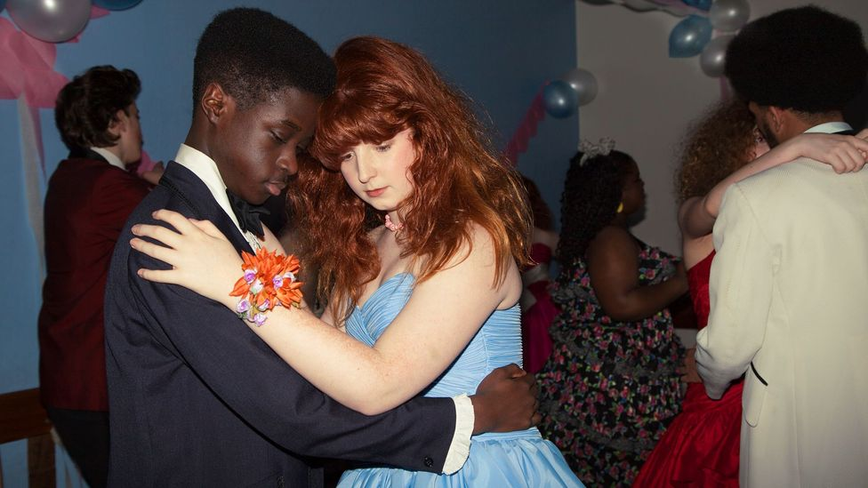
Entire cultural traditions have evolved around the passage from childhood to adulthood, such as prom night (Credit: Getty Images)
There may also be a greater emphasis on safety among this latest teenage generation, Twenge suggests, both physically and emotionally, which encourages young people and their parents or guardians to keep them insulated from the harshness of the adult world for longer.
So, what will this mean for our ideas about teenagers if these trends continue? It might suggest that the 20th-Century notion of a teenage rebel-without-a-cause is becoming outdated. Whereas many teenagers in the 1950s and 1960s were driving their own cars, getting into trouble, and experimenting with drink and drugs, their similarly-aged counterparts today are often far more clean-living and safety-conscious. If there is reckless behaviour and an urge for independence, it's coming later.

By many measures, adolescence now continues until around the age of 24 to 25
A slower path to adulthood is not the only way that cultural perceptions of youth may need updating. In recent years, science has also shown that adolescence doesn't finish at the end of the teenage years. By 20 years old, a young person is usually considered an adult: their body size is fully grown, they can vote, get married, and many have already entered the workplace. But the evidence suggests that, by many important measures, adolescence continues until around the age of 24 to 25.
At the end of the teens, puberty may have finished but the development and maturation of the brain is far from complete. Brain imaging shows that white matter, for instance, continues to increase into the mid-20s, coupled with a rise in cortical complexity. Some researchers now also see these years as an important developmental social stage too, where young people are still learning about intimacy, friendship, family, self-expression, and political and social awareness, and so deserve more support and protection than they currently receive from society.
Could there therefore be a case that these older adolescents should become more clearly recognised as a distinct demographic group? Should we allow them to delay their entry into the fully adult world of life and work? It might seem like coddling to some, but then again, our ancestors might have said the same about how we treat teenagers.
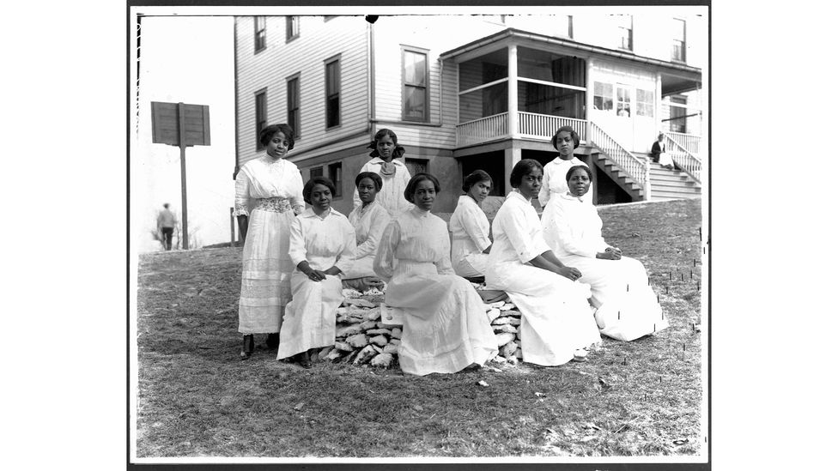
In tougher times in history, teenagers had to grow up quickly and behave like older adults. When life is more forgiving, they tend to take more time (Credit: Getty Images)
Signs of this cultural change may be happening already. The "boomerang" phenomenon describes recent rises in the number of young adults returning to the nest to live with their parents after higher education, or because they can't afford their own property or rent. (Some never move out in the first place.) In the UK, around 3.5 million single young adults now live with their parents, which is a third more than a decade ago, according to research led by Katherine Hill of Loughborough University in 2020. Wealth imbalances between older generations and today's young people have only strengthened this trend.

It's possible that cultural changes brought by longer lifespans will soon begin to play a role too. As parents work for longer, they may be in a stronger financial position to support their older children, as opposed to retiring. But that's not all. Lynda Gratton and Andrew J Scott of London Business School propose that greater longevity will also soon begin to make the "three-stage" life of school, work and retirement feel outdated. And this, they argue in their book The 100-Year Life, may bring particularly big changes for cultural expectations of young people in their early 20s.
"One difference we should consider is the assumption that in our 20s we are meant to go immediately from schooling to a career. In the 100-year life we should consider taking a period of our 20s and dedicating to a new stage, exploration," write Gratton and Scott. "Your decisions early in life impact the entirety of the rest of it… so it is rather absurd that we expect people in their late teens and early 20s to make decisions like what direction they want their lives to take. Instead they should have a period of exploring the world and trying different paths."
What's curious is that this specific period of life, post-teen, doesn't have a commonly known name to describe it, at least in English. Perhaps it should. After all, pre-teens have their own moniker as "tweens". Some researchers have labelled the period pre-25 as "prolonged adolescence", but perhaps another name could be adolthood – spanning the teenage and adult worlds.
And if the idea of adolts doesn't catch on, someone can surely find a better name: after all, from ephebes to younkers to backfisch, we have been coining new categories for young people for most of history.
*Richard Fisher is a senior journalist for BBC Future and tweets @rifish

