Teht. 3

3. b)

Teht. 4

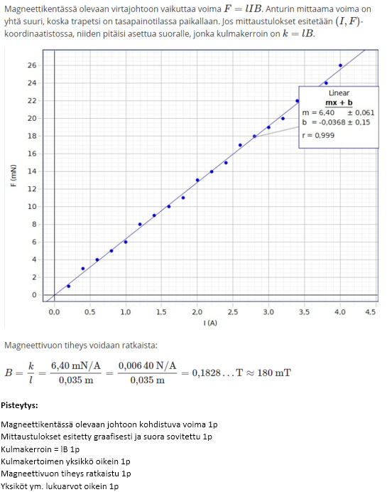

4. b)

4. c)

Teht. 5

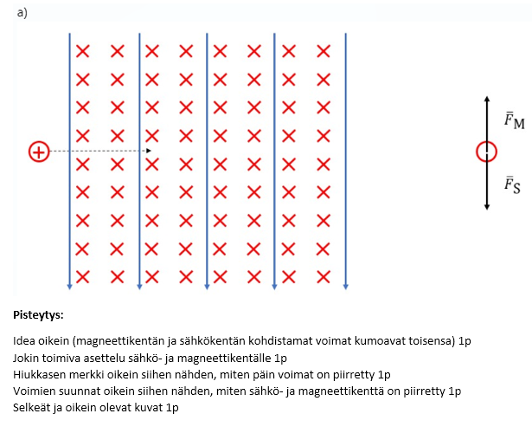

Teht. 6

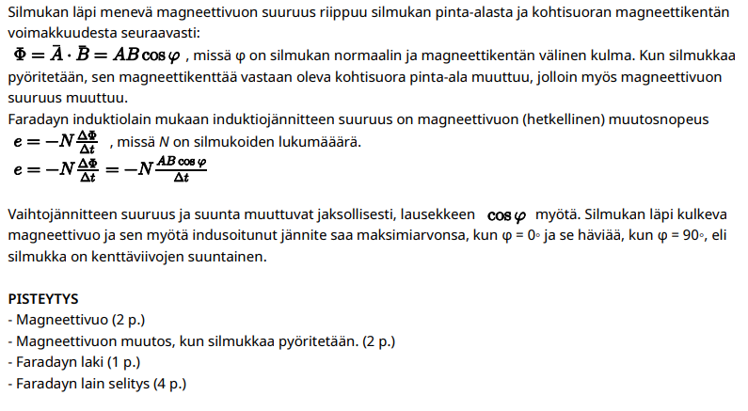

6.2

Tässä oikea huippuarvo on 311 V.

6.3



6.4

Teht. 7

a)

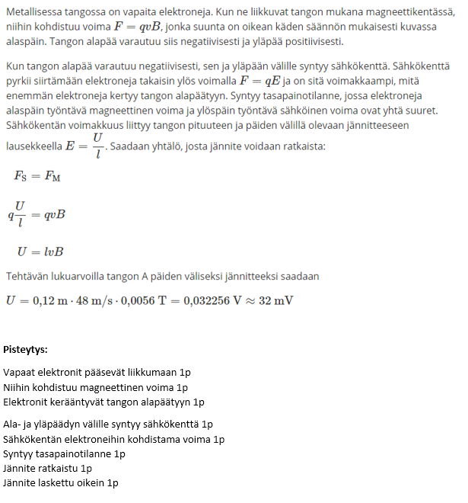

b)

c)

d)

e)

