CGI-VESA Information

Early childhood education time

1. 11.2023

Loviisan kaupunki - Lovisa stad

Loviisa

Sisällys

Early childhood education time 2

How to schedule attendance 3

Unit: 3

Children: 3

Days: 3

How to schedule absences 4

Days 4

How to edit scheduled attendances or absences 5

How to remove an attendance or an absence 6

# Early childhood education time

On the page Family, you can **apply for early childhood care**. Select Topics.

Here, you will find the attendance plan and the related calendar. The calendar is used for information about when the child will be attending and when the child will be absent.

A v next to the date means that there is a plan for at least one child (the child will be attending or the child will be absent on the day in question).

By selecting a specific day in the calendar, information about the scheduled time or announced absences is displayed next to the calendar. If there is no information about the child, the following text will appear: *No Plan.*

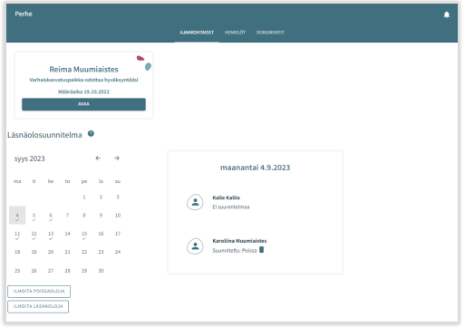

By clicking the trash icon, you can remove a plan (attendance/absence), one by one, if your access to the days in question has not been blocked.

By clicking *add presence* and *add absence,* you can proceed to schedule time or announce absences.

## How to schedule attendance

When you cklick *add absence*, a new window opens. The window contains:

* Information about the unit/units where a decision on the child/children is valid or shall become valid in the future.
* Name of the child for whom there is a valid decision or a decision that shall become valid in the future
* Current month in the calendar view
* It is possible to browse backwards and forwards in the calendar
* When the need for early childhood care is uniformly repeated during the same month, you can select all the days and the time periods during which when the child needs child care

Unit:

* Information about the unit/units for which there is a valid decision on the caregiver's child/children
* Select the unit by clicking the name. Submit the information unit by unit.

Children:

* Click the name to select the child for whom you are scheduling time in child care. You can schedule time for each child individually or for all of the children at the same time, if all of the children will be attending child care during the same time period.

Days:

* Select the days one by one by clicking on the ones for which you want to schedule time. You can schedule time for the same month. You have to make a separate reservation for the next month.
* Announce when the child is coming in and when the child is leaving, either by entering the time or by clicking the clock icon.
* By clicking ‘OK’, the time in question is selected and appears in the field that displays the time at which the child is coming in and the time at which the child is leaving. By clicking *cancel*, you can go back.
* You can not report attendences outside of opening hours, you will get a notification abouth this when you save the information.
* By clicking the *Add time window* button, you can schedule several time periods for the same day, as long as they don’t overlap.
* After you have entered the time periods, save the information by clicking *Save.*

## How to schedule absences

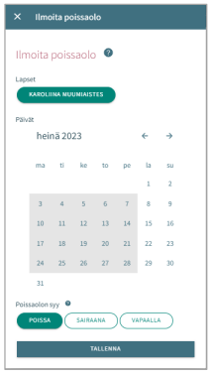 Children:

* Here, you find the names of the children for whom there is a valid decision on child care, or a decision that shall become valid in the future.
* Select the child/children by clicking the name.
* You can schedule absences for more than one child if the scheduled absences are the same for every child in question.

Days:

* Select the days one by one by clicking on the ones for which you want to schedule schedule.
* You can schedule absences for the same month. You have to make a separate reservation for the next month.
* Select the reason for the absence. The same selected reason is transferred to all of the days selected.
* Lastly, save the information by clicking *Save*.

## How to edit scheduled attendances or absences

You can replace/edit scheduled attendances or absences by adding an overlapping attendance or absence for the day in question.

If the attendance or absence that you are about to schedule overlaps an existing attendance or absense, the program will notify you about this:

* by clicking *cancel*, you can edit the information before you accept the changes made
* by clicking *OK*, the former attendance or absence will be replaced by the new attendance or absence

Days that already have been locked cannot be edited

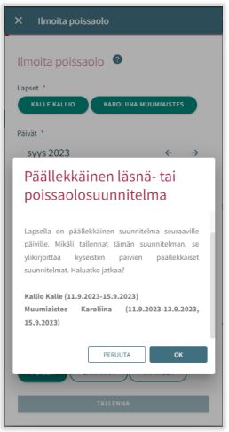

## How to remove an attendance or an absence

You can remove a scheduled attendance or absence by selecting the day in question and then clicking the trash icon next to the scheduled attendance or absence

The program will ask you to confirm that you want to remove the attendance or absence. If you click *cancel*, the scheduled attendance or absence will not be removed. By clicking *Poista*, the scheduled attendance or absence will be removed and replaced by the text *no plan.*

Days that already have been locked cannot be edited

