CGI-VESA INFO
How to login to ECEC service
1. NOVEMBER 2023
Loviisan kaupunki - Lovisa stad
Loviisa

Content
How to login to CGI Vesa 2
The first time you login, and terms and conditions of use of the service, and the use of cookies 3

How to login to CGI Vesa
Proceed to login by clicking the link on the website of the City of Loviisa, or by navigating to the login page on the website of CGI Vesa, https://loviisa.cgivesa.fi
When you arrive to the website via the link, the user interface language (Finnish, Swedish, English) is selected based on the link you used. Next, your identity must be verified through strong authentication (suomi.fi). After you have verified your identity, you can log in to CGI Vesa.
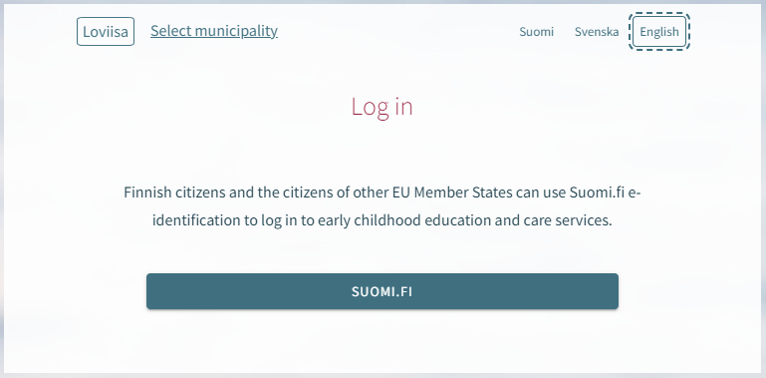
Click ‘Log in’ on the homepage.
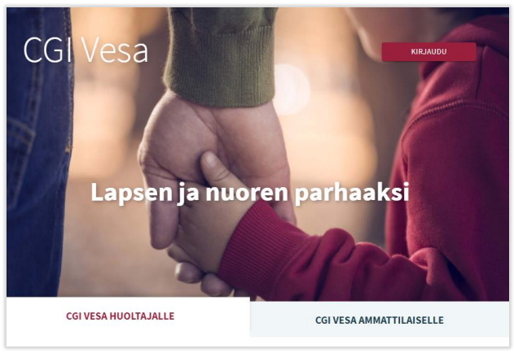
When you login to CGI Vesa for the first time, you are required to select your municipality of residence. The selected municipality of residence remains in the temporary data on the browser or mobile. If you delete the temporary files, the program will ask you to select your municipality of residence once again.

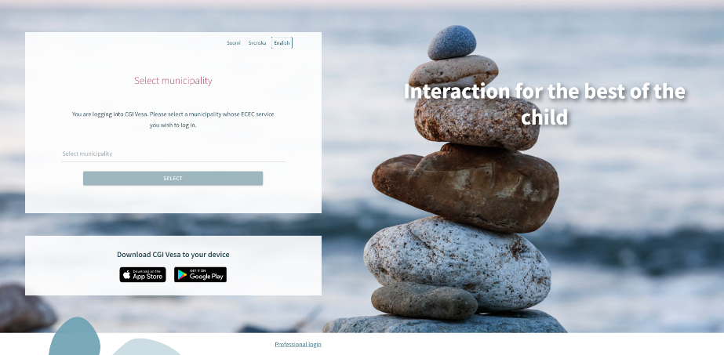
Next, you must select ‘Suomi.fi’. You are required to verify your identity through strong authentication. After you have verified your identity, you can log in to CGI Vesa.
You can verify your identity with your citizen certificate, mobile certificate or banking credentials.
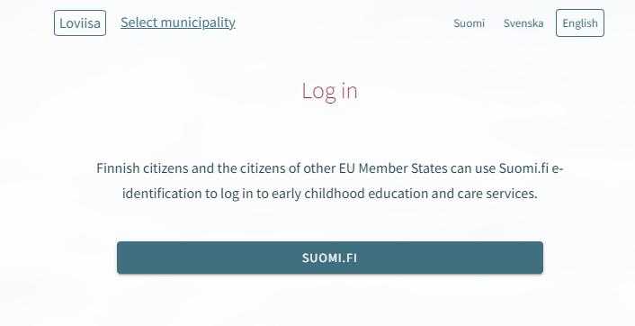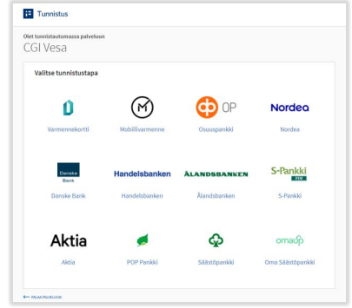

The first time you login, and terms and conditions of use of the service, and the use of cookies
When you log in to CGI Vesa for the first time, you are required to accept the terms and conditions of use of the service and the use of cookies if you want to use CGI Vesa. If you do not accept the terms and conditions of use and click the Hylkää button, a new window opens. The new window informs you that you cannot use the service if you do not accept the the terms and conditions of use. Click “Hyväksy” to accept the terms and conditions of use, and the use of cookies.

