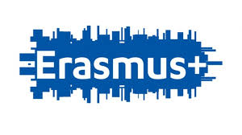
Erasmus + Logo contests

The task is to create logo for our project by using artificial intelligence image program (itc- tool). There will be 7 groups and in each group there will be 4 students. Every group make one picture/logo.
Choose 5 words out of the 15 words list. Those words what you can use, are listed below. EU is only mandatory (obligatory) word, so you have to have it. Your group can choose 4 word+EU.Use this tool https://www.craiyon.com/
- EU
- Europe
- skills
- people
- languages
- students
- co-operation
- school
- future
- internationality
- friendship
- well-being
- studing
- history
- culture
Our choices are
- EU

