The Asemanpelto School
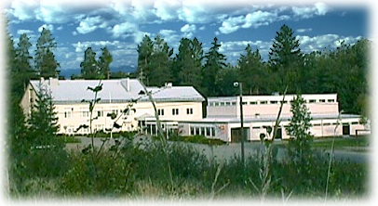
Asemanpelto Primary school is located in Lohja, Asemanpelto, in the middle of a pleasant suburban residential area 3 km from the city.
The three-storey school building offers space for six basic classrooms and room for handcraft. There is also a nurse’s clinic operating in the same building. Physical education (PE/sports) and handcraft (textile) have a separate building next to the main school. There are about 120 students at grades 1 to 6 in our school. We have 6 primary instruction groups.
There is a big schoolyard; area for playing and swinging, field for athletics, games and ice-skating during winter season. Our own school area offers possibilities to enjoy the outdoors activities. We also have a great opportunity to use forest located next to the school while studying science and sports.
Emphasis
We emphasize strong basic instruction in the mainstream primary school system. Our goals are set together with parents and school staff. The curriculum gives us the limits. The main goals during 2018-2019 are communality, team spirit, participating of the pupils, recognition of different emotions and reading skills.
The Mission Statement of our School
Our aim is to teach a child to achieve knowledge and skills needed in life by building a positive self-esteem and character. We raise our students for the future, so they can have better chances to face its challenges. We emphasize healthy self- esteem and good manners, following the school rules and tolerance. We encourage our students to build up self-motivation and responsibility. We are trying to let pupils work in peace and create a supporting atmosphere.
