Sunday 13.3
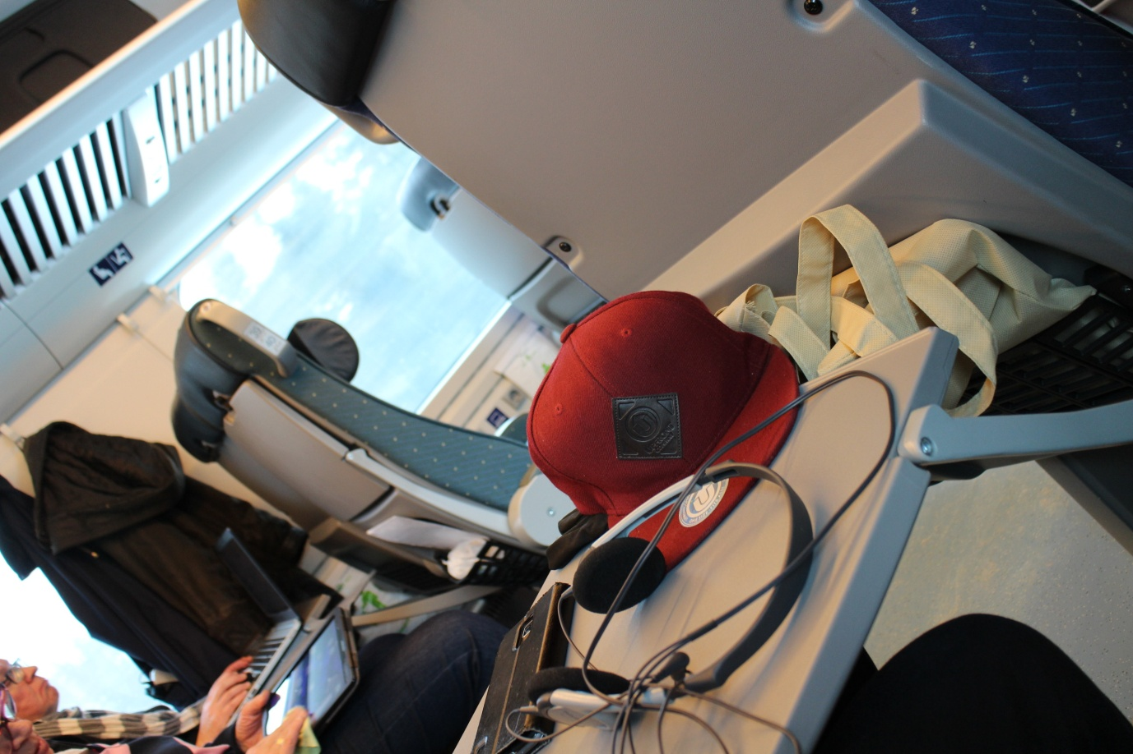
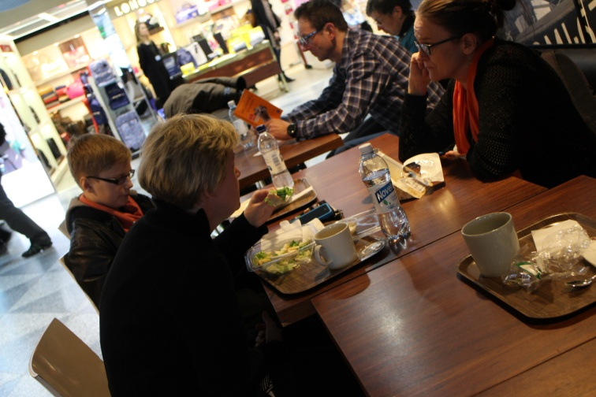
Sunday morning started with a meeting at the trainstation. We said bye bye to our parents. Otto, Noora, Minttu and Kukkis moved on to train and we waited for Mirja and Aila. Trip started train travel from Joensuu to Helsinki. Train left at 9.15. Then everything was okey and train change went well. The next stop was in Helsinki-Vantaa airport. After Check-in and security check we had lots of time weiting for flight to Rome. So in that case we ate. We made our phone calls. After eating Mirja and Aila went somewhere and we four went walk and to kill time. At least we were able to sit somewhere next to the wall and we just waited.
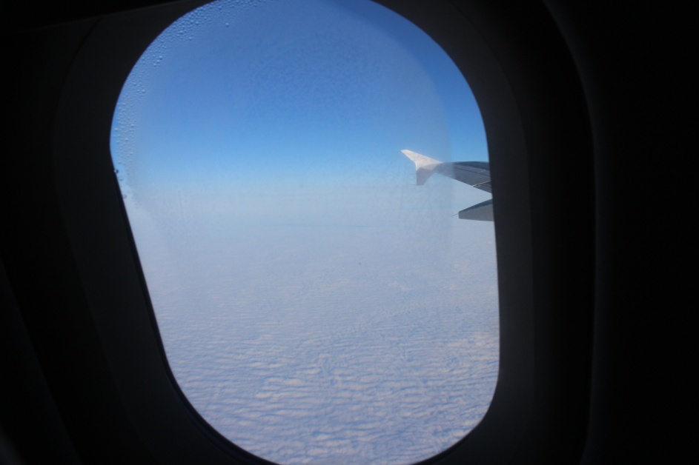
The flight went pretty good. Few of us had travel sickness.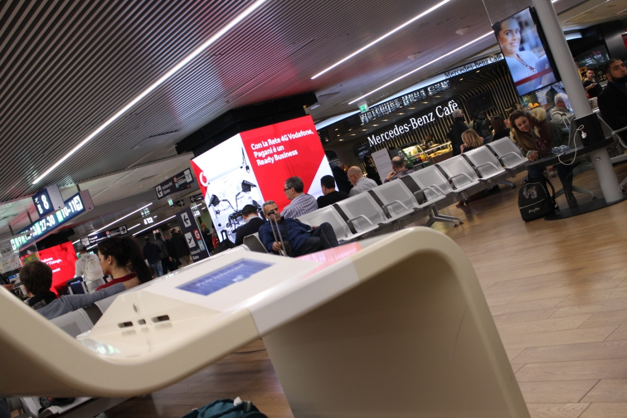
Finally we arriwed to Rome. Noora's ears were very sore. We ate and talked on airport. Connecting flight to Palermo from Rome leaft locationtime at 21.00 it is 22.00 in Finland. In Palermo we got our's luggages last. Everything was okey and our hosters were waiting us in Palermo airport. Everybody get to know each others and we just went our hostfamilies home.
Monday 14.3
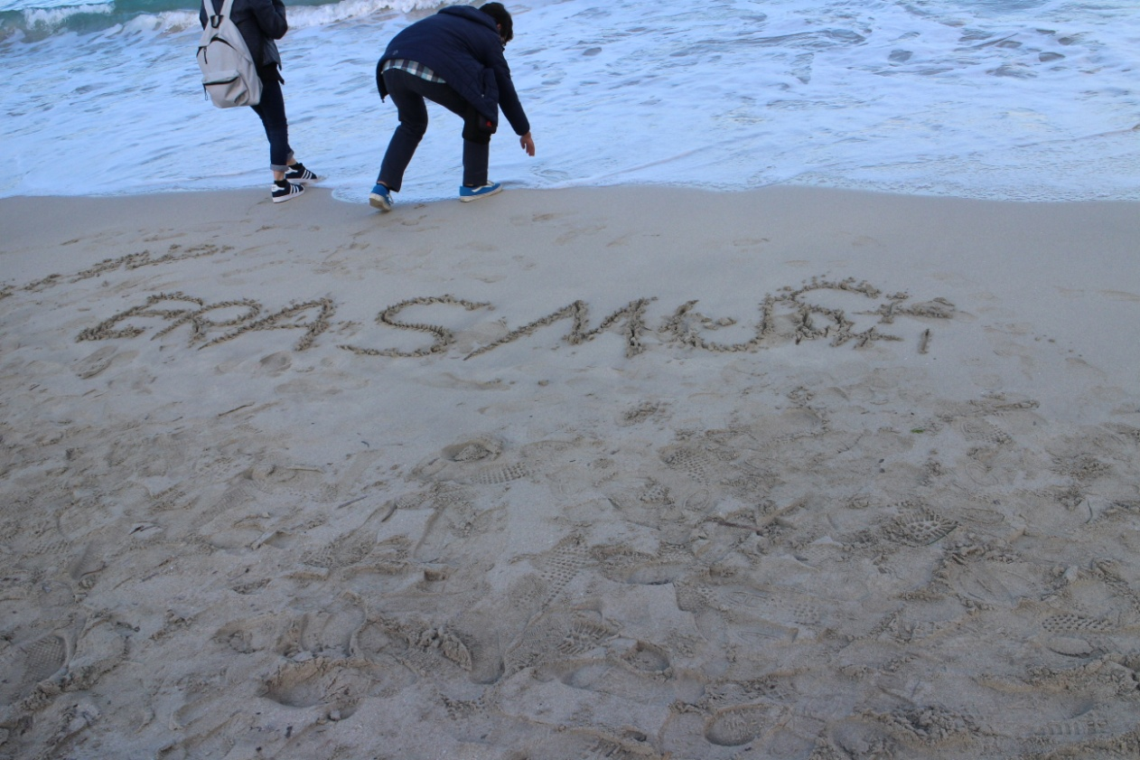
In Italy nobody ate breakfast so they just made breakfast for us. Then we went to school and meet other Erasmus+ peoples from Romania, Poland, German, Turkey, Firenze and Palermo. In the afternoon we went to Mondello beach. It was beautiful place. After that we ate icecream. Fransesco as a gentleman payd. We proved that is imposible payd back to italian peoples. Few of italians, Matteo, Fabio and Fransesco took Mirja, Aila, Otto, Noora, Kukkis and Minttu showed us " the most beautiful place in Mondello " pier on the Mondello village.
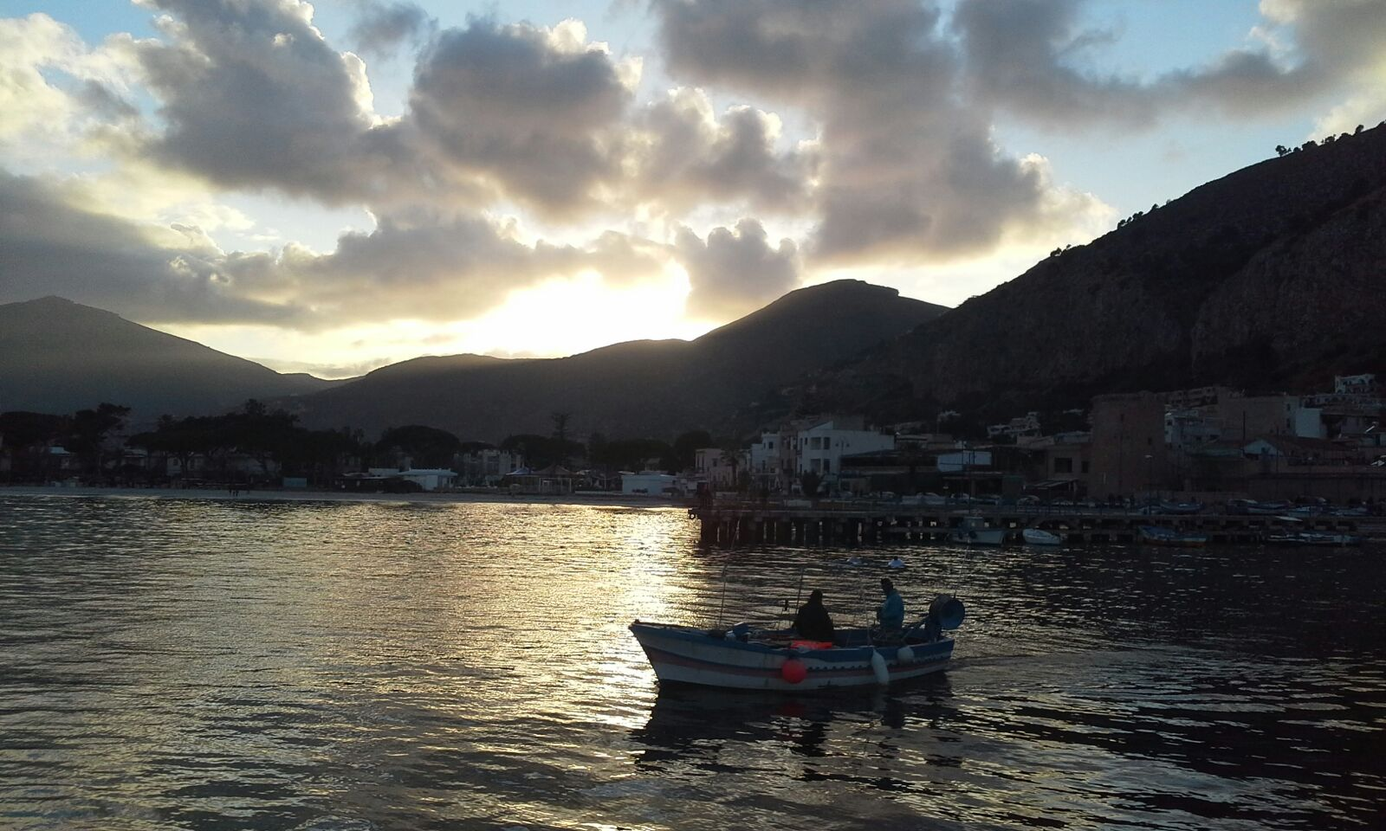
Tuesday 15.3
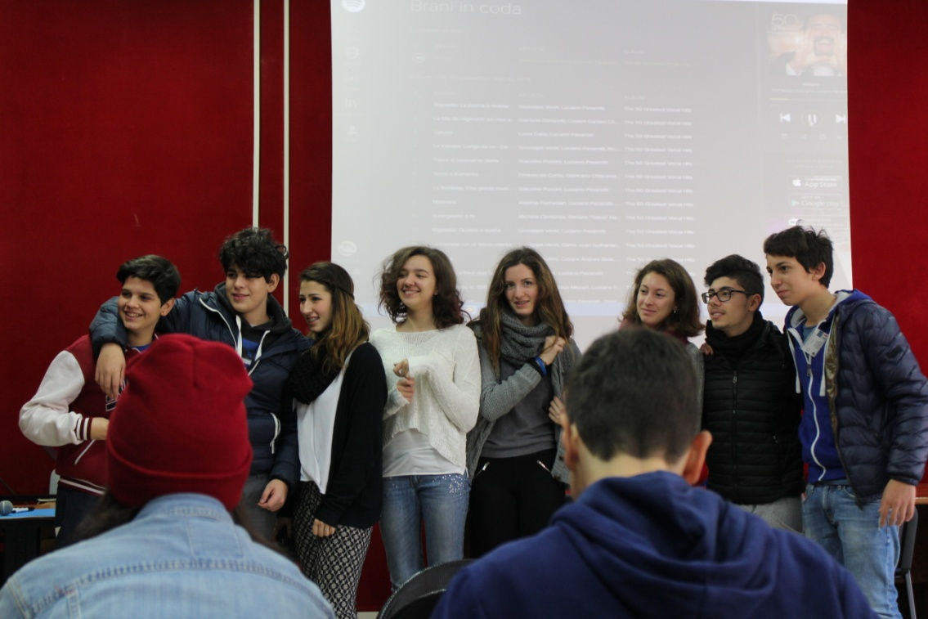
On tuesday we went to school on the morning. In school were only finnish students and Palermo students. Palermo students sing for us as pastime. It sounded good. Whole day went doing everything actve. In the afternoon we had city navigation. It was interesting navigate in strange city, on the middle of traffic, whit strange peoples. Fanny and interesting experiense.
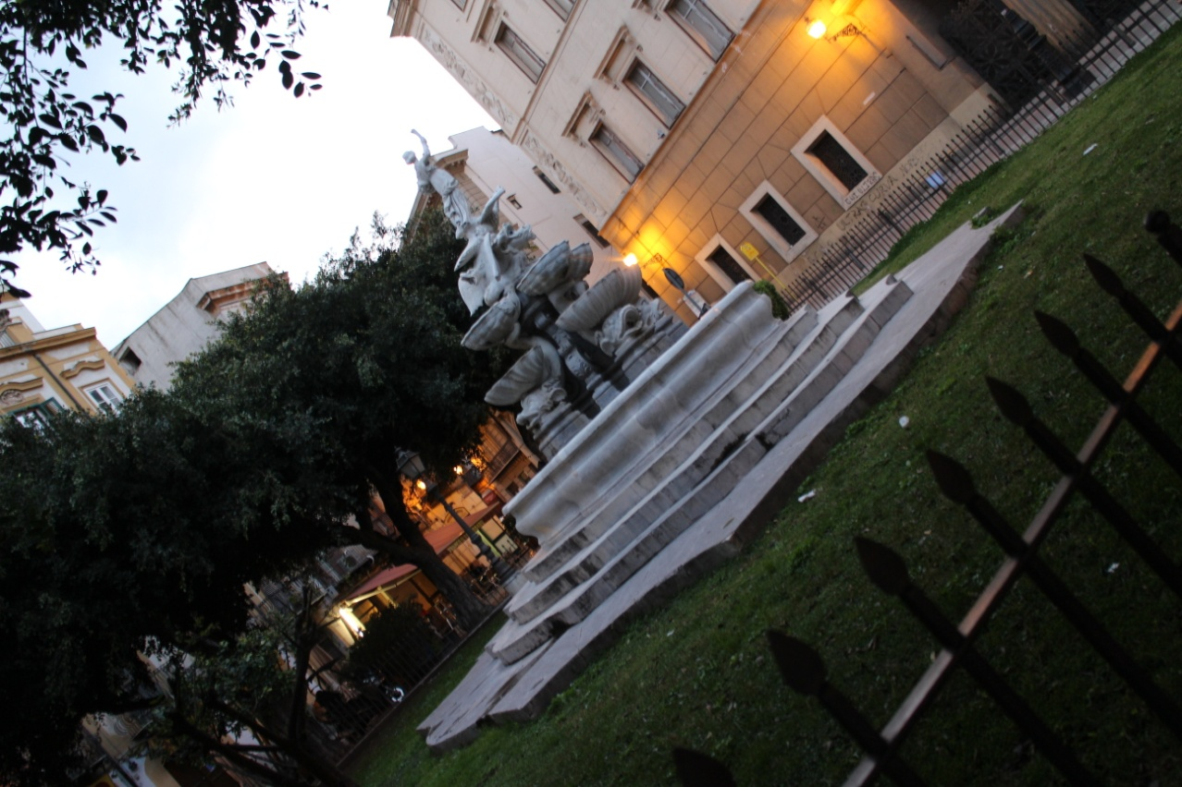
Wednesday 16.3
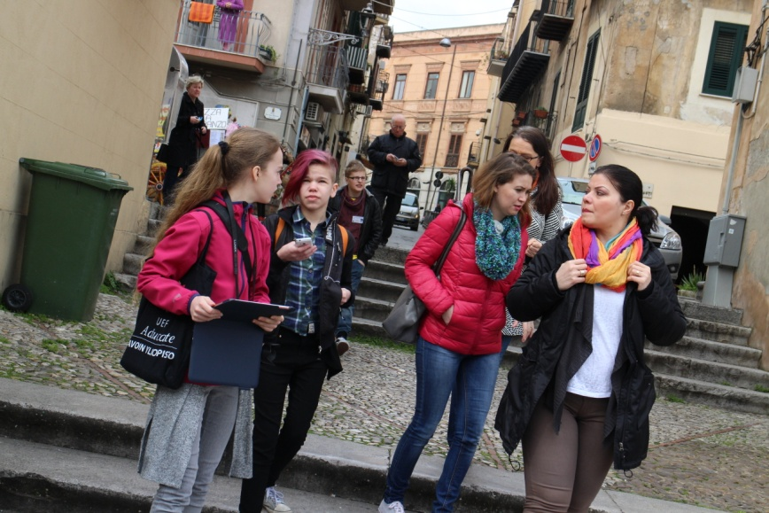
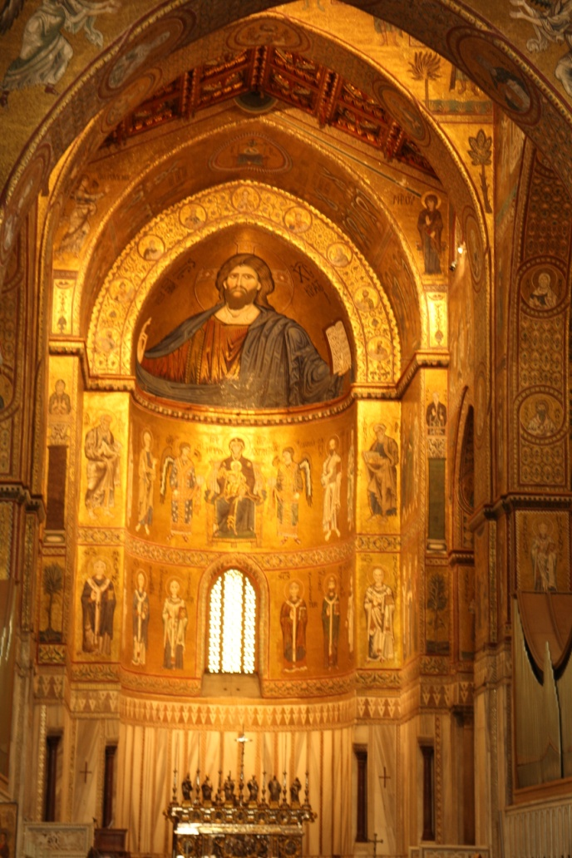
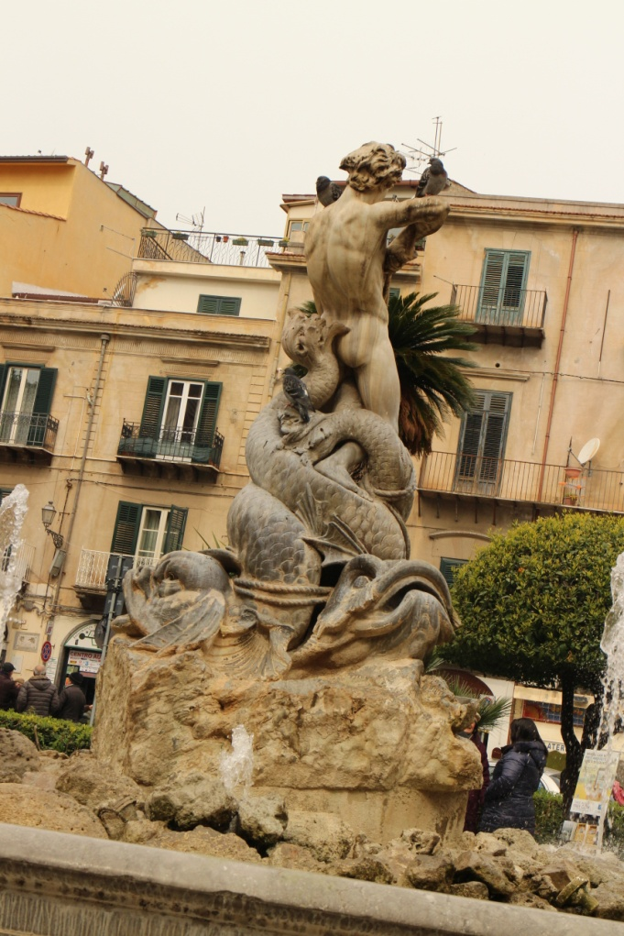
Wednesday went getting know Palermo. We can tell that better with pictures.
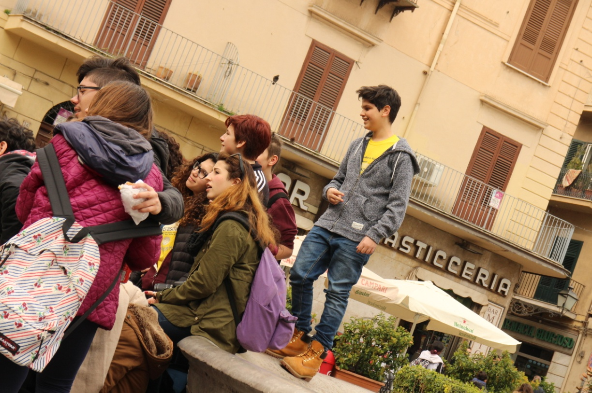
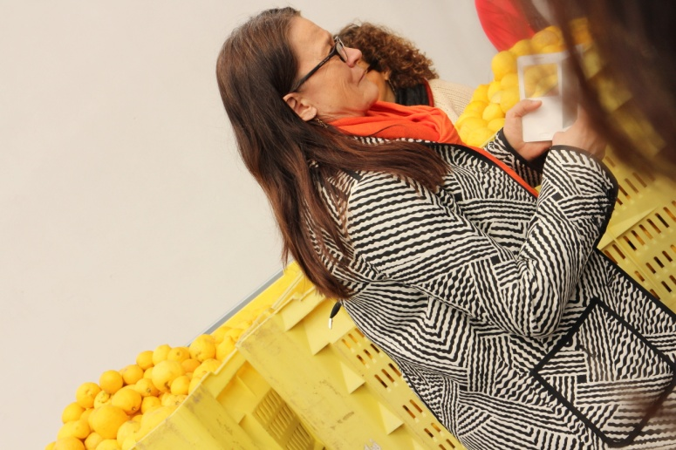
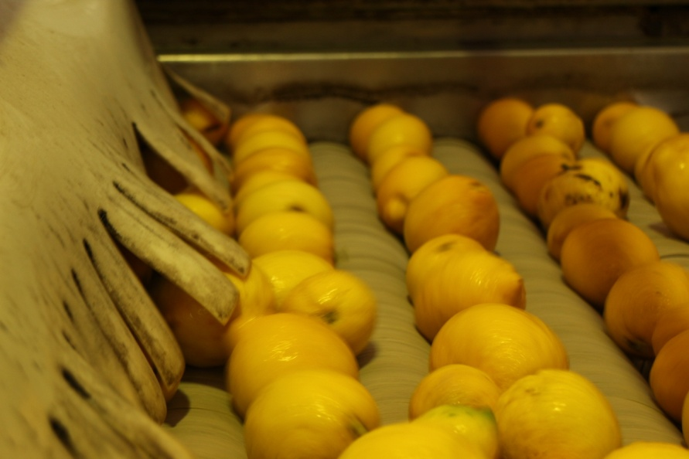
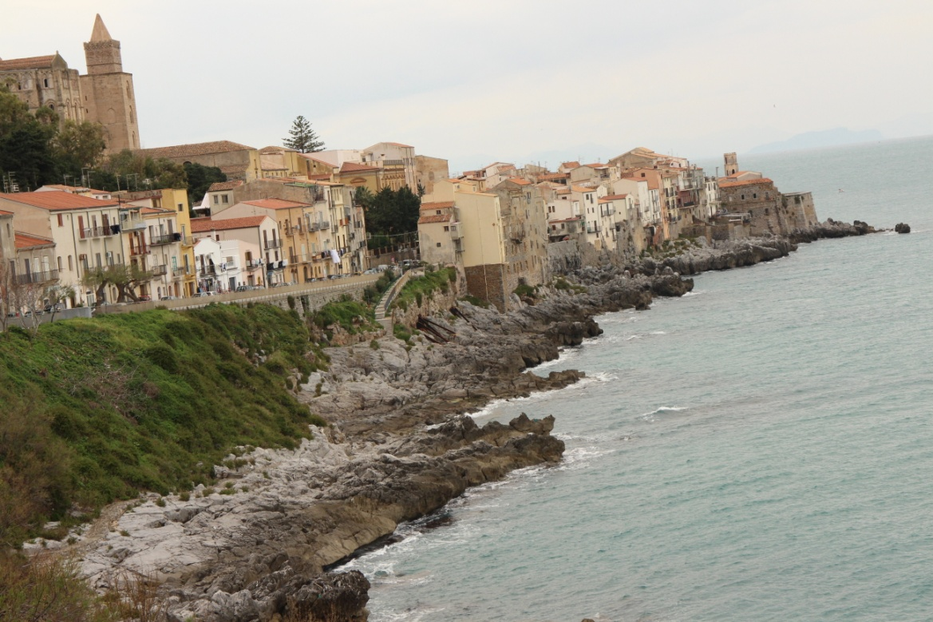

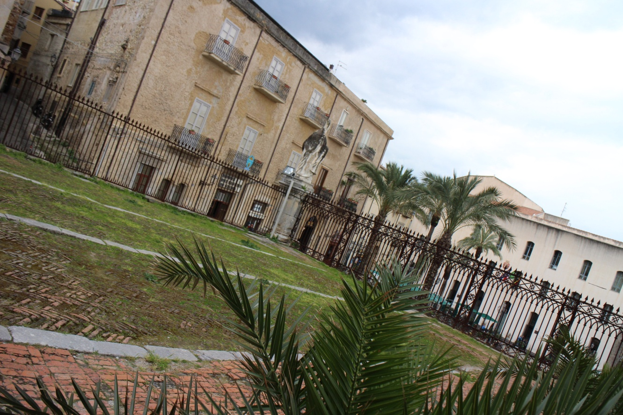
At the last place we; Kukkis, Otto, Noora and Minttu went to sit down to the bench. We laught to our own jockes and thinked: "What other peoples think about us?" We ate icecream and weited. On the wayback we talked with the others. We comparison witch language was most difficult

Thursday 17.3
Mission of the day: get to know German people.
We went to city with out hosts. German peoples were hoped that we culd get know them. In the first stop we went to shoping. We visited in few company. After that we went shoping gifts for our family, germans with us.
At the even all Erasmus peoples went to eat pizza. All Finns were very hungry and we had to wait very long time. And finally than we get our pizza, but it was mushroompizza. We ate it, but it was mushroompizza so it was so bad! Lucily we get an other pizza and it was very good. We all were tired and wanted just sleep.
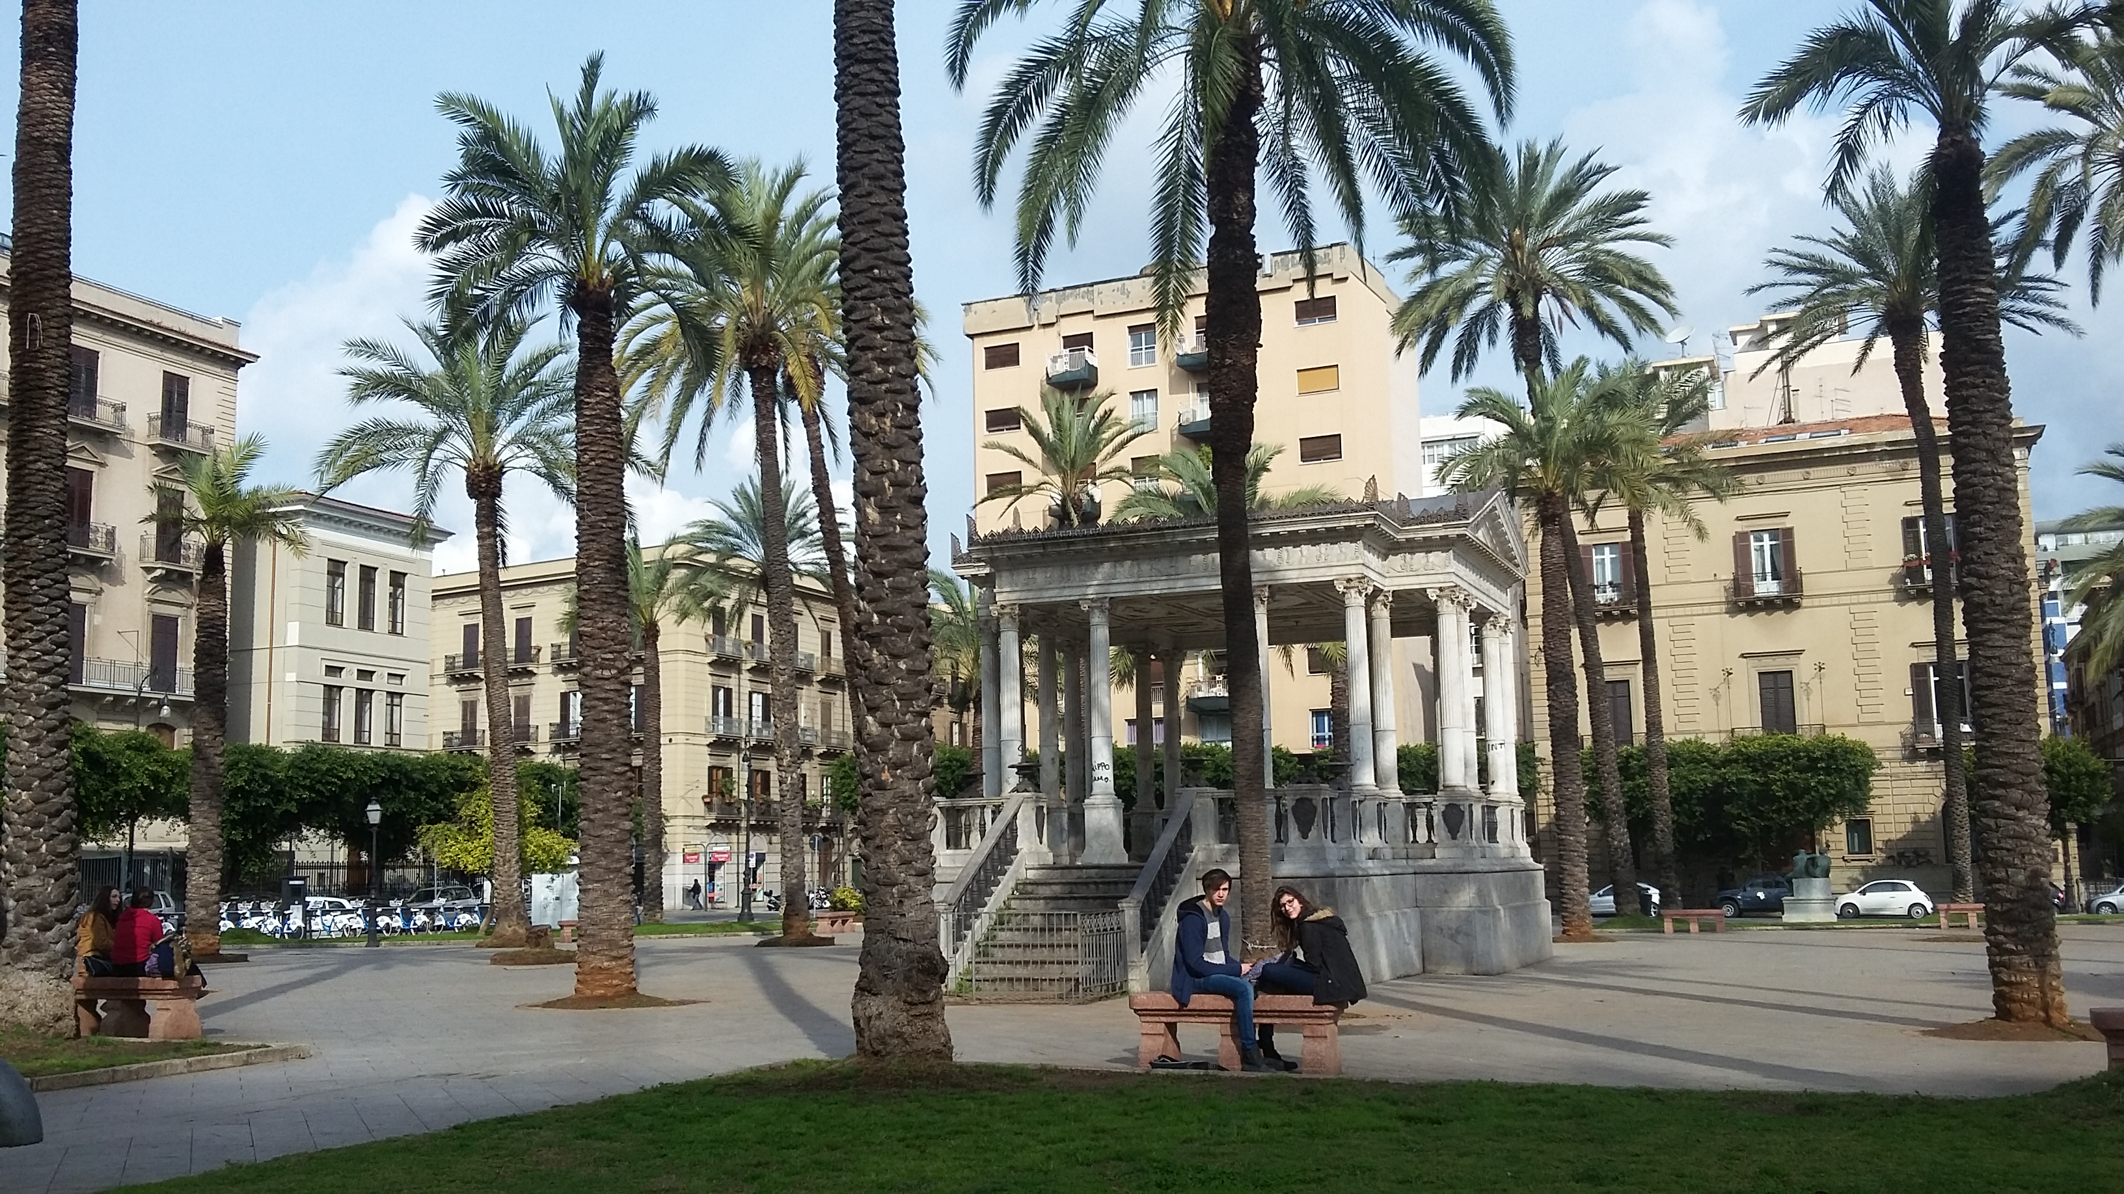
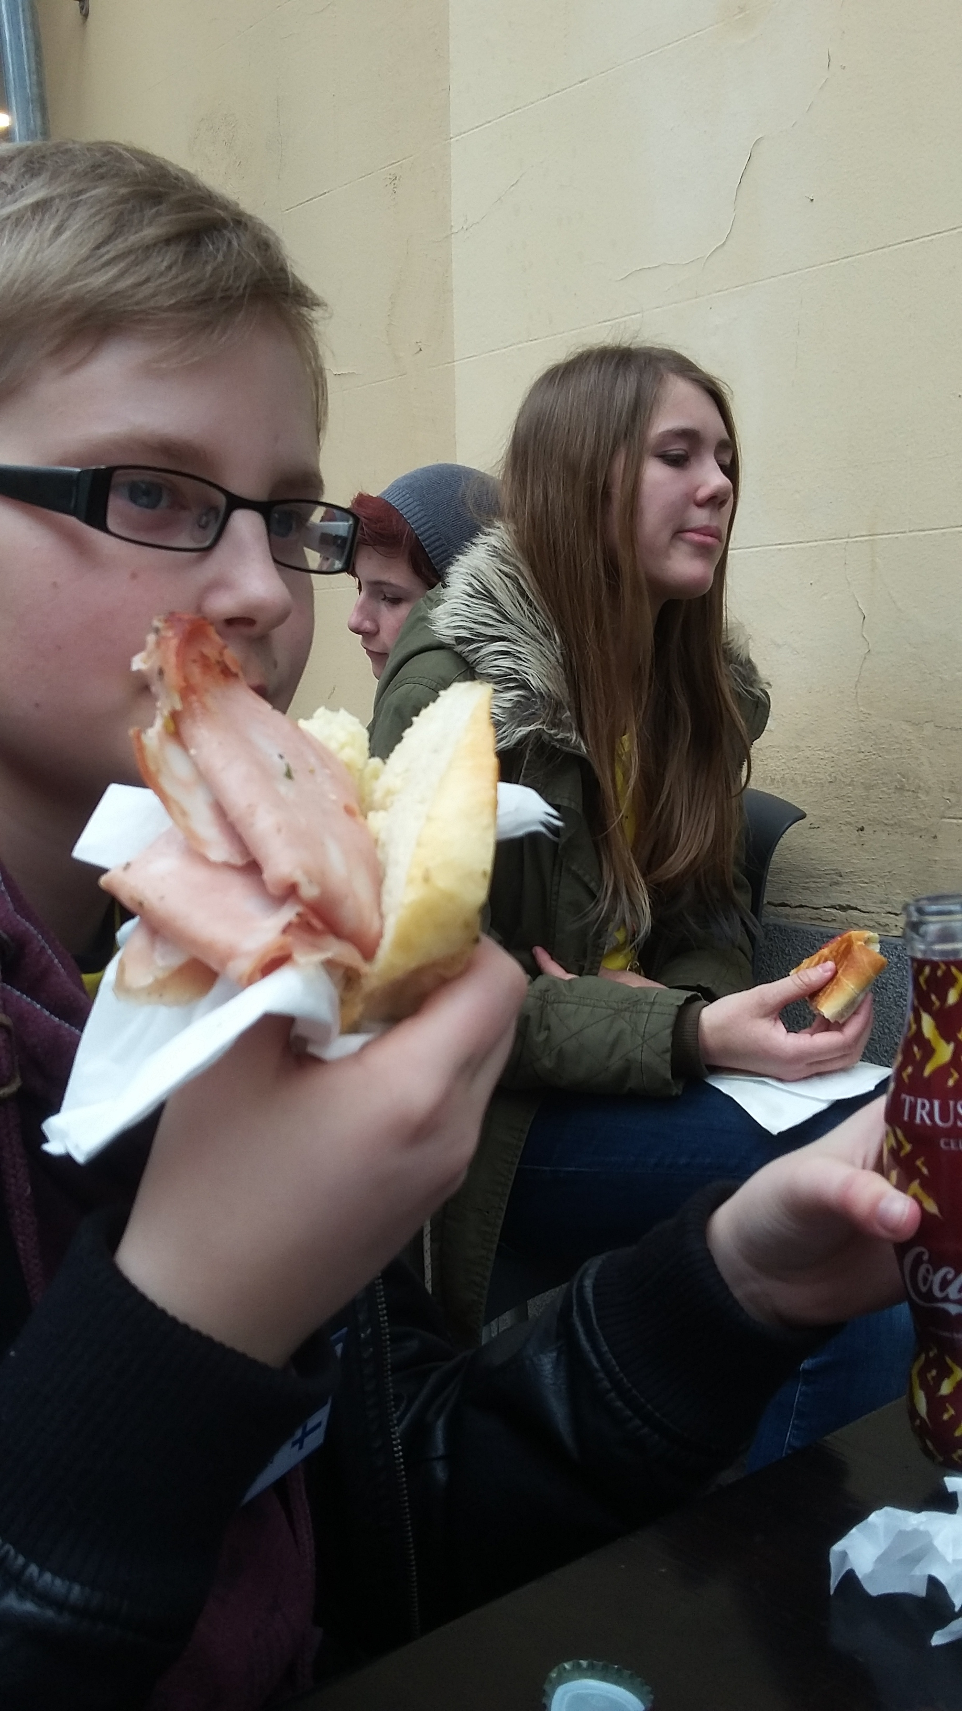
Friday 18.3
First in the friday morning we went to computer class do summary of the week.
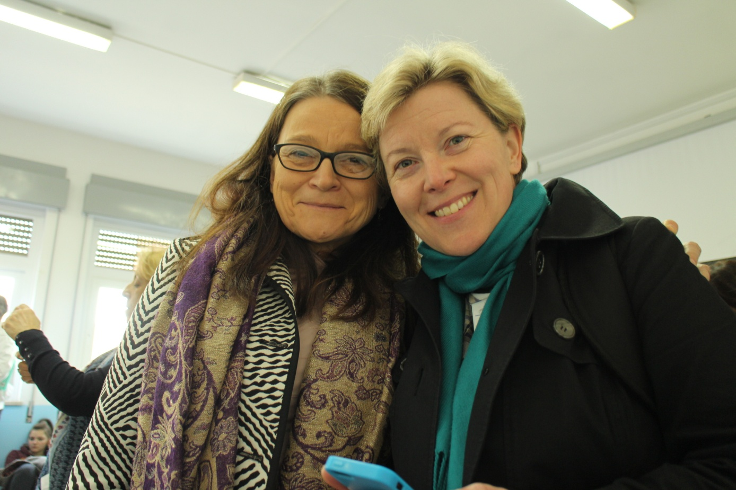
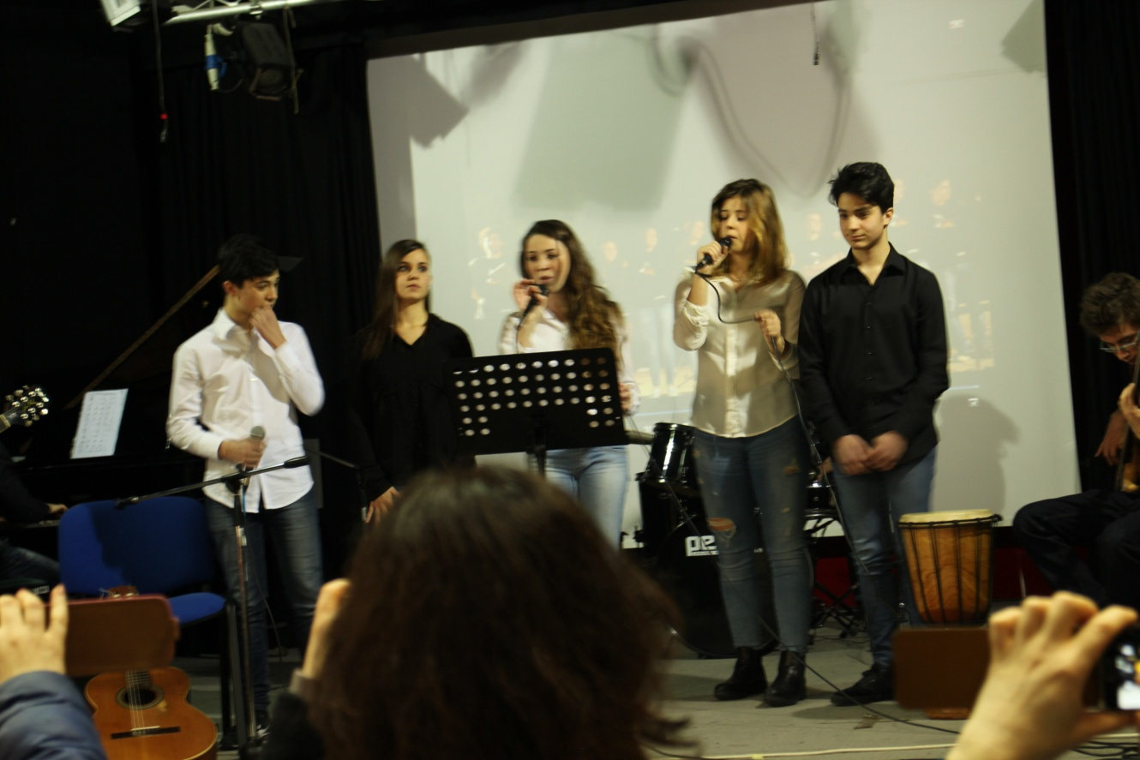
After that we had a consert. Music was good, but with a loud. Then we watched all summarys what we did and After that students went play volleyball. Later we went to houst families and get ready for party. In party we ate and most of students danced. For last we sayd bye bye for everybody and went sleep.
Our trip in Palermo was nice and we mede new friends.
