[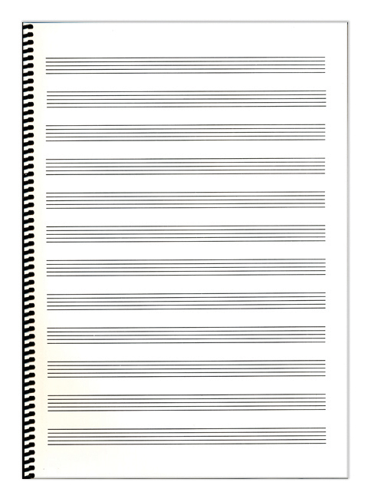](http://www.google.fi/url?sa=i&rct=j&q=&esrc=s&source=images&cd=&cad=rja&uact=8&ved=0ahUKEwjZxor-xsnKAhWJ93IKHdh6AMQQjRwIBw&url=http%3A%2F%2Fostinato.fi%2Ffi%2Ftuotteet%2F15927%2F&psig=AFQjCNGFgad2DYbU7XmVsVvzdayQDYJ3KQ&ust=1453968688280578)