**Erasmus+ Nature and outdoor education**

**Braga, Portugal 25.-31.5.2019**

The first day Sunday evening we arrived to Braga. After quick stop in the hotel we started the project week by visiting the historical centre of Braga and took part in “Braga Romana”. We had nice dinner at Roman market. City seemed to us vivid and charming. We also found out that Finland had won world championship in ice-hockey!

The second day visited our host school EB1 Nogueira. In welcoming ceremony we saw a nice musical performance and Portuguese story play Cuquedo made by pupils. Pupils in this school are from grades 1 to 4. We noticed schools concern about the environment. They had made a song called “Sing to the climat”: “We need to build better future and we need to start right now”. It was nice to notice that the concern about the environment is universal. Lunch was enjoyed in a middle school nearby. After lunch we had workshop Hydrangea macrophylla and we gave presentation about insections wich students had prepared in advance.

After school day we were tired and had nice dinner with Finnish team. After that we were raedy to sleep.

The third day we visited North Coast Natural Park in Apúlia just outside of Braga. The coast was windy and beautiful, the weather was sunny. We were happy to see the ocean and some students went to swim even though the weather was a bit chilly and the water was cold. We had an activity at the beach where the students made insects from nature elements. After late lunch at school Finnish team took a train to Porto and we had there some sightseeing and had tasty bacalhau dinner.

The fourth day we continued to our tour to historical Braga. We met the mayor of Braga at the city hall. Reception at the city hall was impressive. We felt that Erasmus projects and other kind of international co-operation is important to the city.

In the evening we lovely dinner with the teachers. We discussed about the project, educational systems in different countries, cultures and future plans. The atmosphere was nice and relaxed.

The last day we had a guided tour to ESAS (secondary school). We had impression that the school was nice and had a lot of space. We even had some ideas for our own new future school. The robotics class was something familiar to our students but they enjoyed it anyway.

In the evening it was time for a farewell. We had a nice dinner all together with musical performance by a student from ESAS. We were happy to see that the student finally made connections and shared contact information in social media.

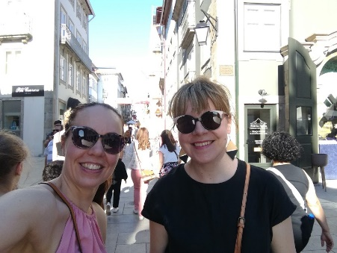After all the week was productive and we had lovely time in Braga. We learned about Braga’s history and Potuguese school life. It was great to meet everybody and share ideas. We are enthusiastic about this project and already started to plan our next homework in a way home. Special thanks to Portuguese team for taking a good care of us.

Hope to see you soon again!

Katja Uuksulainen and Saana Juuti

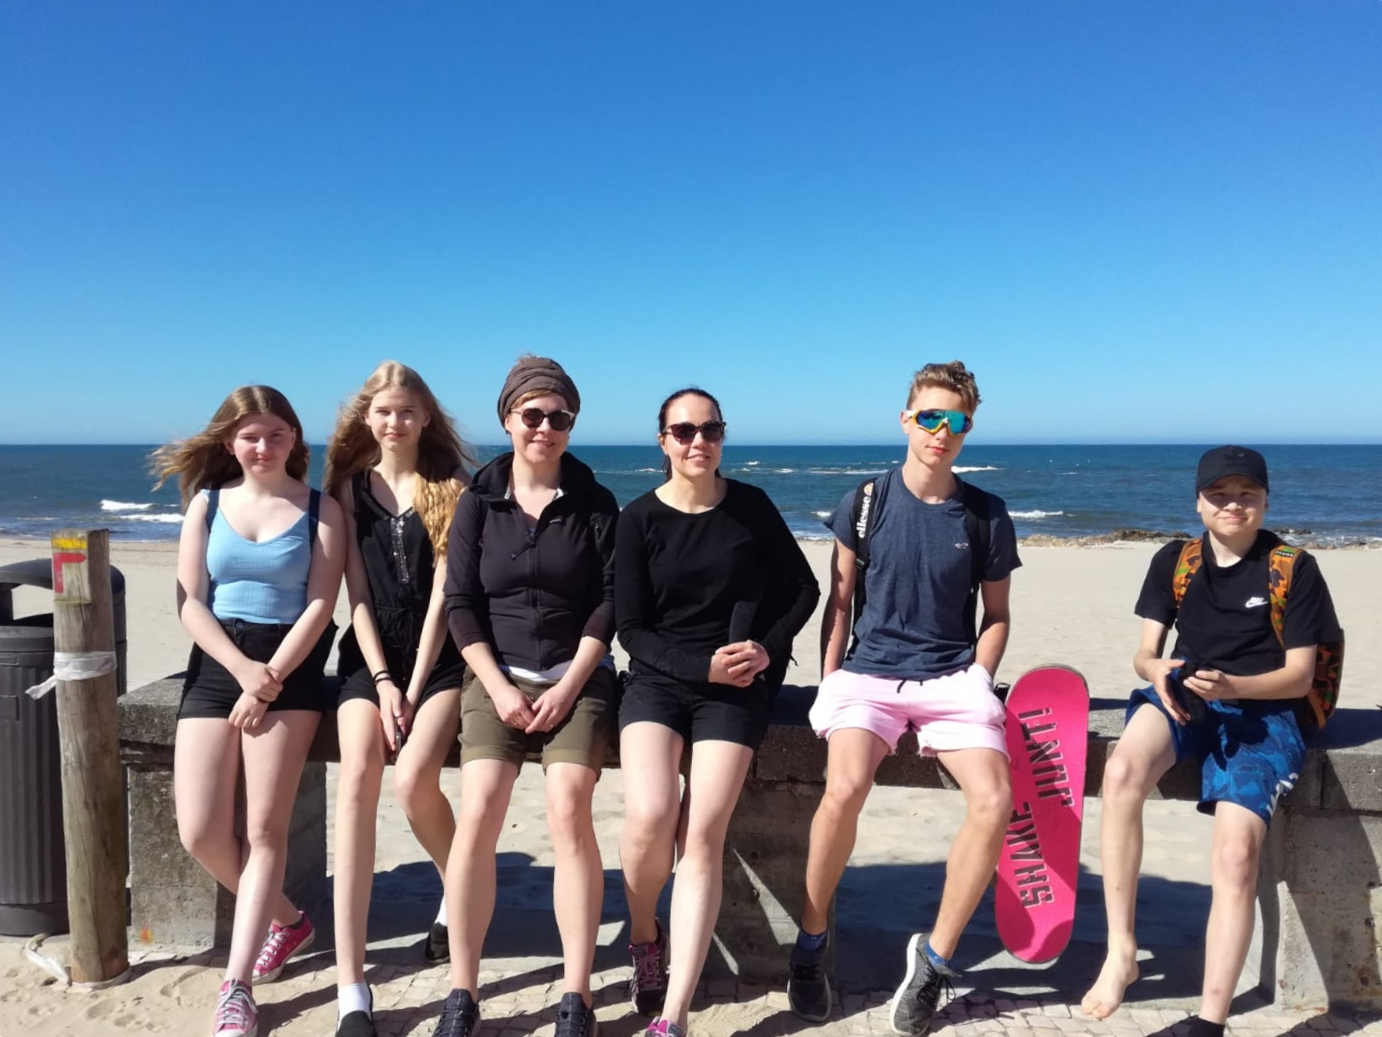

**Kirsikka and Minea’s thoughs about the week**

Sunday

We arrived to Braga and went to our hotel. The hotel was nice. Then we left to see the old town and Roma Carneval. There were acrobaticts performing. Their performance was really good. After that, we went to eat a traditional portugese food. We didn´t like it.

Monday

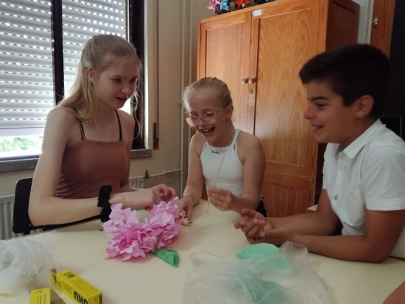We went to see the primary school. The students had prepared us a singing performances. They sang really good. Then we had a school tour. We saw the yard, classes and cafeteria. The school was nice and small.

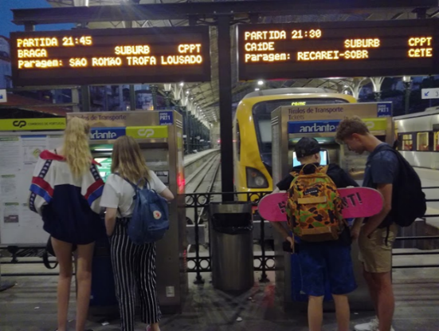We went to see the middle school. It was really big and fancy. The students were nice and asked us many questions. We had lunch there. Cafeteria was kinda small but nice. The system was different than ours because the students had ID cards that they have to show at the door so they can get to eat. It looked interesting. The food was really good.

We had workshop about portuguese flower and it was fun too.

Tuesday

In the morning we went to the beach. It was really windy but the sun was shining! We took pictures, played with sand and took a walk around the beach. The weather was good but we both sunburned.

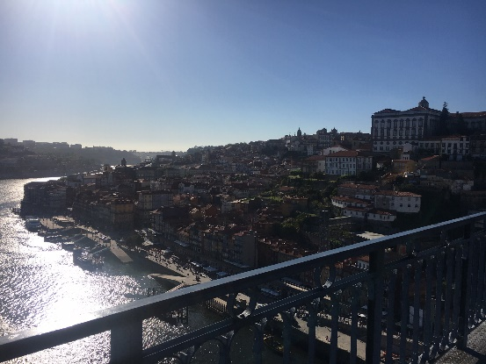Later we went to Porto by train. We walked there a lot and saw many sights. We visited very high bridge called “Ponte de Dom Luis”. There was an awesome view over the city and the river Douro. We were really tired in the evening.

Wednesday

We went to the old town to see some sights. For example we saw many historic districts, the city hall and museums. We even met the city mayor. It was really hot day so we didn´t pay much attention.

Me and Minea went to shopping. We walked to the mall and the weather was soo hot. We bought clothes,some random things and gifts to our families and friends. Our legs were very tired after that day.

Thursday

We visited one of the local high schools. The school was huge and modern. There were students from 7th to 12th grade and it was really cool. The school was interesting because there were “mini gardens” around the stairs. That would be cool to have in our school. We also had school tour. It was nice that there were lots of “hanging” places for kids. In the evening we had dinner. Food was okay.

But altogether we really enjoyed our time there.

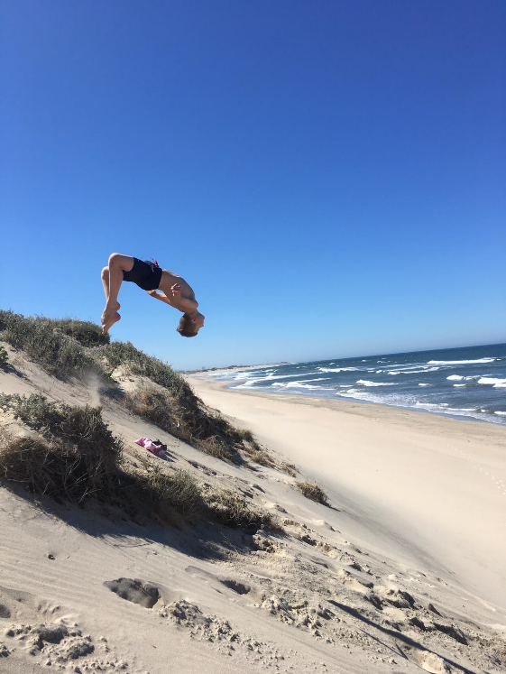**Herman and Tomas’ thoughs about the week**

Braga was nice and warm, we liked the old town the most. The school system was very weird compared to our school in Finland, it looked like a prison. But i didn't like that there was no swimming places close to us, and there were good skate spots!

Sunday evening we came in Braga and we went to the market place and there was lot of places where you can buy food so we ate there good food and the evening was it. We liked it and it was good welcoming seremony.

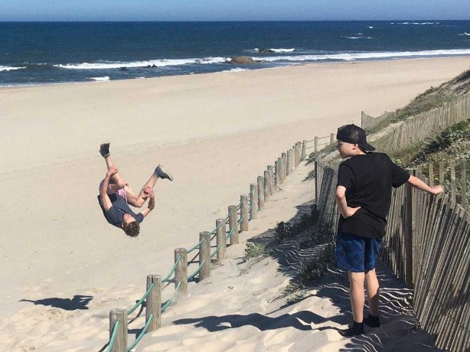On Monday we went in primary school and we learned a lot about portugeise primary school system. We also went in secondary school and there we learned about secondary school in portugal and we also had a school lunch and it was way more different than ours.

On Tuesday we visited the North coats natural park and it was a fun day, but the natural park was a litlle bit lame. We also went to swim and did some tricks on sand dynes.

And on friday night we left home after midnight.

