On Thursday (6.4)
The alarm clock rang at half past six in the morning and the bus left at half past seven but this time we missed our bus. But luckily we got a lift for my houst's mother and school started at nine o'clock. Or it should have to start but teacher came to say that lesson start at ten o'clock. So because we had one hour waiting we decided to go to Mc Donald's. There we waited when school start and drank a free coffee.
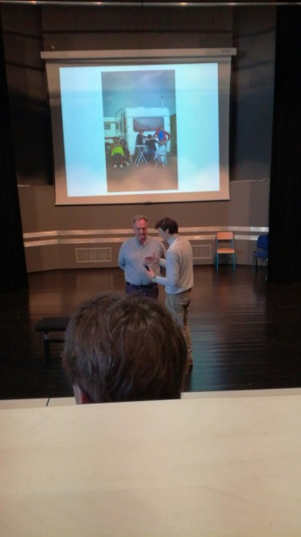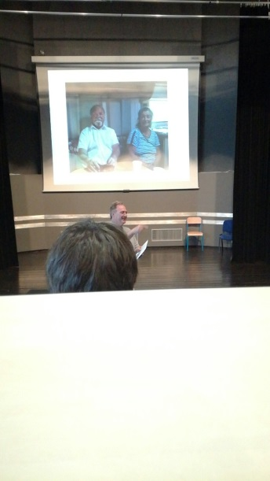
When school day started we went to listening to Bryan Parrish's speaking. Parrish spoke French Romans and theirs life in France. The lecture was so interesting.
Then we had a lunch time at 12 o'clock. On the meal had chicken, vegetables, different salads, cheeses and fruits. Meal was so good and more versatile than our school food in Finland.
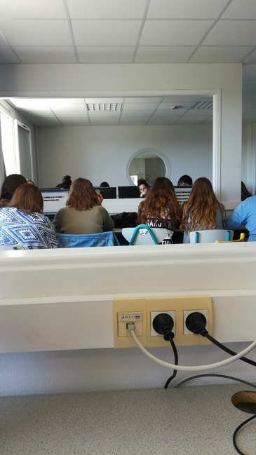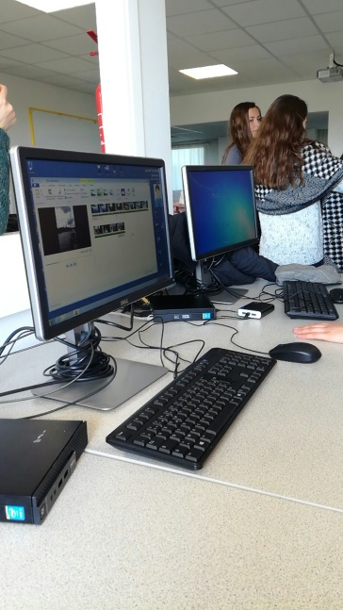
After lunch we made videos about 'Our trip to Royan' with Movie Maker.
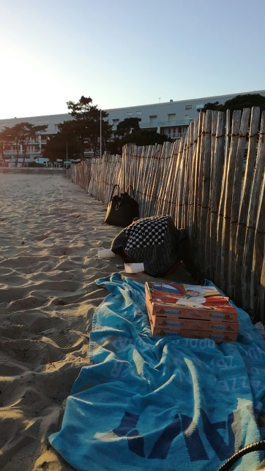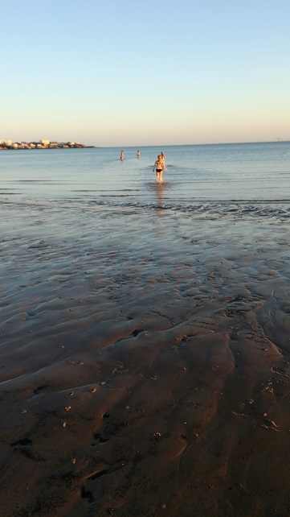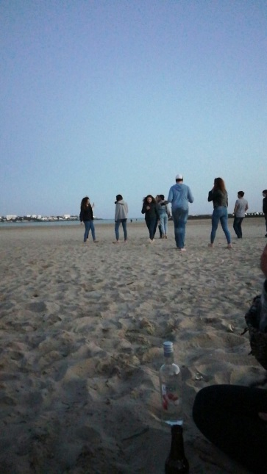
We decided that we would go to beach together on Thursday evening. So we went to buy a little food and after that we met everyone on the beach. There we ate pizza, some of Finns went to swimming and some of us played games. We left to home at 11 pm with my houst. But evening was so nice and relaxed.
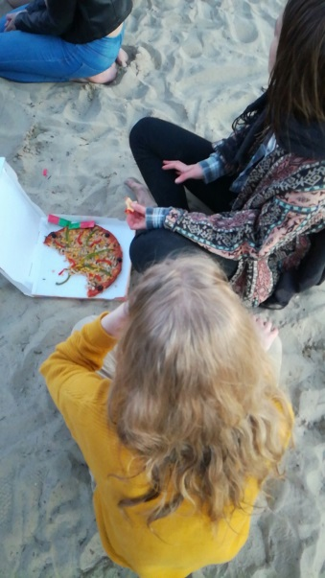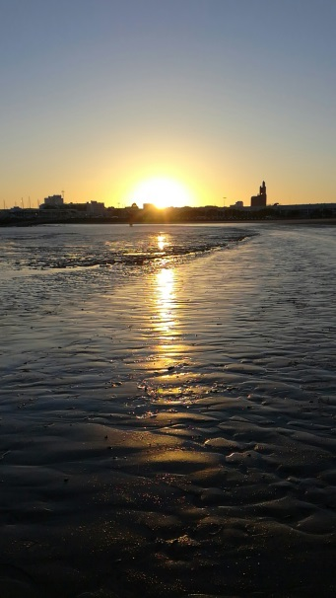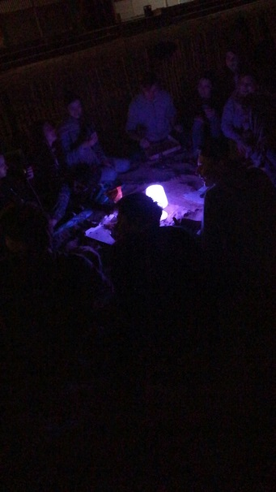
Weather was so warm whole day like a summer of Finland. But whole day was really nice!

