Erasmus trip to Royan: Tuesday

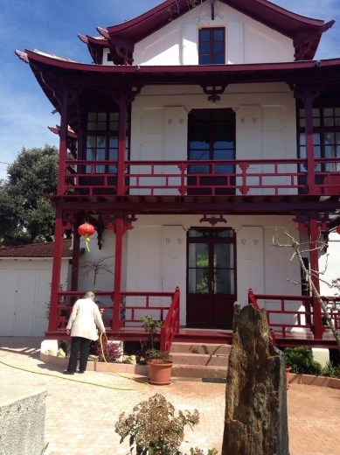
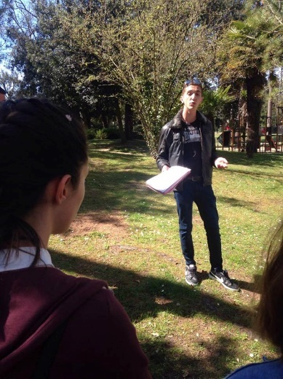
At first we had a normal day in the school, but afterwards we got a nice tourist tour through Royan. The guides took us to some parks and showed gorgeous villas. Some villas were worth over 1 million euros and usually these villas were placed near the beach. They told us that the whole city of Royan was bombed in the second world war. They had to rebuild the whole city afterwards and that’s why some houses look kind of weird there. For example you can see a very old house next to a house which is made in the 80s.

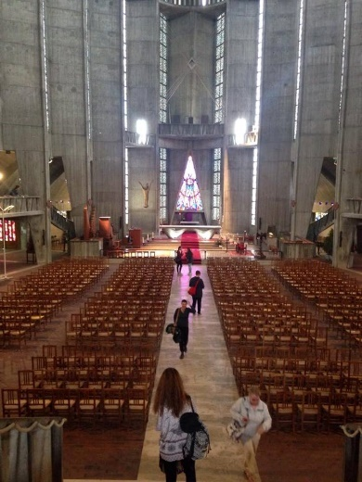
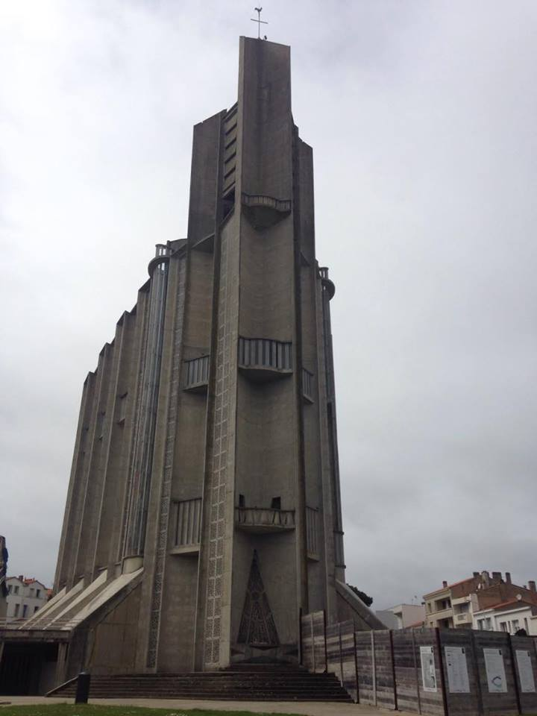
The tourist guides took us also to Royans modern church. Some locals called it ugly, but I thought it was fascinating in a weird way. The roof was just 80 centimeters thick but thanks to the abnormal desing the roof held steadily.

Written by Mika Müller

