Monday the 3rd of April
We started our first "school day" in Royan by introducing ourselves to everyone. After that French students had little performances about France. Also Italians had a performance about their school and we Finns had one about Finland. Then we had a lunch in which we hand french-fries and boiled eggs. After lunch we went outside and we were told that French students had collected over 400 euros for the children of Aleppo. 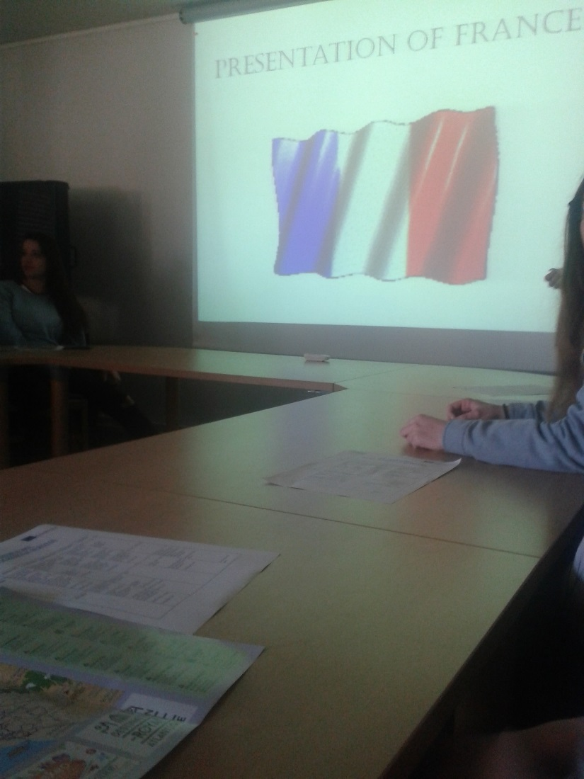
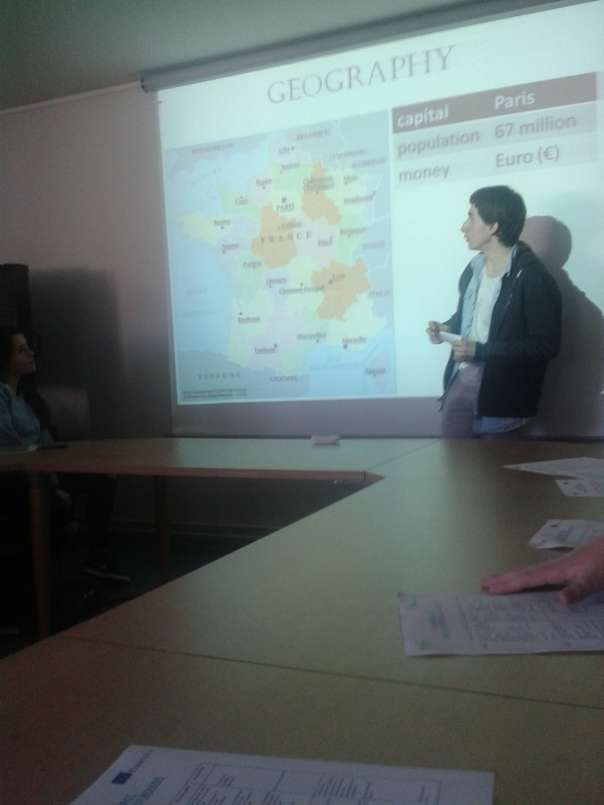
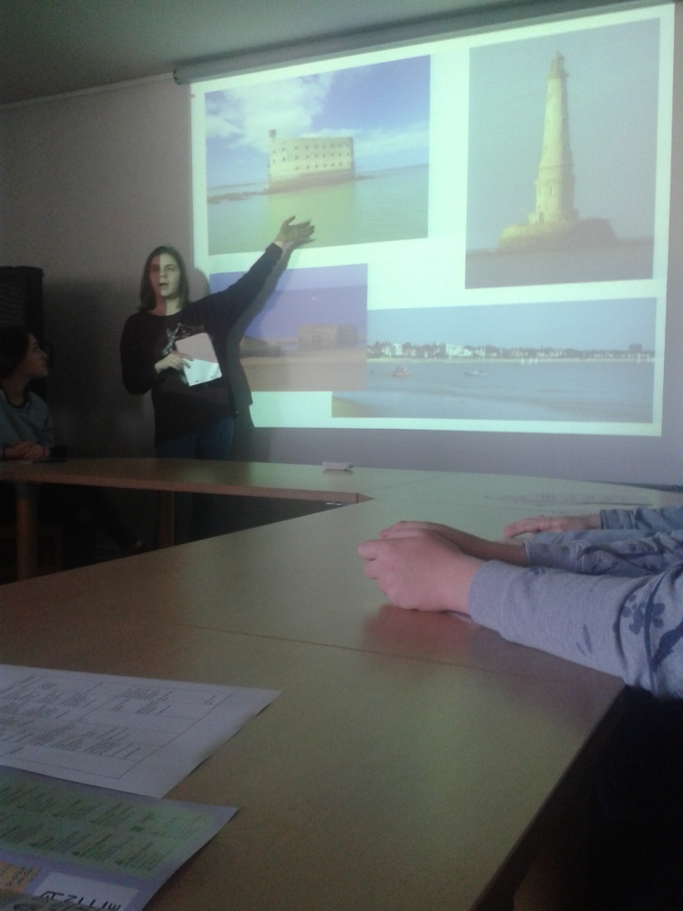
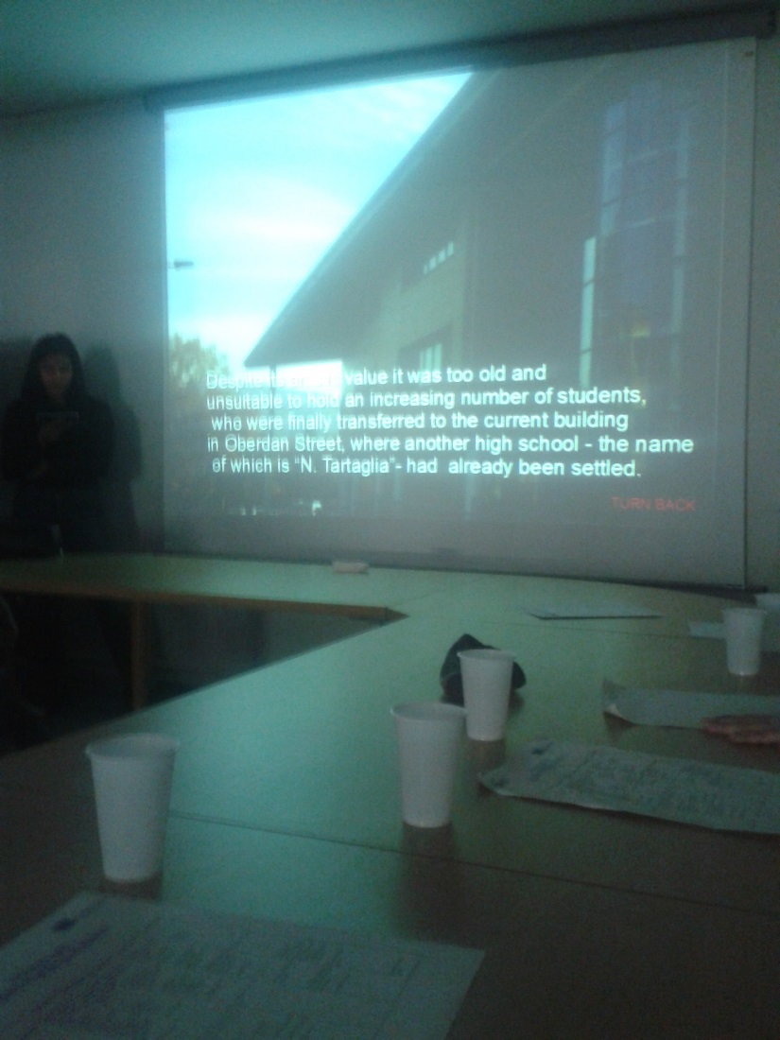
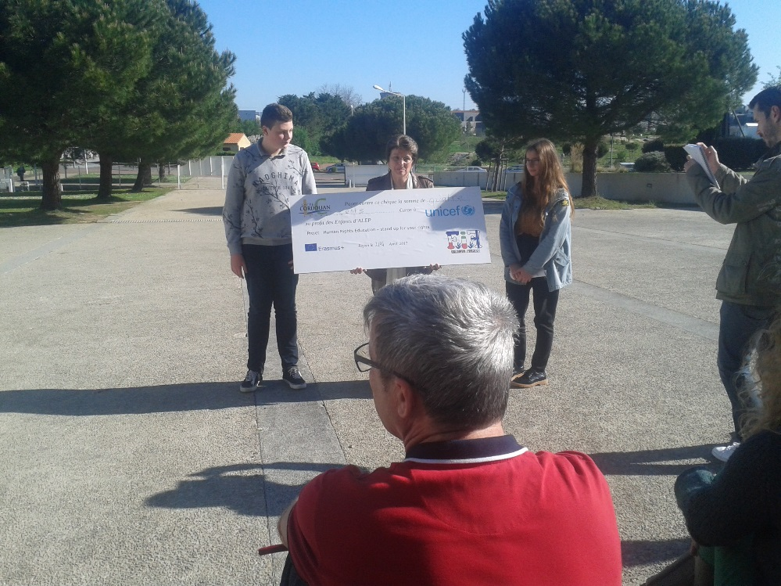
In the evening I went to beach with my host family. We saw some dead jellyfishes and I also swam in the sea.
