Sunday 2.4.2017
We woke up at 8-9 o'clock on Sunday. We went to eat breakfast and there were French cookies and four different drinks to choose. After breakfast we had free time about two hours. We went to the graveyard but we were little lost before that. Then we went to the train station and we waited for half an hour for the train. We spent five hours in two trains and everyone was bored.
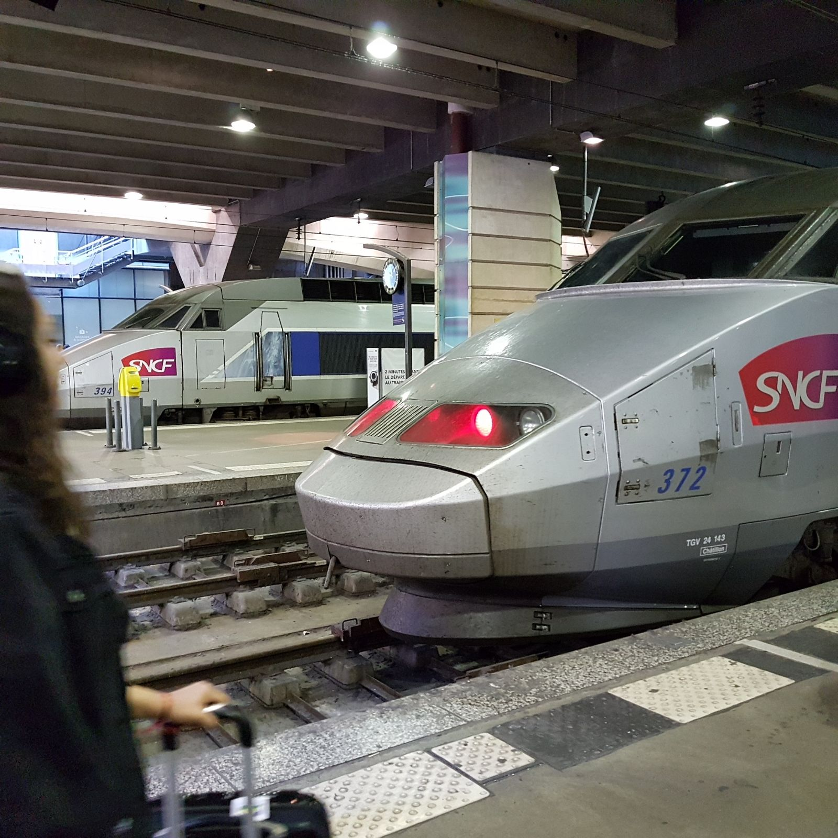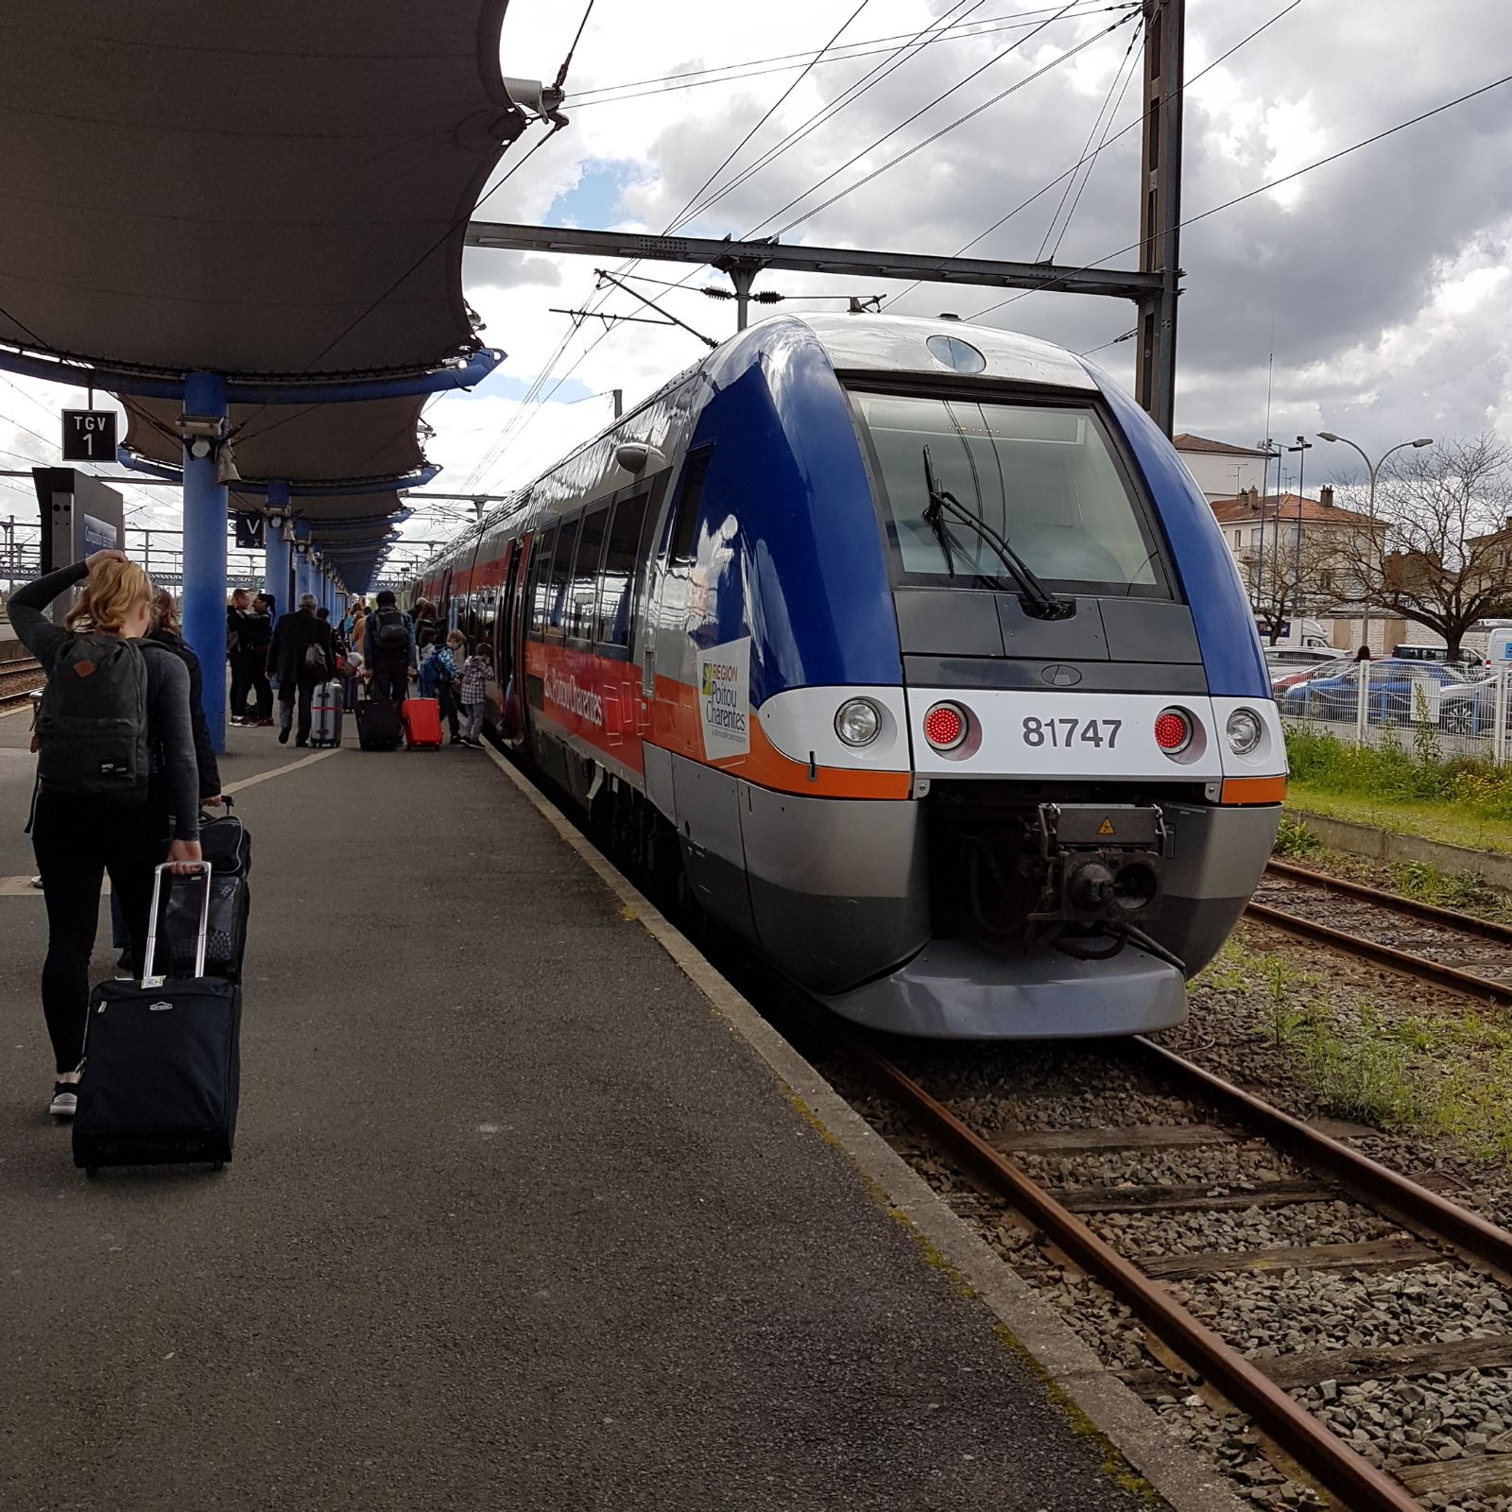

When we arrived to Royan, we were all very excited. We met our hosts and talked for a while then ours hosts took us to their houses. Now it’s my part. When I arrived the house was cold inside and looked old house but nice one. I played football and videogames that day. In the evening we ate seafood like oysters, they were very salty but good. After that I went to sleep.

