Saturday 1st of May

We went to the Kuopio airport at 4:45 and everybody seemed to be tired. The flight to Helsinki airport left at 6 o'clock.
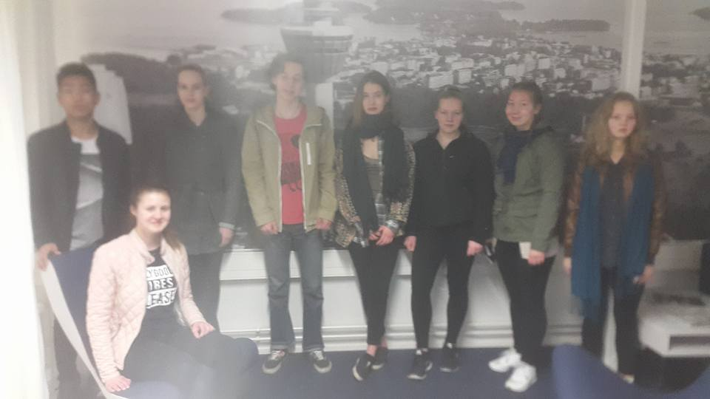
Our flight from Helsinki airport to France left at 8:30 and the flight took 2,5 hours. We were still tired but excited. It was a little cloudy but warm in Paris when we arrived. We took a bus to Paris center.
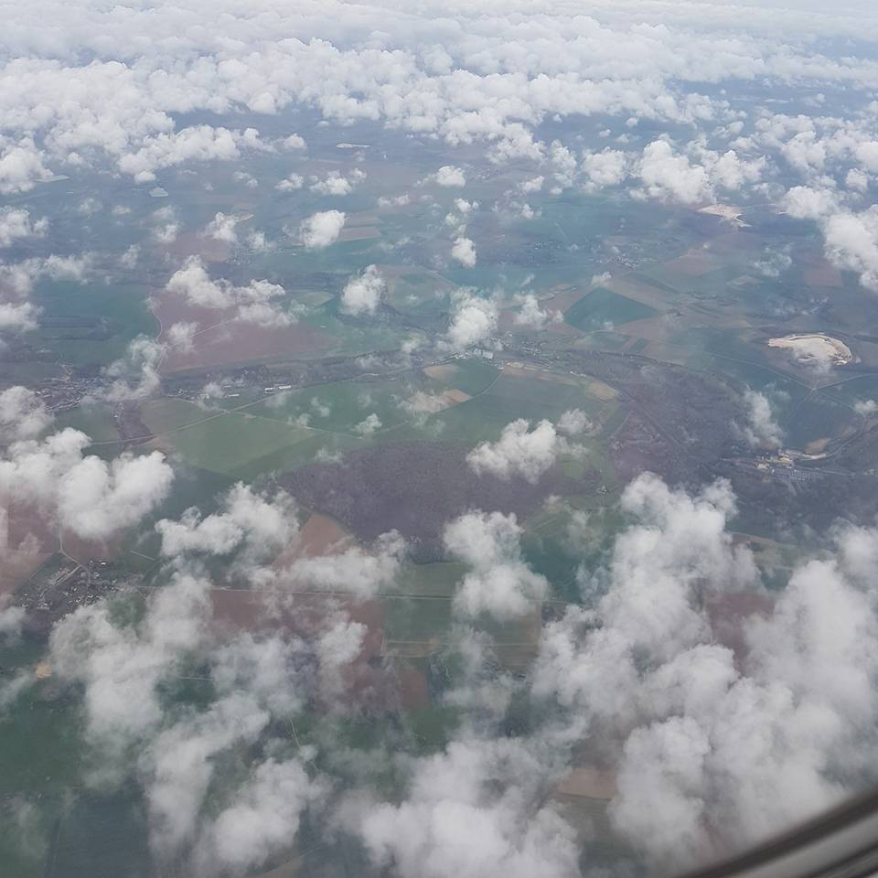
We went to our hotel, named Transcontinental Hotel and rest there a little. Then we walked together throught the Montparnasse Cemetery and admired.
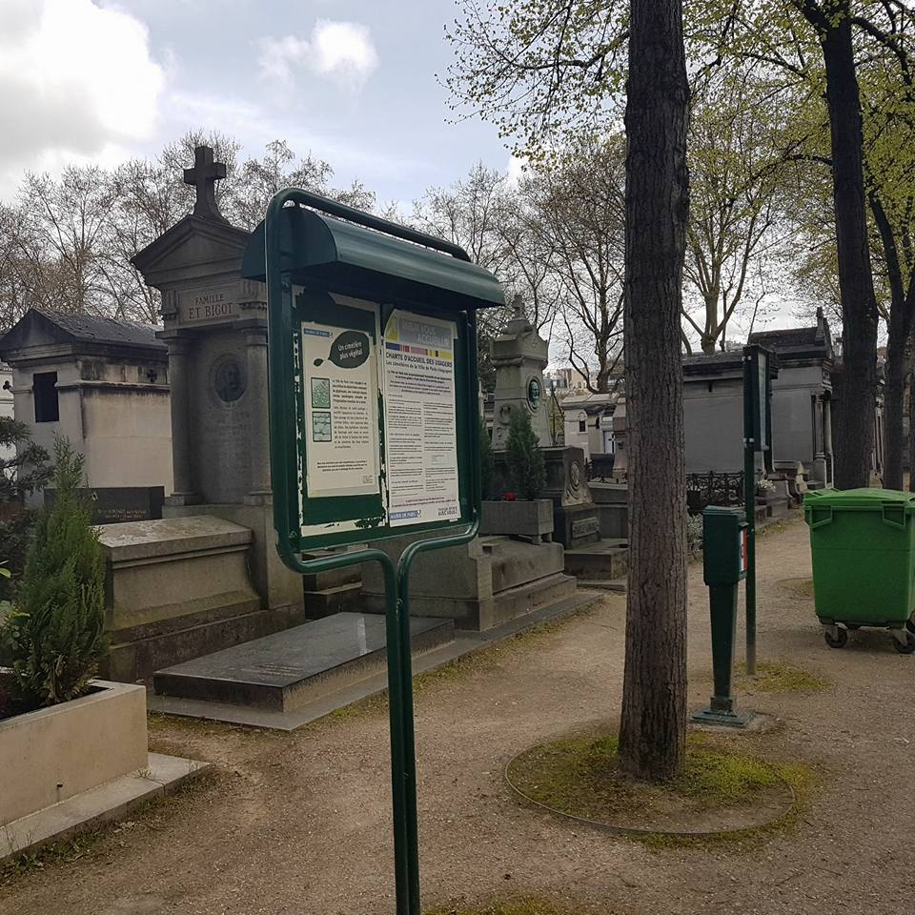
Then we went to eat to a restaurant. Food was good. I took an avocado with shrimp and mayonnaise for a starter. Then I ate chicken with French fries and for dessert I took something like a bun that included vanilla ice cream with hot chokolate sauce.
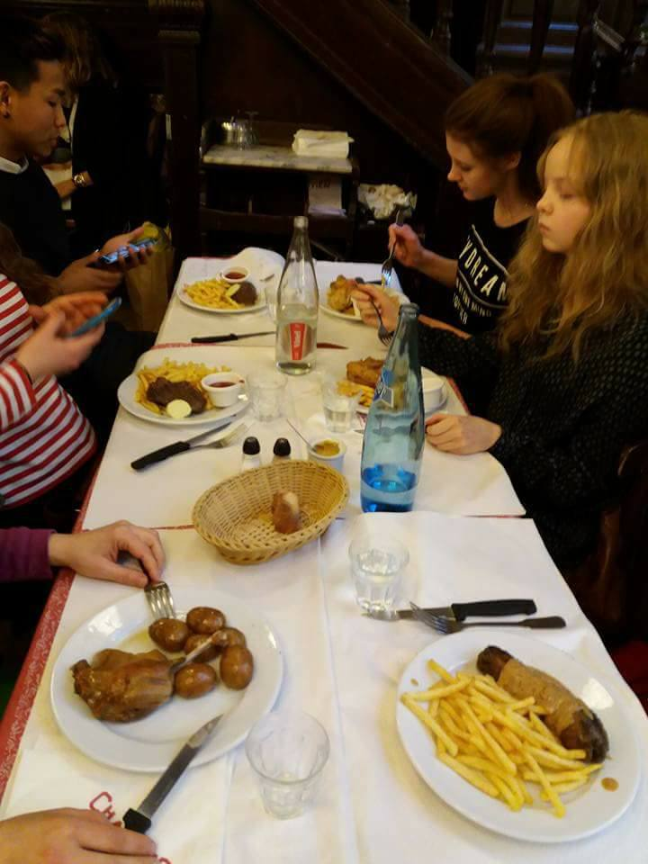
After eating we began to walk to the Eiffel Tower. Sun shined and it felt actually hot even though there were still clouds on the sky. We saw beautiful buildings and other sights while walking. When we arrived to the tower we had to wait an hour before we could rise up.
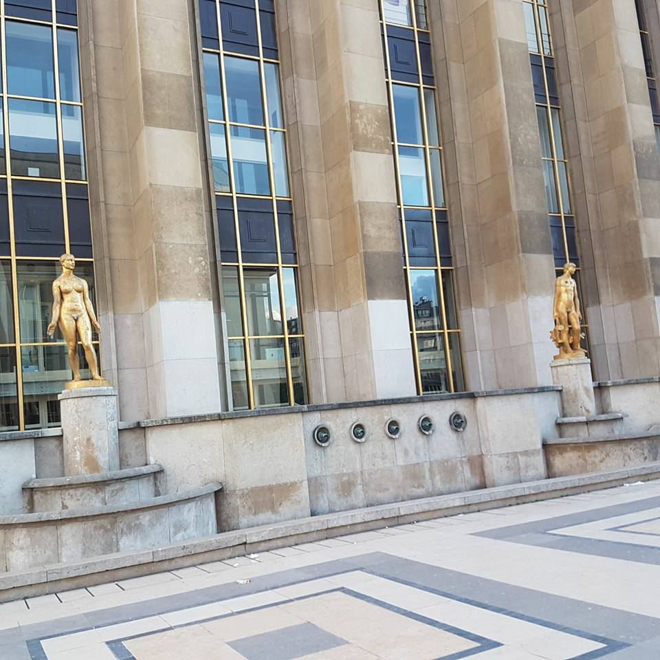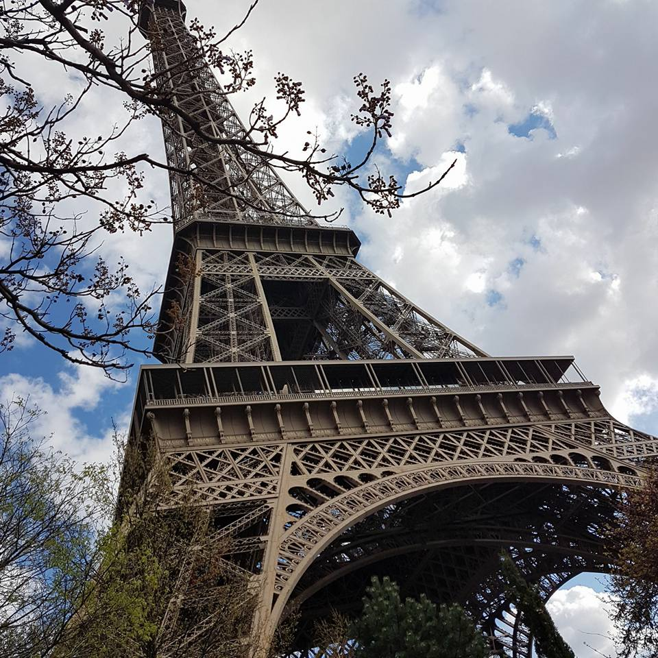
I think it was very exciting, scary infact, to be on the tower. It was so high. But the view was amazing. We could see the whole city from the tower. We spent there about 2 hours.
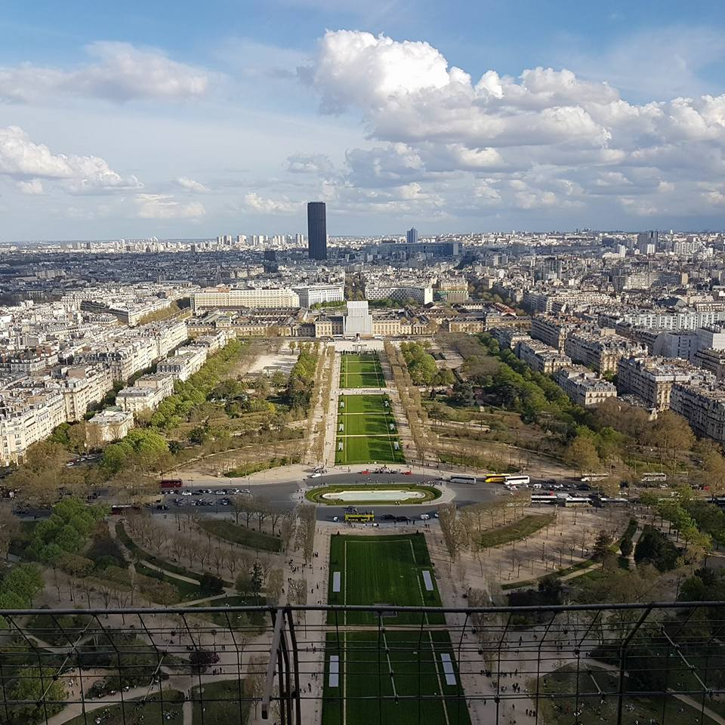
Then we took a metro near to some church. We got few hours free time. I went to buy some snacks with Susu to a small market. We went to picnic in front of the church and later visited some tourist shops.
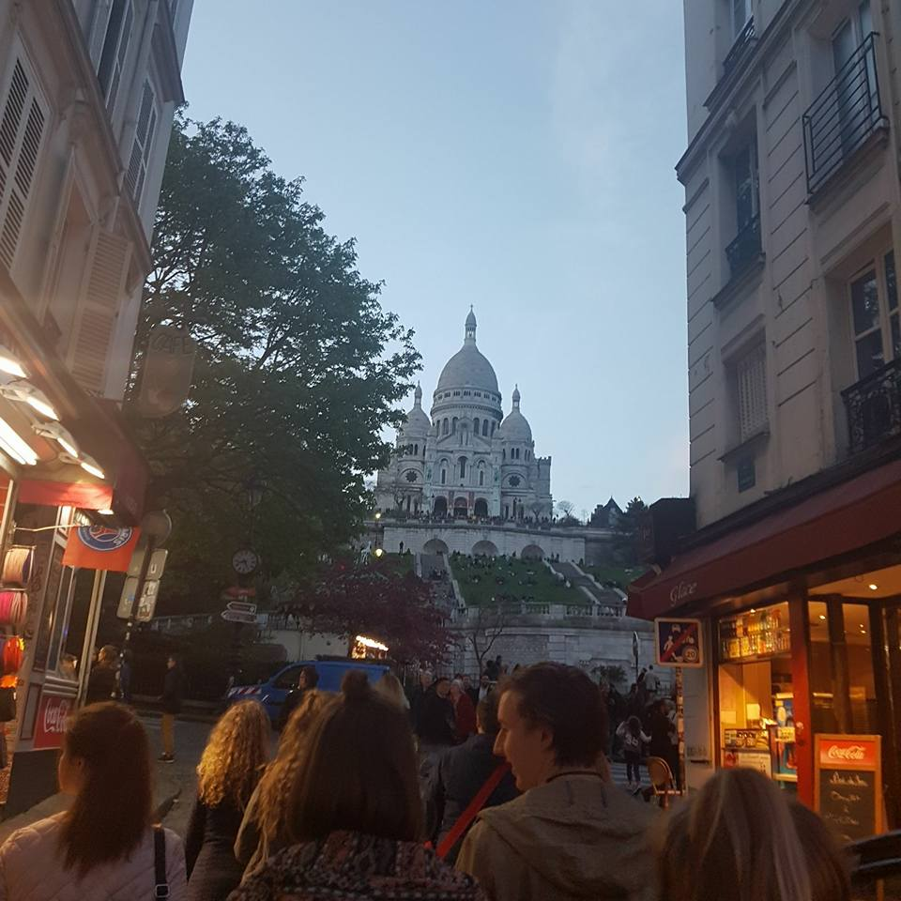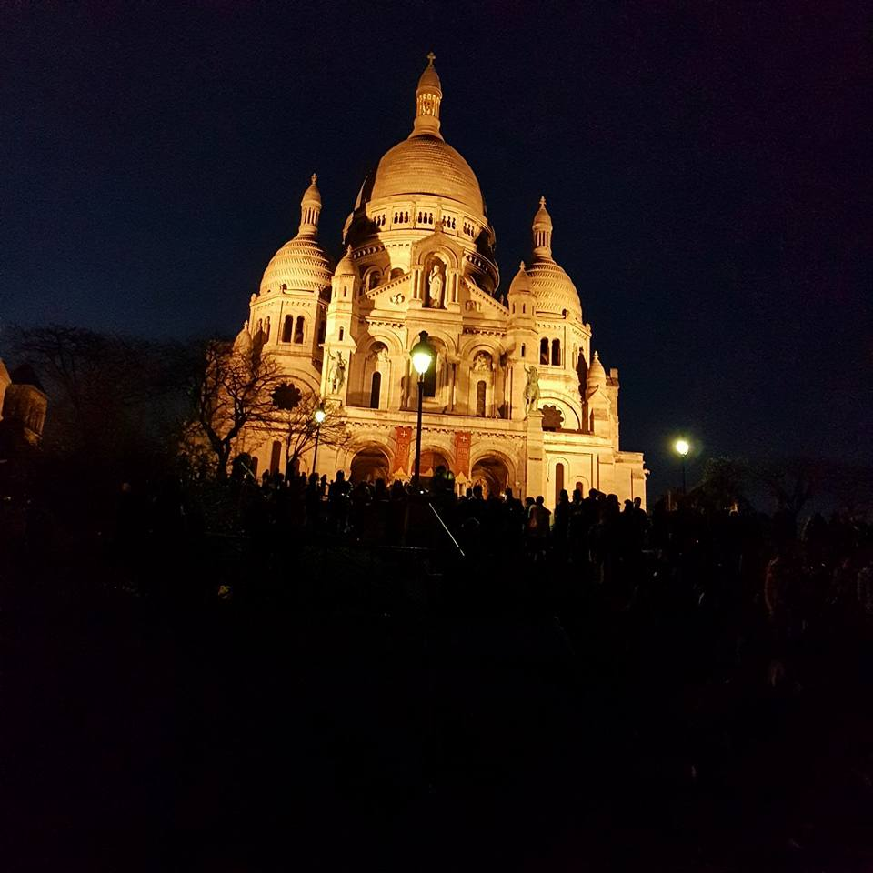
It was late when went back to our hotel to sleep. The day was long but full of very nice experiences. So our trip started well.

- Julia Tauriainen

