Kuusankoski
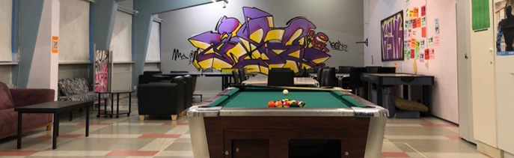
Here is Kuusankoski’s Youth Center. There you can play billiards, air hockey, ping pong and board games. Here you can spend time in the evenings.

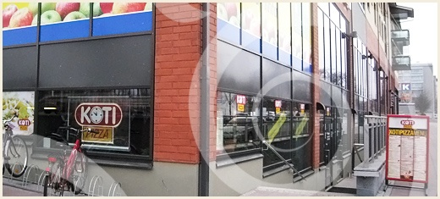
This is Kuusankoski’s Koti Pizza. It’s a nice place to eat. They serve pizza, drinks and dips.

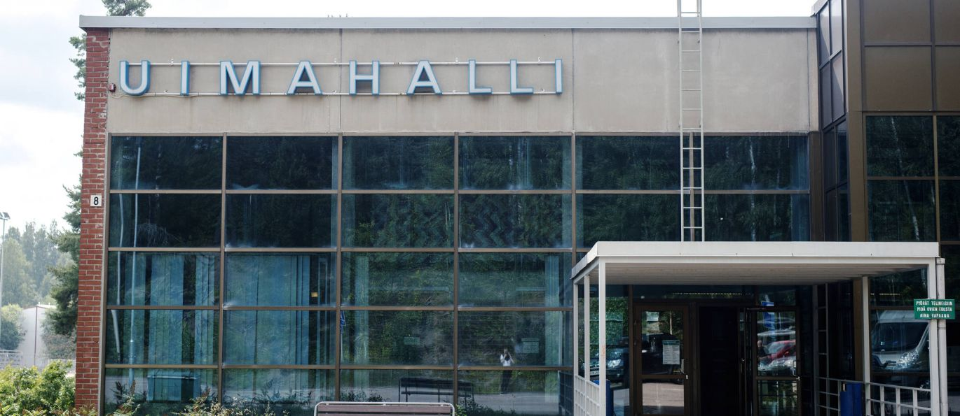
This is Kuusankoski’s swimming hall. There are swimming pools for adults and for children. There is also a hot tub.

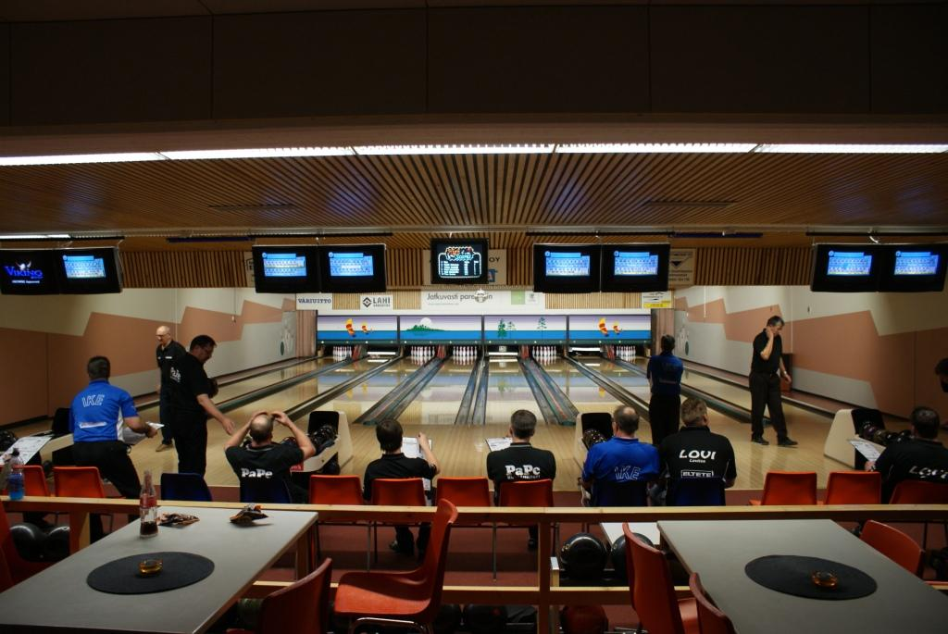
This is Kuusankoski’s bowling alley. It’s called Koskibowling. There you can bowl.

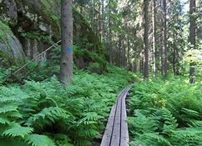

This is Niivermäki. There you can jog or hike in the flesh. In winters you can ski there.

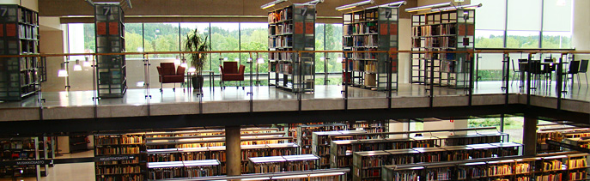
This is Kuusakoski’s library. There you can loan books homeward or read books at the library. From there you find books for all age groups.

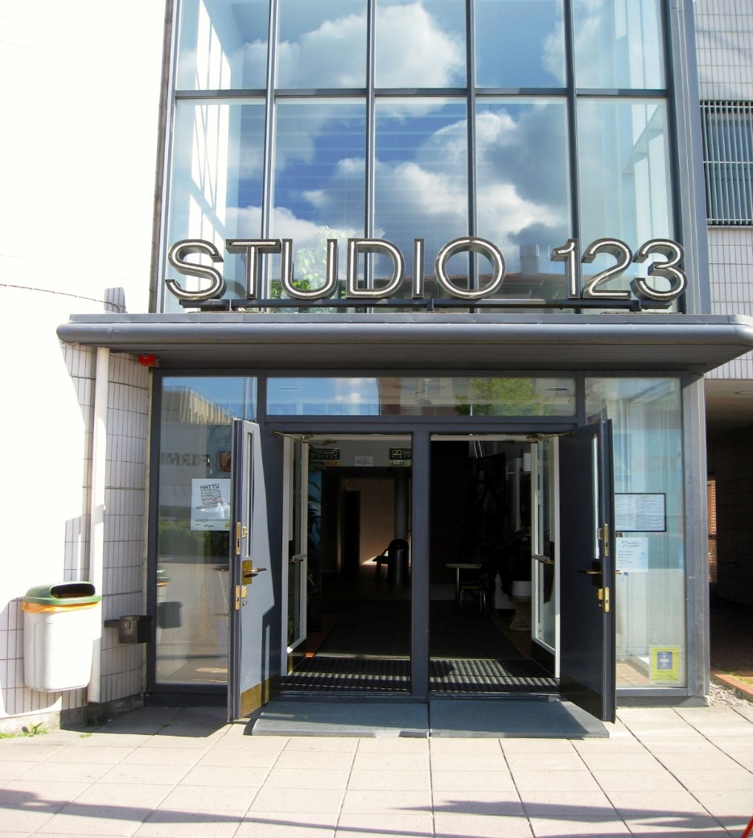
Here is Kuusankoski’s cinema. It’s called Studio 123. There you can watch movies.

There are ten schools from elementary to high in Kuusankoski.
We also have the biggest shopping mall in the South-East Finland. It’s called Veturi and it has about 80 stores and a cinema called Kino123.

