KUUSANKOSKI

We have a hockey hall, a swimming hall and the hotel Sommelo in Kuusankoski. The hockey hall is cold and small. We have two cinemas, one library and a church in Kuusankoski. We also have the biggest mall Veturi in southeast Finland. We have ten schools, Kymintehdas, Naukio, Keskustan koulu in the town center, Tähtee, Pilkka, Hirvelän koulu, Voikkaan alakoulu, Pilkanmaan koulu, Tähteenkadun koulu and Kuusankosken lukio. We have Sami Hyypiä sports hall in Kuusankoski.

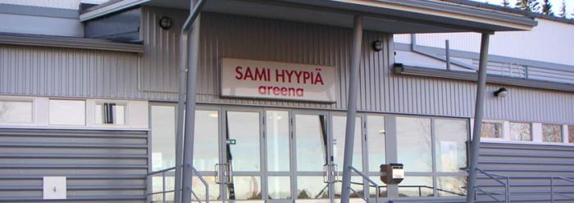
This is Sami Hyypiä sports hall.
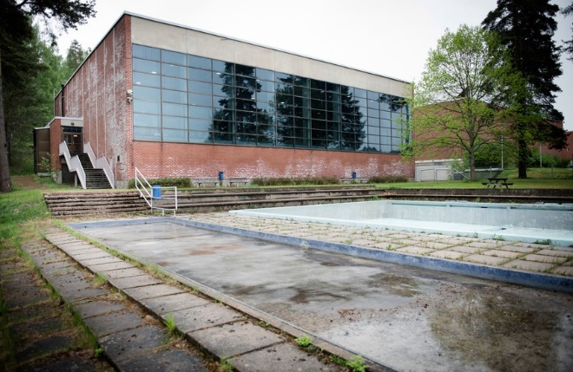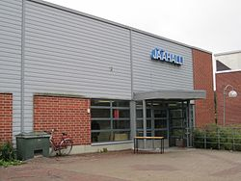
This is the swimming hall. This is the hockey hall.

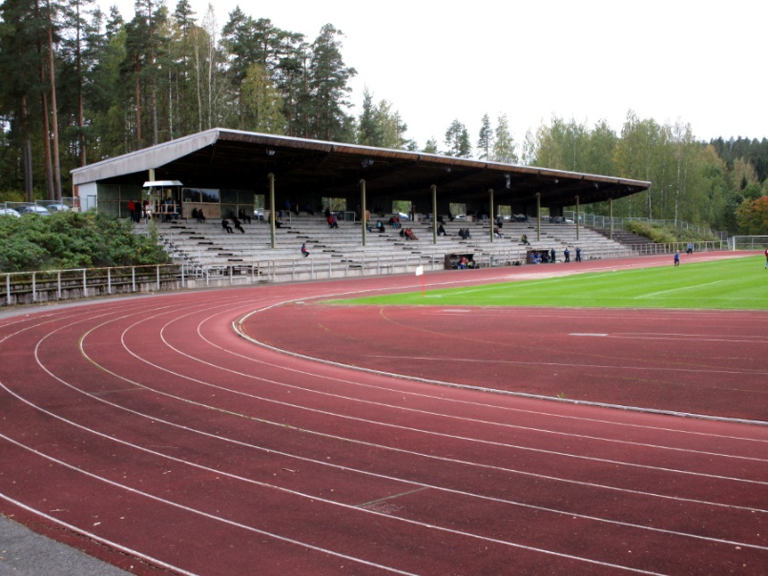
This is the sports park.

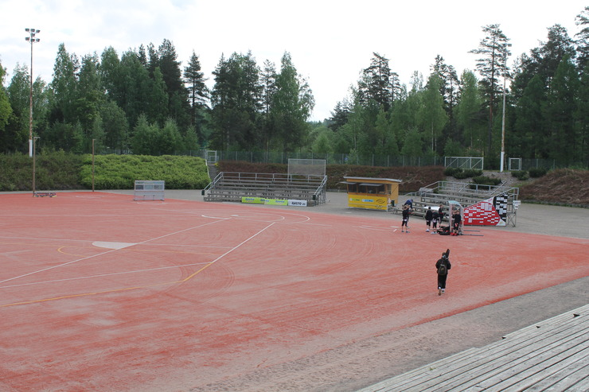
This is the Finnish baseball stadium.
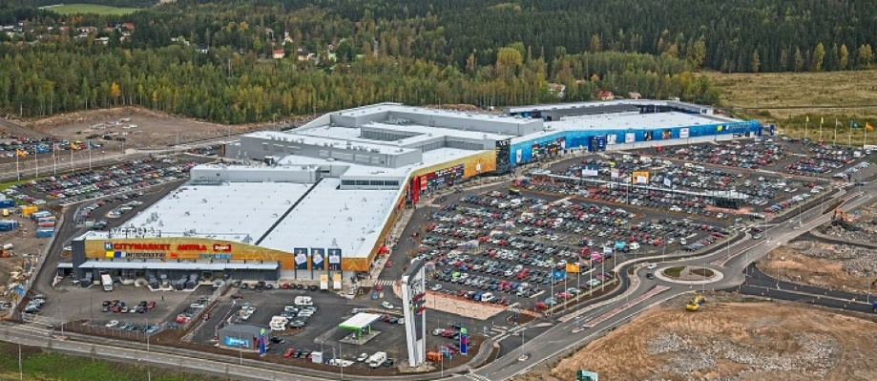
This is the shopping mall Veturi.
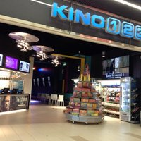
This is the cinema Kino123 in Veturi.

