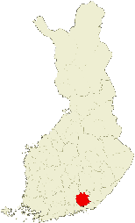Kouvola Centre 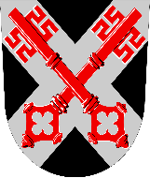

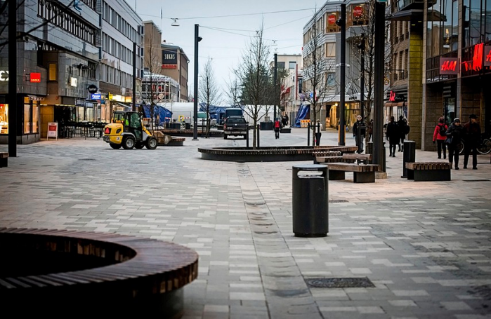
Kouvola has pedestrian street. It’s called Manski. There are many stores, restaurants and coffee houses. Manski also has a very nice fountain and the street has underground heating so when it snows in the wintertime it melts away.
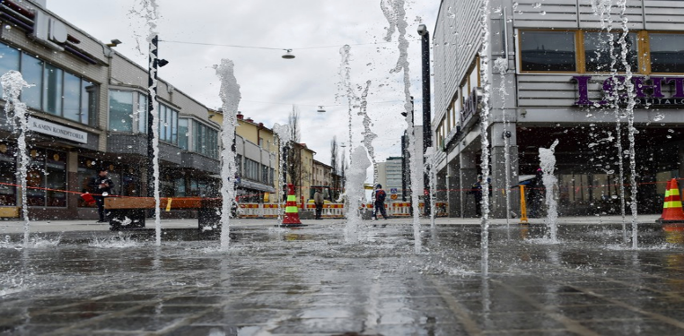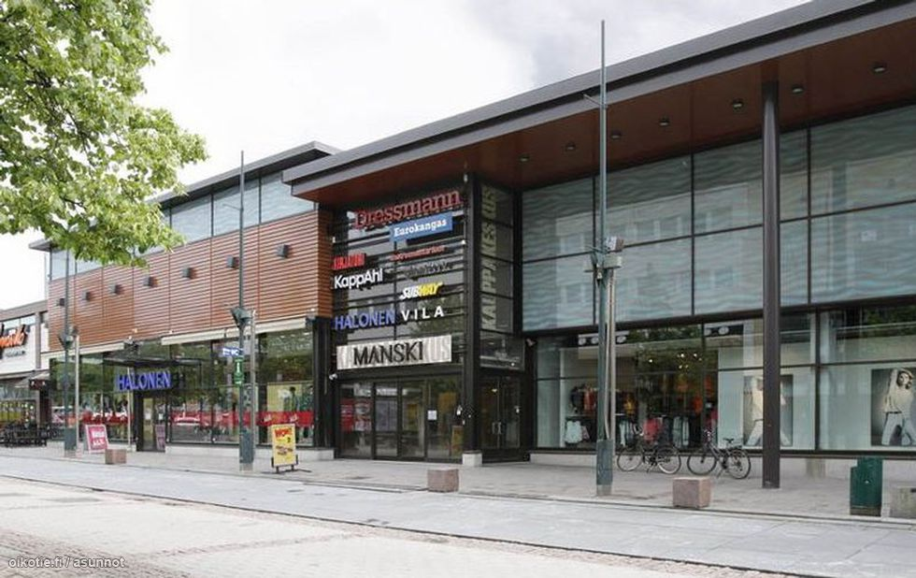

There are some schools, hotels, stores, places for doing sports, parks and playgrounds in Kouvola.
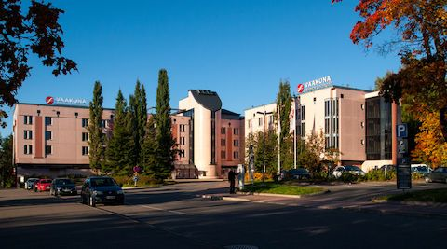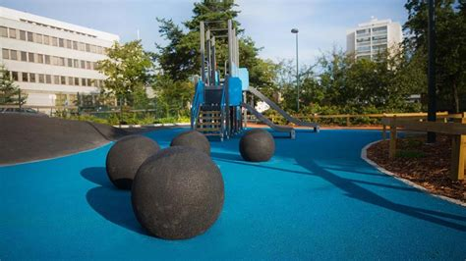
There are also swimming halls, libraries, cinemas, a train station, Lumon´s ice rink, Kouvola-talo and ski jump and the only public transportation is buses. 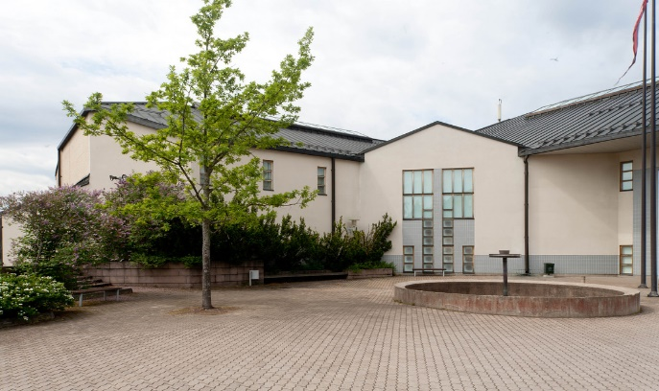 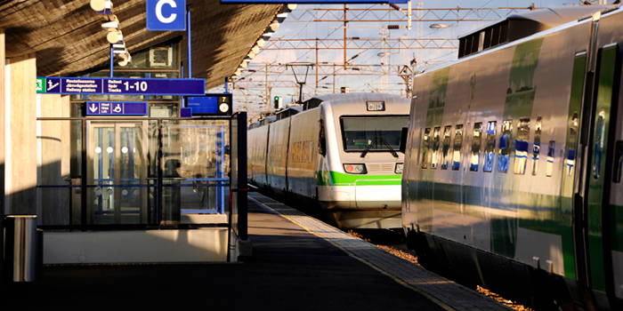 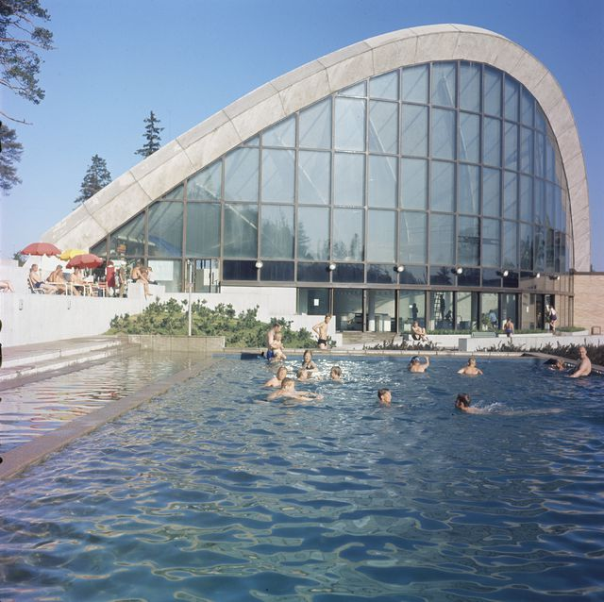 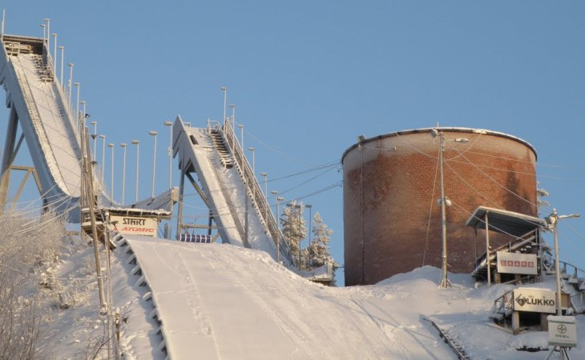

The famous sights in Kouvola are Tykkimäki amusement park, Käyrälampi pond beach and Mielakka skiing centre.
