Nuorisokeskus Anjala – Youth Center Anjala and Environmental School Regina
“The common goals for Youth centre Anjala and Environmental school Regina are developing sustainability and preserving nature. These values guide our everyday life both in our actions and in teaching methods. We aim towards more environmentally responsible choices.
Our environmental school provides environment education and guidance for kindergartens and schools. Target groups also include professional educators, students and other adult groups. Activity programs for children support the curriculum.”
This is how Youth Center Anjala introduces its activities. The center really is a companion for certain grades in Kymintehtaan koulu in arranging activities relating to environment and nature. Most commonly educators from Anjala come to Kymintehdas to arrange various tasks in the nearby nature or surroundings of the school. Also this year they arranged two days of environmental education for Ulla Salo’s class. It is also possible to get connected to other schools in environmental education, but so far it has not been much.

Environmental Education Day in the autumn 2015 PICTURES
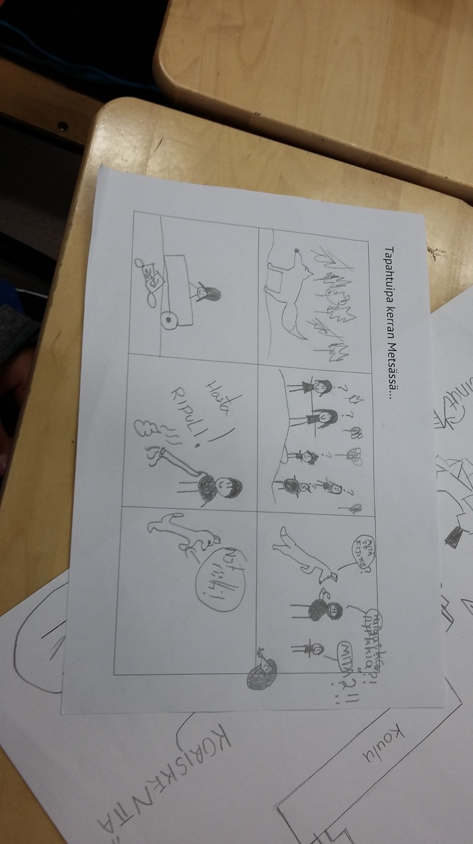
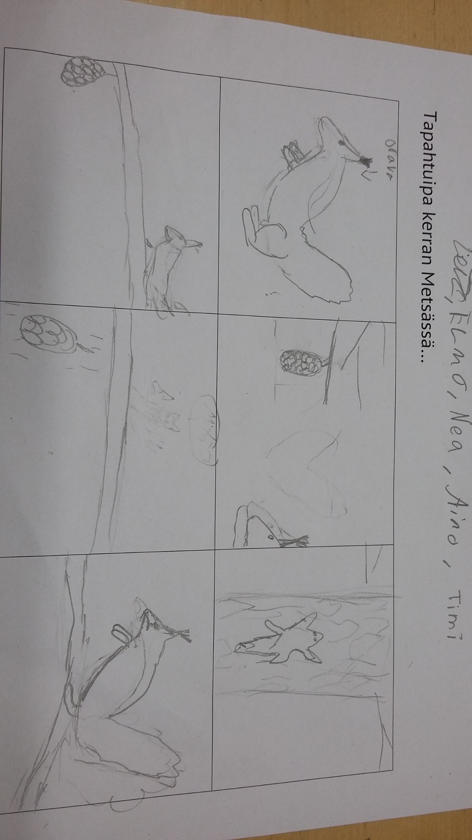
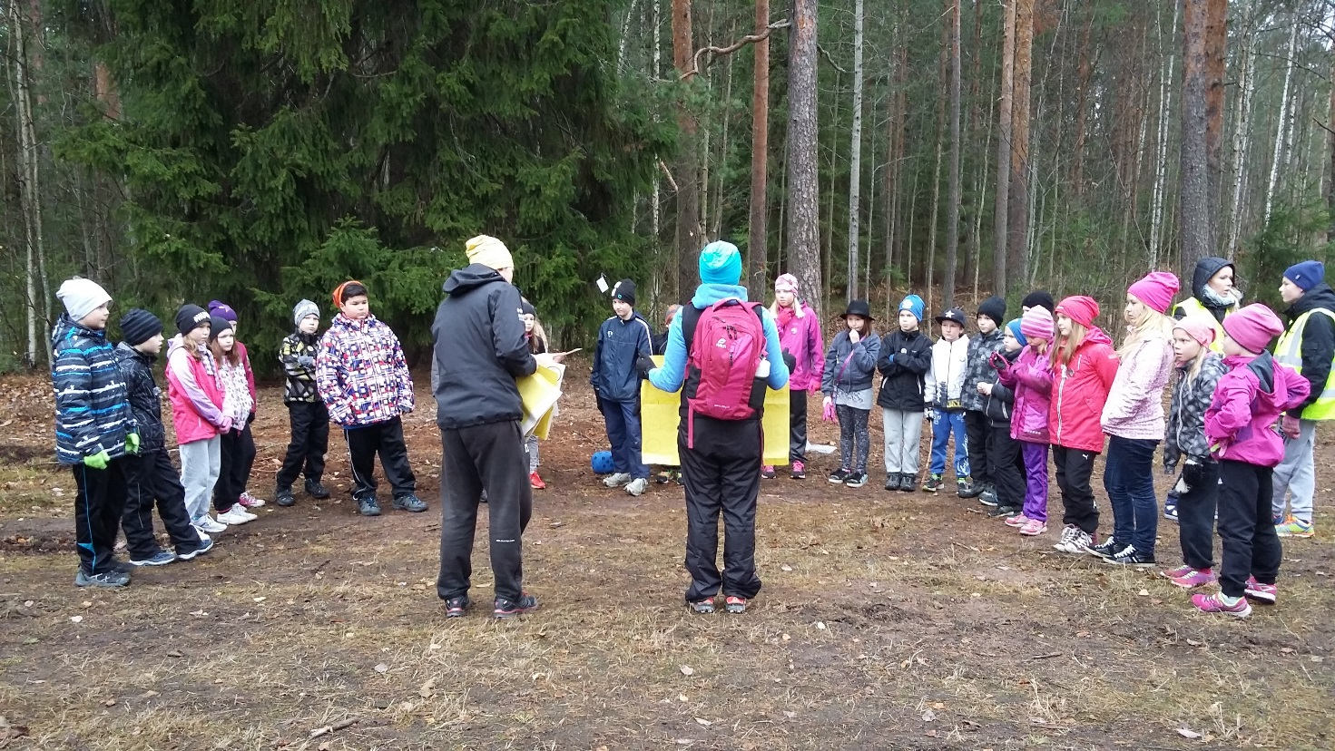
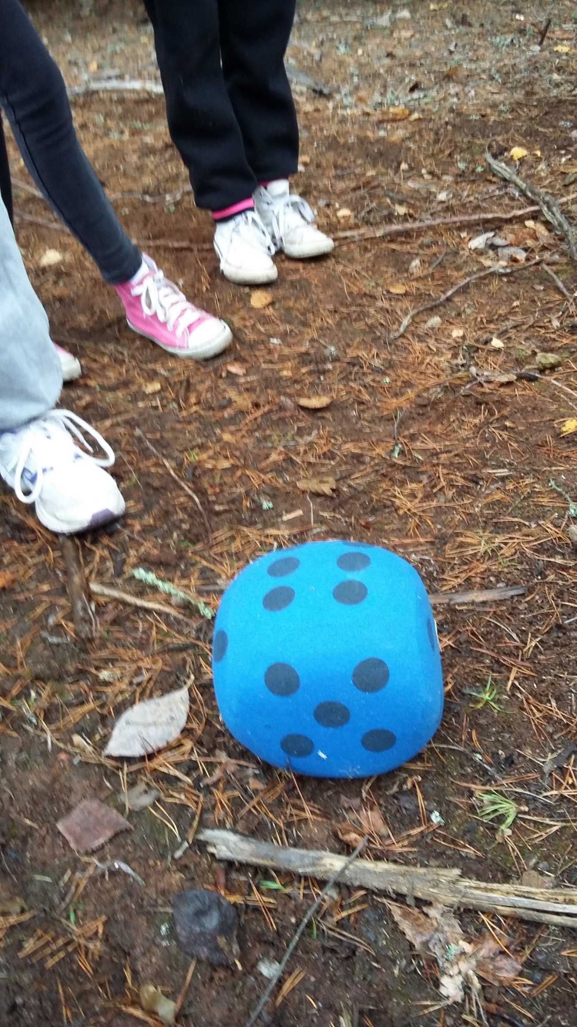
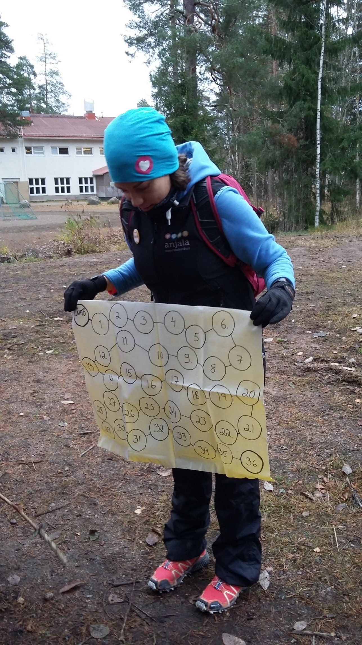

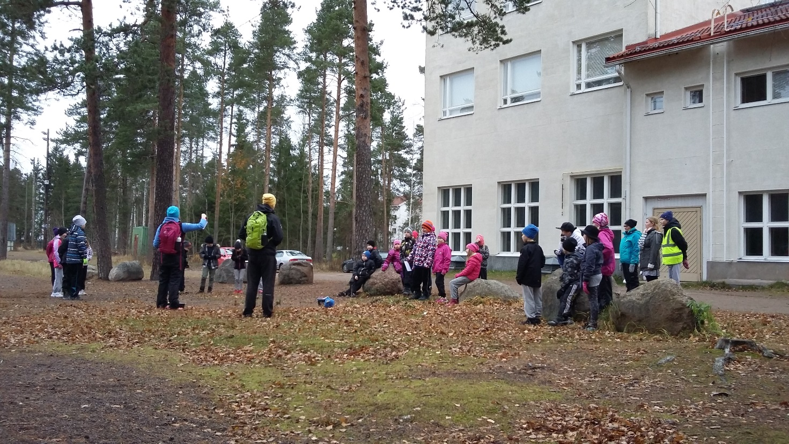
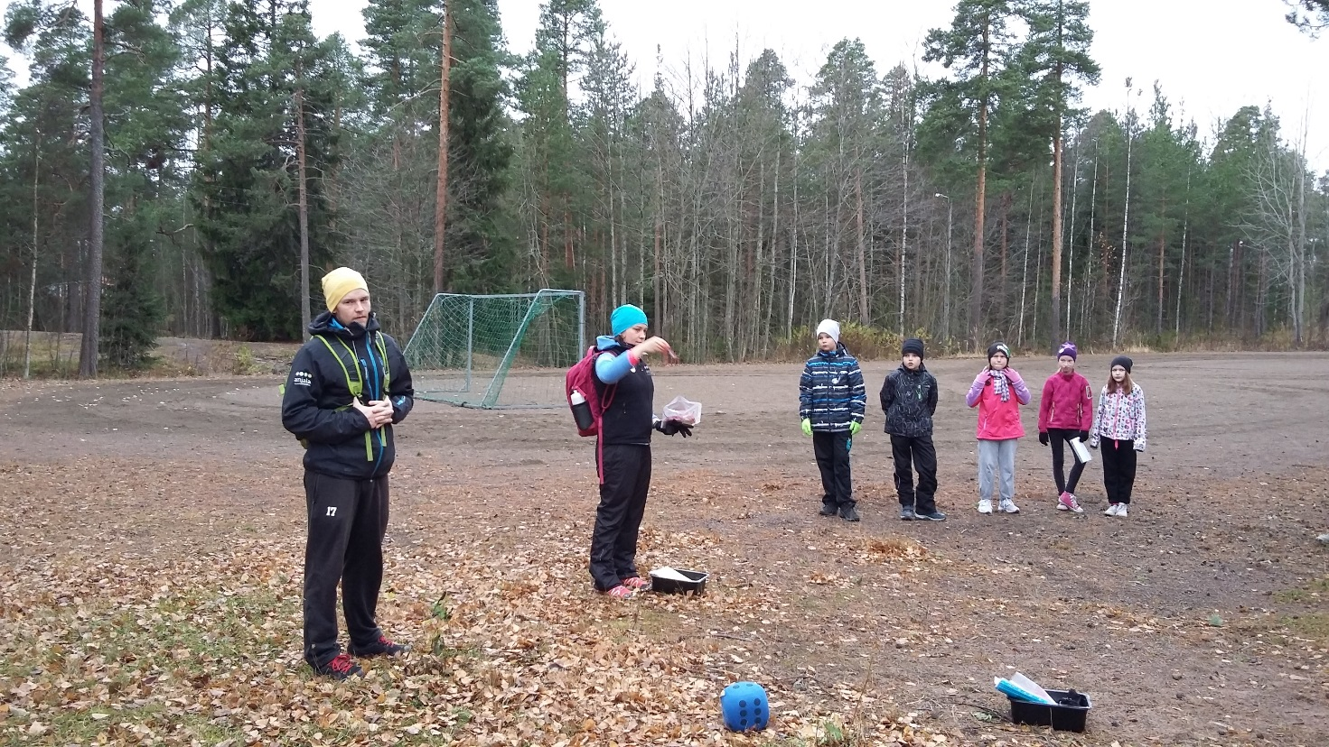

Environmental Education in February 2016 PICTURES
