Lukusanat
- lukusana myös yhden sadan/tuhannen/miljoonan eteen
-> one hundred, one thousand, one million
- kymmeniä/satoja/tuhansia = monikko + aina of-prepositio
-> hundreds of birds / thousands of flowers
- lukusana + sata/tuhat/miljoona yksikössä
-> three hundred/seven thousand/fifteen million
- suomen ’kymmeniä’ pyöristyy tusinoiksi -> ’dozens of cows/people/cars’
- järjestyslukuihin kuuluu aina the-artikkeli
-> the first, the twenty-third, the 4th, the 101st
- lukusana osana attribuuttia (adjektiivi- + substantiivifraasia): muista väliviivat ja ajanlaskentasana yksikössä
puolitoistavuotias tyttö = an 18-month-old girl
Käännä

- toiseksi suurin kaupunki
- suunnilleen kolme miljoonaa
- puolet asukkaista
- kymmeniä tuhansia työpaikkoja
- kymmeniä rantoja
- kolmevuotias poika

Lukusanat ajan ilmaisuissa
- vuosikymmen = decade / vuosisata = century
in the late 50s/in the early 1600s/ in the mid-1970s
= in + the + early/mid-/late + s-päätteinen muoto vuosikymmenestä/vuosisadasta
- 1600-luku = the 1600s = the 17th century
600-luku = the 600s = the 7th century
2000-luku = the 2000s = the 21st century
- vuorokausi = 24 hours
2 vuorokautta = 48 hours
puoli vuotta = 6 months
puolitoista vuotta = 18 months
- kerran = once / kaksi kertaa = twice / kerran viikossa = once a week / 2 x kuussa = twice a month
- at three o’clock / at three
pm = klo 12 – 23.59 / am = 00 – 11.59
- viisikymppinen
he is in his fifties / fiftyish / he is fifty-something
he is in his early/mid-/late fifties
Käännä

- vuonna 1991
- 60- ja 70- luvuilla
- 2000-luvulla
- 20. marraskuuta 1923
- 1800-luvun loppupuolella
- hän on vähän yli kaksikymppinen

Paljoussanat 1
little / a little / few / a few / many / much / more / most / most of
We had a party the other night. At midnight there were only 1) __________ people left, 2) _______________ had gone home. There was 3) __________________ wine left, the guests had drunk 4) _______________ it. 5) ______________ people had anything to eat. Perhaps they had already eaten. How 6) _______________ people came to your party? Quite 7) ____________________ . We had invited even 8) ____________________. How 9)______________________ money did you spend? – Not a lot. I don’t have 10) ____________________ money to spend on parties.
Paljoussanat 2
a lot of / a lot / little / a little / less / the least / few / a few/ fewer / the fewest / many / much / more / the most
- My grandmother gave me _______________________ money.
- Are there any people here? No, only ____________________
- Is there any tea left in the pot? Just _____________________
- How _______________________ tourists visit Finland annually? - ______________ in summer but not
___________________________ in winter.
- How _______________________ time do you have? – Not ________________ ; tomorrow I will have
___________________________ though.
- I’m lucky to have _______________________ friends, not too ___________________, though.
- _____________________ people visited me on my birthday. I wonder where everyone was?
- I’ve got __________________ money. I don’t need to borrow any.
- He had __________________ money. He couldn’t afford to buy a new pair of shoes.
- There are _____________________ people in Jyväskylä, _______________ in Turku, but ___________________ people live in Helsinki.
- _____________________ time is spent watching TV, ________________ on outdoor activities but _____________________ is spent sleeping.
- The situation is serious. There are _____________________ rivers in Europe which are not polluted.
- The country with _____________________ people per square kilometer must be Finland.
- Scientists have _______________________ hope of finding a cure for cancer before the year 2010.
- She had ______________________ time to study than Paul but had _________________ points in the test.
- Give that girl ____________________ opportunity and she will start to spread rumours.
- There were too __________________ people at the concert – we couldn’t see the band.
- There were _____________________ at the concert.
- There’s not so ___________________ work to do this week.
- I’ve got ________________________ work this week.

Paljoussanat 3
Humans and their factories take up 1) ___________________ (paljon) space in the biosphere. 2) ___________________________ (kuinka paljon kauemmin) can we keep on expanding our share at the expense of that of other species? No one knows what the future holds, but at present it seems painfully obvious that there are 3) ____________________________ (liian paljon) inhabitants on our planet. Although the population explosion is a major problem, there are also 4) _____________________________ (melko paljon) other reasons why the current situation is alarming. One of them is our Western lifestyle which consumes 5) __________________________ (niin paljon) energy that it makes 6) ___________________________ (aivan liian paljon) demands on our limited resources. A single nuclear family in Los Angeles consumes 7) ______________________ (paljon) if it has two or more cars, a swimming pool and a meat-based diet. In a developing country, it takes 8) _____________________ (suuri määrä) people, perhaps an entire village , to make the same demands on the ecological resources. Therefore, although our earth has 9) ___________________ (paljon) problems, we shouldn’t put the blame on others. How can we ask poor peasant farmers in Brazil to safeguard rainforests, when they don’t have access to half as 10) _______________________ (useat) natural resources as we do?

Paljoussanat 4
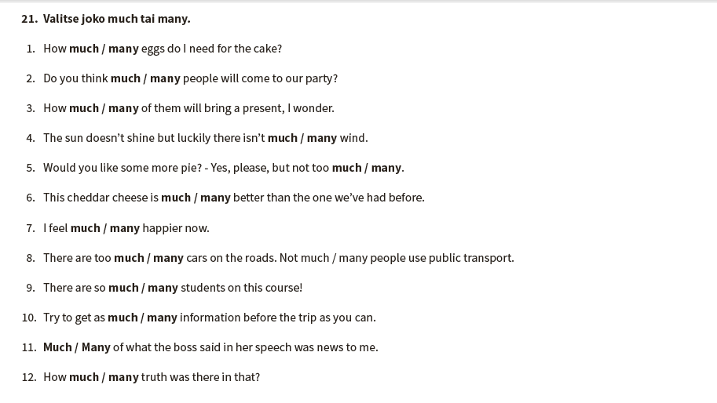
Paljoussanat 5
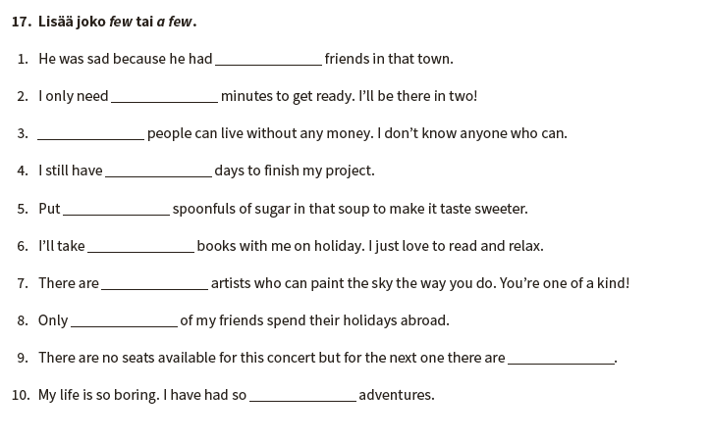

Paljoussanat 6
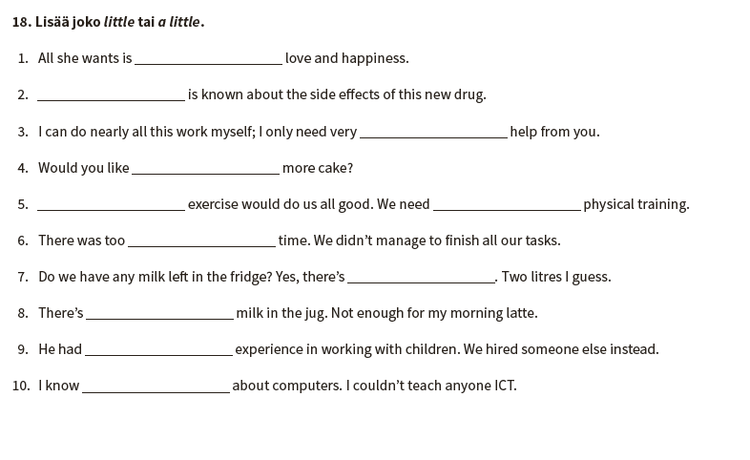

Paljoussanat 7
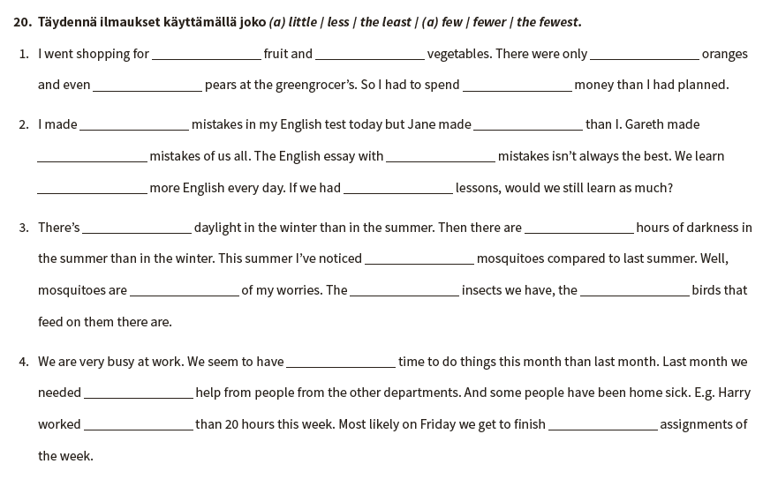

Infinitiivi, ing-muoto ja that-lause
A Kirjoita annettu verbi oikeassa muodossa.
1. Did I hear you ……… my name? (call)
2. I was busy ……… a book. (read)
3. I really enjoy ……… detective stories. (read)
4. But perhaps I’d better ……… now. (stop)
5. Did you want me ……… something? (do)
6. Is there something ……… in the kitchen? (do)
7. It’s funny: your mother made you ……… a lot of housework, (do)
8. while my mother didn’t let me ……… anything! (do)
9. Actually I’m quite good at ……… things. (fix)
10. I’m also used to ……… the floors. (mop)
11. This toaster is broken. Is it worth ……… it anymore? (fix)
12. What must I ……… next? (do)
13. Maybe I ought ……… the rubbish out. (take)
14. Or are there any other jobs for me ………? (do)
15. If not, I’d rather ……… back to my reading. (go)

B Käännä.
1. Bob sai minut itkemään.
2. Jim näyttää tehneen parhaansa.
3. Istuvat härät eivät nauti juoksemisesta.
4. Johnnyn uskotaan lähteneen maasta.
5. Useimmat lapset ovat huonoja valehtelemaan.
6. Sitä, mitä ei kannata tehdä hyvin, ei kannata tehdä ollenkaan.
7. Jack antoi minun ajaa autoaan.
8. Bill sanoi tulevansa myöhemmin.
9. Vaimoni ei halua, että menen sinne yksin.
10. Paddy jätti kellonsa tänne korjattavaksi.

C Valitse sopivin vaihtoehto.
a. to be trusted.
1. Appearances are not always b. trusting.
c. to trust.
a. that he smiled
2. The salesman at the door kept b. smiling at me.
c. to smile

a. explain
3. When he had finished b. to explain about the vacuum cleaner,
c. explaining

a. come
4. I invited him b. to come in.
c. coming

a. show
5. I even let him b. to show how it worked.
c. to be shown

a. clean
6. I have never enjoyed b. to clean the house.
c. cleaning

a. that he was
7. He said b. to be an expert.
c. being

a. clean
8. So I made him b. to clean the whole house, almost.
c. cleaning

a. buy
9. In the end I decided I’d better b. to buy the thing.
c. that I buy

a. lift
10. After he’d left, I tried b. to lift the machine, but it was too heavy. Bummer!
c. that I’d lift

D Valitse sopiving vaihtoehto.
a. dance.
1. Donna felt like b. to dance.
c. dancing.
a. play
2. She had just heard her favourite band b. to play live at a concert.
c. to be played

a. get
3. She was glad that her mother had let her b. to get a ticket.
c. getting

a. come
4. Maggie had promised b. to come there, too.
c. coming

a. to bring
5. She said b. to be brought her boyfriend along.
c. that she’d bring

a. to live.
6. On a night like this, life was definitely worth b. living.
c. be living.

a. go
7. Donna was not used to b. be going out a lot.
c. going

a. help
8. Her father often made her b. to help in the shop.
c. helping

a. to serve
9. She didn’t mind b. serving the customers, …
c. being served

a. to clean
10. … but she wasn’t too keen on b. cleaning the shop in the evening.
c. that she cleaned

